Home Learning Ideas for all
Tuesday 12th May 2020
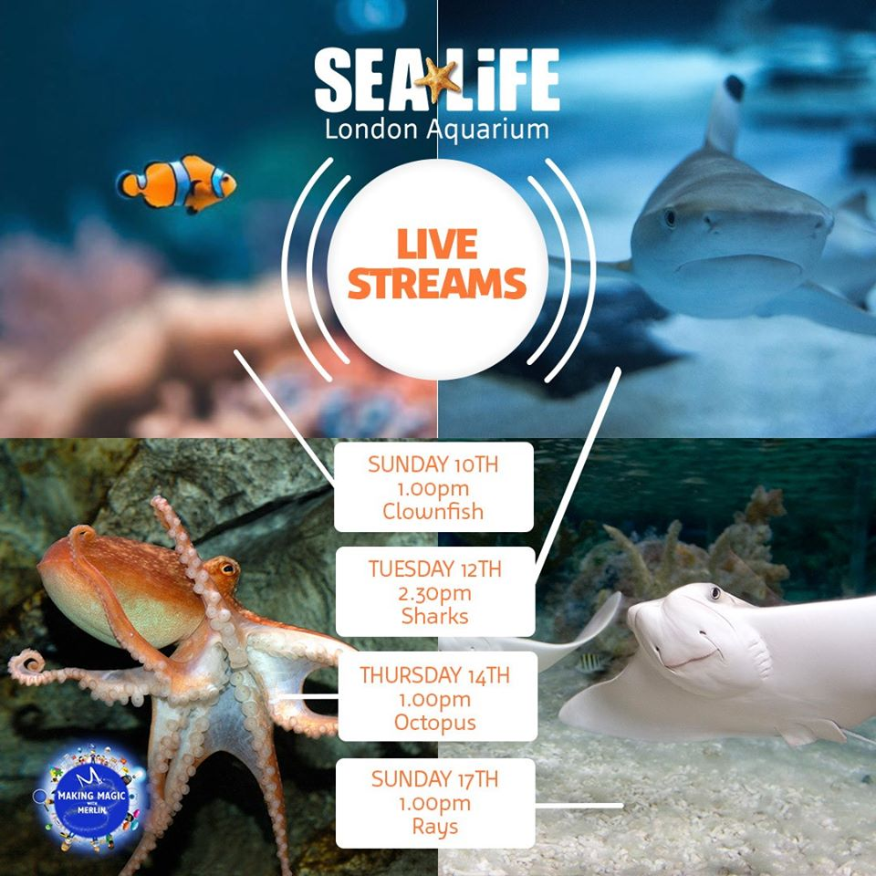
SEA LIFE London Aquarium
If you have access to Facebook, the London Aquarium are doing live streams throughout the week. Swim on over to their Facebook page at 2.30pm today to get close to the sharks!

Highworth Reading Challenge!
Can you have a go at recreating a front cover from a book you enjoy reading? Be as creative as you like! Mrs Harris had a go at Matilda…
If you would like to join in the challenge, email the photo to your teacher and let them know if you’d like us to add it to the Reading Challenge page on our website!
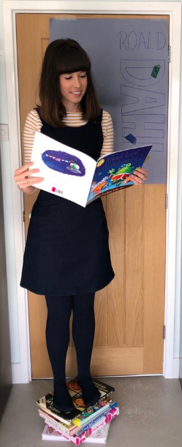
https://www.highworth.bucks.sch.uk/web/highworths_reading_challenge/481110
