Year 4 Home Learning – Friday 5th June 2020
Please email us your work to:
Year4@highworthcombined.co.uk
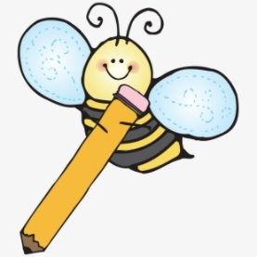  Remarkable Writing!  Fun Friday includes fun writing!  Today you are going to write some lists.  The funnier the better!  Here are some ideas to get you going:  10 reasons you can’t possibly write something today!  10 things that remind you of summer.  5 things you would change about the world.  10 grumpy words.  10 happy words.  10 things to hide from a gorilla.  List of names to call a fantasy pet.  A list to describe a character (from a book or film, or a character you have created)  Things you should never say to a cranky dragon.  The list of possibilities is endless! We would be really happy if come up with some of your own list ideas too!  See if you can write at least 3 lists – but more would be make it Fantastic Friday!  Challenge: Use one of your lists to write a list poem. There is some guidance attached (written by the poet Ken Nesbitt) to help you expand your list into a poem! | Splendid SPaG!  Words that you just have to know how to spell!  List the following words and check that you have copied each word correctly. Make sure you use neat joined handwriting.  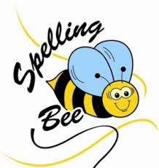  complete  consider  decide  describe  different  difficult  Fun ways to learn include:  Write each spelling twice.  First, write each word in CAPITAL letters.  Second, write each word in lowercase letters.  Example – BICYCLE bicycle  Next ask someone to test you!  Now write some silly sentences using at least two words in each sentence.  Challenge: create a wordsearch of common exception words. Remember to include a list of the words that are included. Send it to us and we could try it or include it with a future matrix!
Wonderful Wellbeing  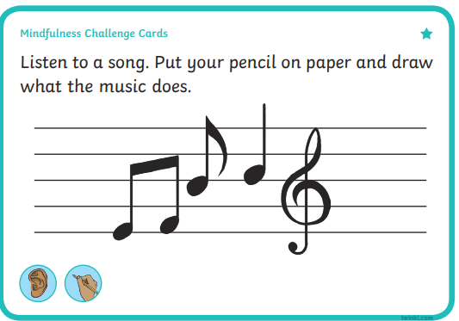  Listen to a different song and repeat the activity. Try to choose music that is different to your first choice. How does your pattern differ? Why might that be? | Terrific Topic  First of all, you could illustrate one  of your lists or your poem if you  have written one.  Fun Friday art activity ….  Draw a scene from your favourite story or film. Now try another but with your eyes closed!  You could also do this with a self portrait. Draw a picture of yourself (head and shoulders). Now close your eyes and draw your self portrait again! Repeat for other members of your household. Can they guess who’s who?

Marvellous Maths!  Times Tables and division practice for quick recall. You can use this link: https://www.topmarks.co.uk/maths-games/daily10 Don’t forget you can use Daily 10 to practice other mental maths skills too! Let us know about any you have tried and how you got on.  Remember that you can practice these skills without the internet, using the ideas in the previous matrices.  Place Value Pandemonium  (attachment with Learning Matrices)  Fun Friday continues with this action packed maths game that will remind you all you have learnt about place value, including some reminders about decimals.  The game can be played in a beat the clock version by one player or it can be a group game with more players.  There is another game attached below that involves less paper and you could simply copy out.  Challenge: can you create your own place value game using some of the ideas here? | Super Science!  Reach Out Reporter with a slight difference today.  In line with our list them, this link will take you to a page to find out 5 interesting facts about asteroids (scroll down the web page to see the video links).  https://www.reachoutreporter.com/fact-pack/five-interesting-facts-about-asteroids/  Can you make a list of the 5 interesting facts and explain what you have found out to someone else?  Challenge: do some more research and either create a poster about asteroids or a quiz (with a separate answer sheet). Think about the facts and scientific vocabulary!

Starting with your own list

Writing a list poem
If you prefer to write your own list poem from scratch, one easy way is to figure out what you’re going to make a list of. For example, you could make a grocery list, a list of things in your backpack, a list of your favorite sweets, a list of things you want for Christmas, and so on.
Let’s try it with a list of sweets. First let’s try to think of candies and sweets that rhyme.
Nestle’s Crunch
Hawaiian Punch
Dots
Zotz
Tootsie Pops
Lemon drops
Whoppers
Gobstoppers
Now that you’ve got some rhymes, put them into a list, adding a few more items to make the lines each about the same length:
A half a dozen Nestle’s Crunch.
A gallon of Hawaiian Punch.
Some Cracker Jacks. A box of Dots.
Some Pop Rocks and a jar of Zotz.
Reese’s Pieces. Tootsie Pops.
Hershey Kisses. Lemon drops.
Candy Corn, Milk Duds, and Whoppers.
Skittles, Snickers, and Gobstoppers.
Once your rhyming list is done, give it a beginning, an end, and a title and you’re all done.
My Shopping List
My mother said, “Go buy some bread,”
but this is what I got instead.
A half a dozen Nestle’s Crunch.
A gallon of Hawaiian Punch.
Some Cracker Jacks. A box of Dots.
Some Pop Rocks and a jar of Zotz.
Reese’s Pieces. Tootsie Pops.
Hershey Kisses. Lemon drops.
Candy Corn, Milk Duds, and Whoppers.
Skittles, Snickers, and Gobstoppers.
When mother needs things from the store
She never sends me anymore.
And that’s all there is to it. Now it’s your turn. Make a list of animals, friends, monsters, games, foods, places you’d like to go on vacation, or anything else you like, and see if you can turn it into a funny list poem of your own!

