Year 6 Home Learning
Please email your work into us using the Year 6 email address – year6@highworthcombined.co.uk
We love hearing from you and seeing everything you’ve been up to! Take care Year 6.
Writing – Time Capsule Week  This week, you are going to be creating a time capsule to capture life in lockdown during the week beginning 18th May. The teachers are going to do this too and share theirs with you on our return back to school!  Please see the attached guidance and work through the activities each day.  Friday 20th May – write a short song or poem to explain what it’s like to live in your community at the moment. There are ideas in the guidance.  There are optional tasks for the weekend for your diary. You may wish to carry these over to the following week instead. We’ll leave it completely up to you! They’re fun ones!  Saturday 21st May – How I play. Take photographs of how you play. The weather is set to look nice so garden photos welcomed  Sunday 22nd May – Record a short video to explain how you’re feeling during the lockdown. You can reflect on your feelings at the start and as time has progressed.  Have fun! | Maths  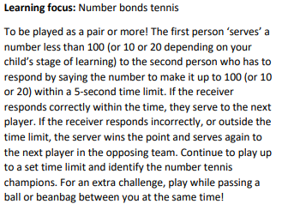  Challenge yourself –  Use decimals to 1 e.g. 0.45 or 0.234 or 0.4  Use fractions to a given number e.g. our target is 4, what do I have to add to get from 2 ¾?  If you want a really challenge, your answer has to be an equivalent fraction. E.g. our target is 1. What do you have to add to get from 2/5. We know it’s 3/5 but you would have to say an equivalent e.g. 6/10 or 15/25 etc…  Use number bonds to 1000, 10,000, 100,000 or 1,000,000
Reading  Reading Bingo!  On the attached document, are many reading challenges. See how many you can complete! You may like to do these over the half term week. Send us in some photos of you completing these activities. | Topic  Continue to use the oak national website. Have you learnt anything in addition to what you already knew? We’d love to see or hear about this!  https://www.thenational.academy/online-classroom/year-6/
Spellings  This term, you have been set lots of spelling tasks. It would be good now to see how many of your spellings you can correctly spell. Ask someone in your house to read out the spellings you’ve been practising and see how many you get right. If there are any you are still finding difficult, look back through some of the spelling tasks we’ve set to practise them.  Let us know how you get on! We might have some useful rhymes/acronyms to help you remember certain spellings. | Mindfulness  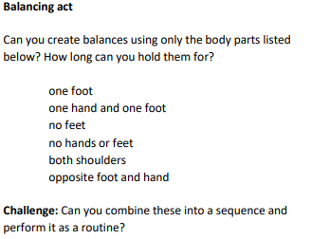  Remember to check that your surroundings are safe before you start!

