Transition Day Activities
Dear 2H,
We are setting you a few challenges so that we can learn a bit more about you! Don’t forget to email them in for us to have a look at using this address: year3@highworthcombined.co.uk
We can’t wait to meet you! Have a wonderful summer holiday.
Take care,
Mrs Phillips and Mrs Moore
Activity | Example/Top Tips
‘Shoebox Portrait’  See if you can find an empty shoebox somewhere at home. Choose 4 or 5 objects to put into your shoebox that are important to you or represent something about your personality. Take a photograph of your shoebox and then write a short explanation for us to explain why you chose each object.  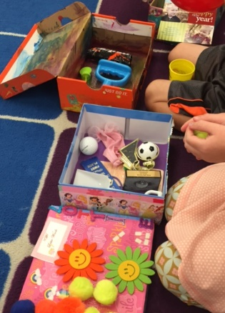 | For example, I (Mrs Moore) would choose a photograph of my dog, Willow, because she is very special to me. She comes running with me and curls up by my feet in the evening, when I am watching the TV.  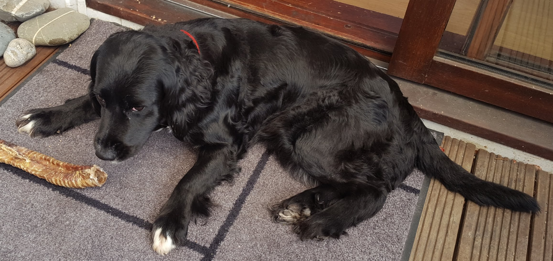  I would also put in my 3 medals for completing the 3 half marathon races I have run. I trained really hard to be able to complete each one, and I was delighted to achieve my goals!  I would also put in a wooden spoon as I love baking with my daughter!  What will you choose?
‘Questions, Questions, Questions?’  Imagine you are a news reporter for Newsround and your special guests are us – your new teachers, Mrs Phillips and Mrs Moore! Think of 5 questions that you would like to ask us. We will try to reply and answer them if we can. | You could write these down or you could even record a short Newsround clip. Think about a short introduction to tell the watchers why the interview has come about – you are going to start Year 3 in September! You might want to watch Newsround to give you some ideas! https://www.bbc.co.uk/newsround
‘Self Portrait’  Create a self-portrait (a picture of yourself) to send us. | You could use colouring pencils, paints or even collage to create your self-portrait. You might even like to go out and collect some natural materials to create a portrait of yourself.  Be as creative as you like!

