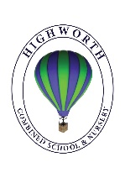
Home Learning Ideas for all
Tuesday 5th May 2020
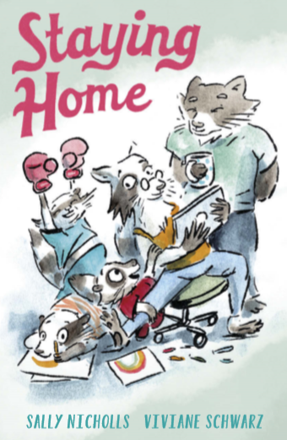
Staying Home book online
Sally Nicholls, a children’s author, has written a free online book for children. She has a four year old and a two year old at home and has used this experience to inspire her story. We hope you enjoy! https://www.andersenpress.co.uk/wp-content/uploads/2020/04/STAYING_HOME_medium-res.pdf

In the basket!
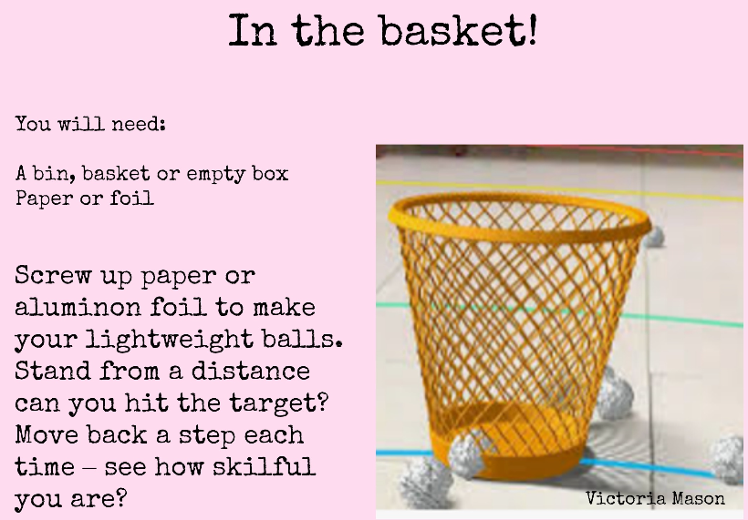

Finger Fiddle
A great way to focus your brain and your body is to do some ‘finger fiddling’! This might be a good idea to do before you start one of your home learning tasks. Have a look at the card below and see if you can follow the instructions!
