Year 2 Home Learning
Week Commencing 8 June 2020- Wednesday
Please send your work to- year2@highworthcombined.co.uk
We always look forward to seeing your work. Please let us know if you need any help or have any questions.

English Task  Listen to the poem ‘The Magic Box’, by Kit Wright.  https://www.bbc.co.uk/bitesize/clips/zkpmhyc  Today you will write your poem in the style of Kit Wright. What sort of things and sights would you put inside the box? What sounds, smells and textures would you put inside the box? What sort of dreams and feelings? Are there things from the natural world like rivers and mountains? Perhaps it has a window inside it that glitters every time someone passes by, or a door leading to a magical land filled with delicious chocolates and the warm smell of cocoa? You could use some of your ideas from yesterday. Use the template below to write your poem.  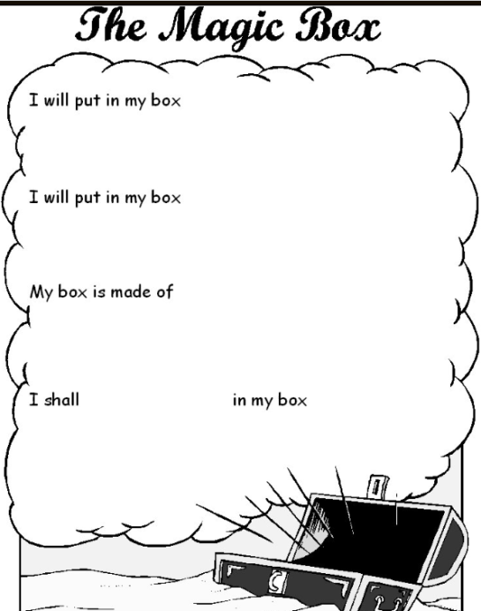  Try to put in:  - a sound  - alliteration  - a colour  - something you can’t keep  - something that doesn’t exist  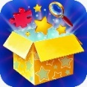  Once you have finished your poem, have a go at illustrating your poem. | Maths Task  Mental Maths Warm Up  1. 63 - 45 = __  2. 27 + __ = 65  3. 2 x 8 = ___  4. 35 ÷ 5 = __  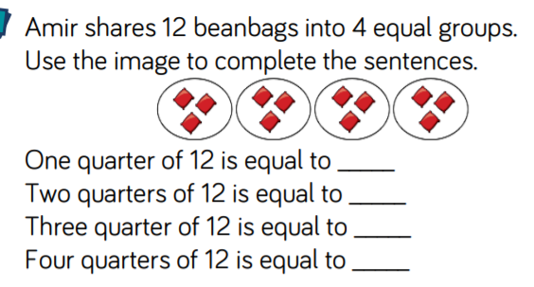  Fractions  Use counters or bar models to help you fill the blanks:  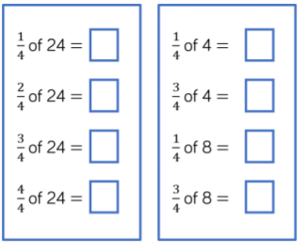  Challenge!  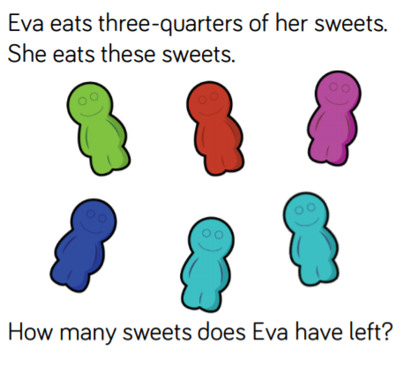  Ask an adult if you can use real sweets to complete this task.
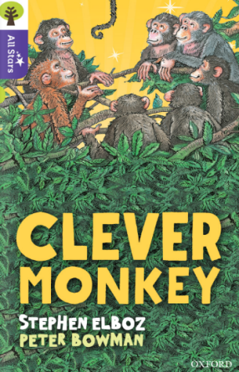  Reading  https://www.oxfordowl.co.uk/api/interactives/26344.html  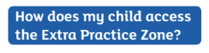  For guidance of how to access the Oxford Owl website go our school website click on coronavirus closure/home learning ideas/scroll down to parent guide for extra spelling zone/scroll down to  For log in details look in your yellow booklet you have been given at the end of March. | Geography: Explain what a continent is and name the 7 continents on Earth.  Research facts about South America  List some of the countries that make up the continent of South America.  How many are there? What is the largest country called? What languages are spoken there?  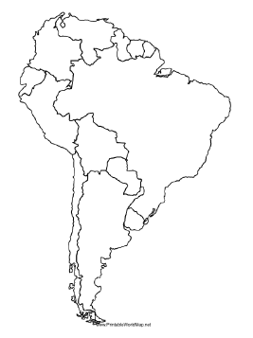  What is the climate like? Can you find out facts about the Amazon Rainforest and the River Amazon? Why is the Amazon Rainforest special? What minibeasts are found in the Amazon?  https://www.youtube.com/watch?v=BO4UYhhU-8c
PSHE:  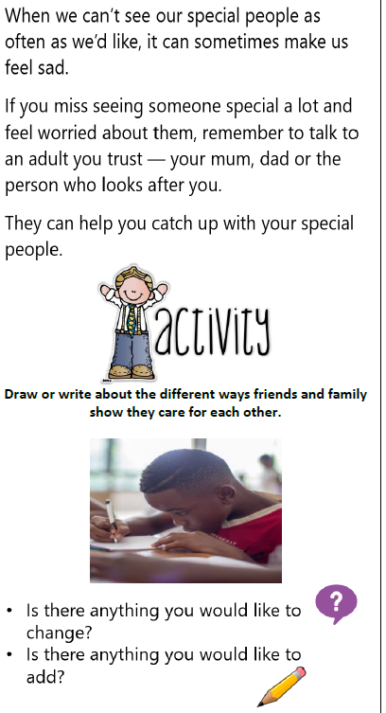 | More Geography  Enjoy this exciting journey to Brazil.  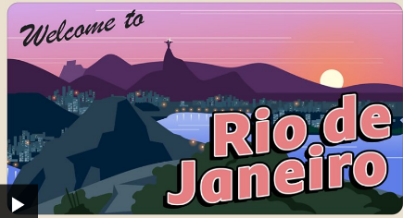  https://www.bbc.co.uk/bitesize/articles/z6yg9mn

The Magic Box
I will put in the box
the swish of a silk sari on a summer night,
fire from the nostrils of a Chinese dragon,
the tip of a tongue touching a tooth.
I will put in the box
a snowman with a rumbling belly
a sip of the bluest water from Lake Lucerene,
a leaping spark from an electric fish.
I will put into the box
three violet wishes spoken in Gujarati,
the last joke of an ancient uncle,
and the first smile of a baby.
I will put into the box
a fifth season and a black sun,
a cowboy on a broomstick
and a witch on a white horse.
My box is fashioned from ice and gold and steel,
with stars on the lid and secrets in the corners.
Its hinges are the toe joints of dinosaurs.
I shall surf in my box
on the great high-rolling breakers of the wild Atlantic,
then wash ashore on a yellow beach
the colour of the sun.
by Kit Wright

