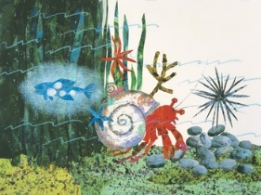
Year 2 Home Learning
Week Commencing 27 April 2020 - Monday

English task  A House for Hermit crab.  Listen to the story  https://www.youtube.com/watch?v=7cYgxknuDmc  or  read it on the Power point document (see our year 2 Matrices folder for this week).  Now listen to it again and write down any interesting vocabulary on a piece of paper like we always do with our words of the week. ( i.e approach, gloomy, discover etc)  I chose these ones: signal, sway, murky, dim, dart, creak.  Now write your own sentences using the words you found or you can use the ones I chose.  Challenge!  See if you can use alliteration (you practised it last week) in your sentences. Good luck! | Maths task  Last week you have successfully practised to add and subtract two digit numbers. This week we will practise to solve word problems. Please remember to read the word problem carefully first. Underline the words that help you solve the problem. Remember to show your workings.  - Hermit crab saw 25 red corals swaying, 37 orange corals stood still and 59 blue ones were swaying. How many corals were swaying?  - A star fish swam 37m. A lantern fish swam 43m. How many meters did they swim in total?  - A whale and a dolphin had a race. The dolphin finished the race in 28 minutes. The whale finished the race 46 minutes after the dolphin. How long did it take the whale to finish the race?  Now write your own word problem using this calculation: 28 + 36 + 12 =
Art/Dt  Crabs, star fish and sea urchins live in the ocean. Can you name 5 oceans? Do you remember our song?  https://www.youtube.com/watch?v=X6BE4VcYngQ  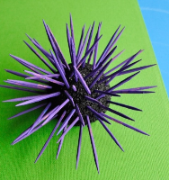  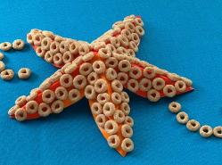  Now have a go at making 3D model of a star fish or an urchin.  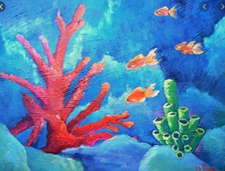  Do you feel like painting instead? Choose one of the characters from ‘A house for Hermit Crab’ book and paint it.  I love this paiting of sea corals. | Science:  In the Autumn term, we also looked at different habitats for some animals. A habitat is the home of an animal or a plant. Almost every place on Earth—from the hottest desert to the coldest ice pack—is a habitat for some kinds of animals and plants.  Can you make a chart of animals that live in the following habitats? - Polar Habitat, Ocean, Woodland, Rainforest.  Your chart can look like this:  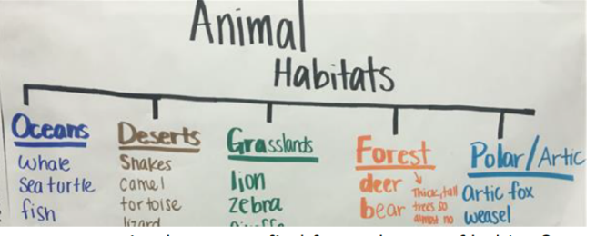  Can you find out which type of plants are found there?
Science quiz  Watch this video on habitats and complete the quiz.  Oceans  https://www.bbc.co.uk/bitesize/topics/zx882hv/articles/zsfkd2p  Polar habitats  https://www.bbc.co.uk/bitesize/topics/zx882hv/articles/z3sr4wx  Woodland habitats  https://www.bbc.co.uk/bitesize/topics/zx882hv/articles/zc42xnb  Rainforest habitat  https://www.topmarks.co.uk/maths-games/mental-maths-train | Fun with maths:  https://www.topmarks.co.uk/maths-games/mental-maths-train

