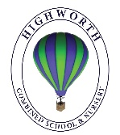
Year 1 Home Learning – Monday 6th July 2020

Below, you will find 6 home learning tasks. You may choose the tasks that you wish to complete and do them in any order.
Please do not hesitate to contact us if you have any queries.
year1@highworthcombined.co.uk
English  When we were all still at school, our Little Warriors group started a very exciting project with another school. They became pen pals with the Kingswood Cherry Trees Nurture Group.  Whilst we have been at home, they have sent us some lovely photos and writing about a trip to Tesco Express and making sandwiches and biscuits.  This week we would love you to write a reply to them, which we can send on to the other school for them to read and enjoy. You can include photos or pictures too!  We would like you to tell them about something fun you have done in the last few weeks, perhaps a game, baking a cake, seeing family or friends for a safe barbecue or going to the playground.  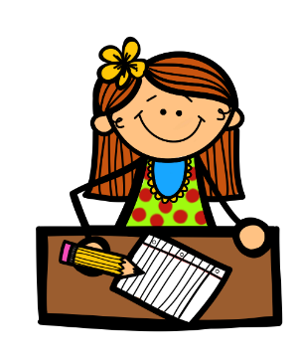  The pictures of the letters from the other children are on the website where this home learning matrix was.  We can’t wait to see your letters! | Maths  Look at the link to help explain what are odd and even numbers. https://www.bbc.co.uk/bitesize/topics/zknsgk7/articles/zt4jj6f  Play this odd and even game.  https://www.topmarks.co.uk/learning-to-count/coconut-odd-or-even  Have you ever noticed that on most roads, the odd numbers are on houses on one side and the even numbered houses are on the other side of the road?  Make a road, with houses on, then number your houses - the odd numbered houses on one side and even numbers on the other.  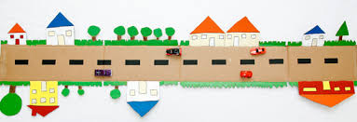
Science and History
Today, we are going to think about the stages of a human life and the changes that occur.
First, in a circle draw the stages of a human and label them e.g. Baby, toddler, child, teenager, adult, elderly.
Write a sentence next to each picture to show what humans can do at each stage of life.
The questions below should help you think of what a human can do at each stage of its life.
- Baby – pretend you are holding a baby, how would you carry the baby to keep it safe?
- Toddler- stand up and pretend to be a toddler. Do some wobbly walking around, when did you learn to walk?
- Child- what can you do on your own now that you used to need help with?
- Teenager- do you know any teenagers, are they learning to drive?
- Adult- What job would you like to do when you are an adult?
- Old age –when you are older, what hobbies would you like to do; do you know any older people are they retired – what does retired mean?
Challenge
- Science- Draw the life cycle of another animal.
- History- Make a timeline of the important events in your own life so far.

Wellbeing  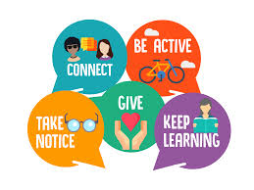  The wellbeing activities we have been thinking about each week have had the themes of taking notice, connecting, giving, being active and learning. This week, we are going to try and do all of them together.  Go on a scavenger hunt and look for:  - Something that makes you happy  - A thing you love in nature  - Something that makes an amazing sound  - Someone you love  - Write a letter to a family member.  - Ask an adult if you can call someone, you have spoken to for a while.  - Talk with a family member about how your day has been and remember to take time to ask how their day has been.  - Give someone in your family your time and ask what they would like you to do to help them.  - Do a physical activity, run, walk, bike ride etc.  - Learn something new, maybe some sign language, baking, sewing etc. (an adult might have to help you with this one) | Geography  Look at the BBC bite size lesson about Australia, watch the videos and complete the activities.  https://www.bbc.co.uk/bitesize/articles/zdk26v4  You could also watch the Go Jetter’s episode about the Great Barrier Reef.  https://www.bbc.co.uk/iplayer/episode/b07xhpnl/go-jetters-series-1-39-the-great-barrier-reef-australia  Lots of information can be found in this All about Australia PowerPoint.  https://www.twinkl.co.uk/resource/t-or-258-part-of-the-party-all-about-amazing-australia-powerpoint  And this link to the Oak National Academy will tell you lots about Australia too.  https://www.thenational.academy/year-1/foundation/what-is-australia-like-year-1-wk2-1  Make a fact sheet to show us what you have learnt about Australia, the Great Barrier Reef and the continent of Oceania.  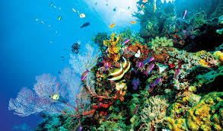
Art
Today we are going to be thinking about paintings made up of dots. The dot paintings below represent the beauty and tranquillity of nature and mostly uses patterns and depictions of animals and nature.

The colours in the pictures below are associated with the earth, including brown, umber, brick red, terracotta, yellow ochre, warm grey, burnt sienna, tan, and shades of green such as moss.

- Look at the pictures below of a range of traditional and modern dot paintings.
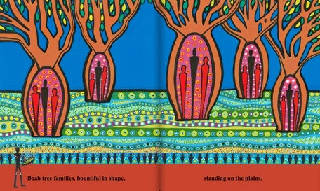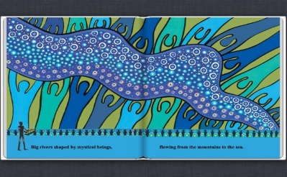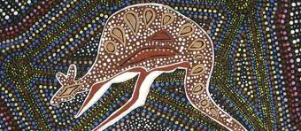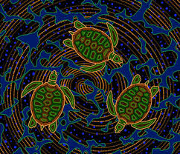
Trees The river Kangaroo Turtles
- Think about the picture you would like to draw, it can be an idea from above or your own picture.
- Decide how you will make your dot picture -cotton wool buds in paint work well, your finger, or the end of a pencil in paint.
Below are some examples made by other children.
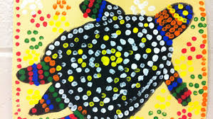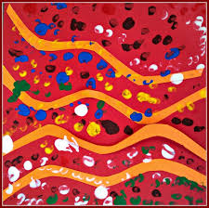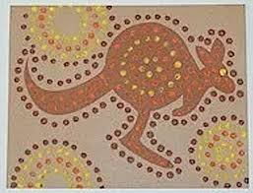

Send us a picture if you can!

