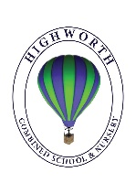
Home Learning Ideas for all
Wednesday 1st April 2020
TTS Home Learning Packs
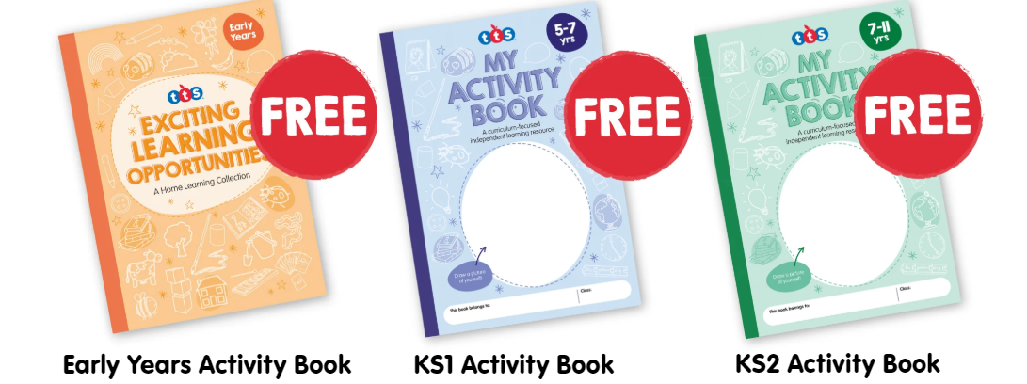
The TTS website has issued free Home Learning packs for the Early Years, KS1 and KS2. There are a range of activities for your children to complete – they can be printed but you could also show your child the activity on a screen and then they can complete it in their Home Learning books.

Audible
Audible are currently streaming hundreds of children’s classic stories online for free. https://stories.audible.com/discovery/enterprise-discovery-21103929011?ref=adbl_ent_anon_ds_ds_dbb_0-0
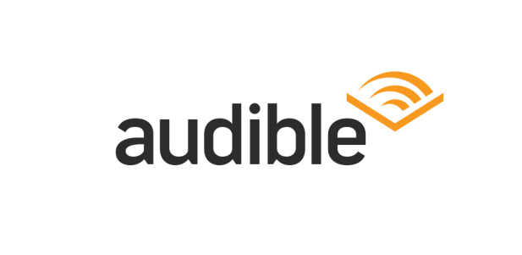
They can be listened to via a phone, tablet or on a computer. You can listen to a wide variety of stories – Nursery Rhymes and Traditional Tales for the littlest listeners and Adventure Stories for inquisitive minds. I wonder what your favourite story will be? You might like to email your teacher and let them know!

And finally, at 11.30am today, MC Grammar is live on YouTube! https://www.youtube.com/channel/UCP4cc9slwfk7942HXYlSKPg. Expect rapping, rhyming, reading, laughing and learning!

