Year 3 Home Learning – Friday 12th June 2020
X means that no internet access is needed. We look forward to seeing what activities you have enjoyed the most. Take a photograph of your work and send it to - year3@highworthcombined.co.uk
X  Terrific Times Tables  Ask an adult to time you for 2 minutes to  see how many times table facts you can  write down in that time.  x3, x4 and x8 (and division facts)  Top Marks website Times Tables games.  https://www.arcademics.com/games/meteor  Roman Numerals  Last Friday, the Maths activity was an  Introduction to Roman Numerals. Have  another look if you have forgotten.  Use your knowledge to answer the  arithmetic questions on the next page.  Write out each of the questions and then  write you answers.  Remember to check your answers! | Sensational Science  Learn about energy sources. Find out  which ones are good for the  environment and better for animals  and their habitats.  Use the link below to watch a short  animation which explains the  different energy sources and then  complete the activities.  The last activity is to design a poster  showing renewable and non –  renewable energy. Draw different  sources of energy and write why they  are good or bad for our planet.  https://www.bbc.co.uk/bitesize/articles/zhvc86f  Which renewable energy sources have  you seen, near your home or when out  in the car? | X  English - SPaG  Activity 1  Check your knowledge of spelling,  punctuation and grammar by  reading and completing each section  on the next page.  Activity 2 – a or an  If we don’t use the in front of a noun  for example, the house, we can say  a house. But a doesn’t work for all  nouns. When a noun begins with a  vowel (a, e, i o, u) we use an. For  example an apple.  Write a or an for each of these words.  shoe  elephant  minute  football  umbrella  chocolate bar  octopus  Can you write 2 more? (use a and an)
Fantastic French  Clothes and Food  Watch two short films. The first, is a  fun, short animation about birthdays and  clothes. The second, is a film about  friends at the supermarket buying  food to make a pizza.  https://www.bbc.co.uk/bitesize/articles/z64xprd  Here are some of the French words  you will hear. Listen carefully.  presents les cadeaux  cake le gâteau  shirt la chemise  jumper le pull-over  trousers un pantalon  supermarket le supermarché  tomato le tomate  banana la banane | X  Super Spelling  Y3 and 4 Common Exception words  Here is the next group of spelling. Write  a list using neat joined handwriting.  heard  heart  height  history  imagine  increase  Activity 1  Write each word in pencil then go over  each letter using colouring pens or  pencils.  Choose one colour for vowels and one  colour for consonants  Activity  Choose 3 words. Now write 2 different  sentences for each of the words.  Activity 3  Draw a picture or symbol  to represent each word. | X  Well Being  List 6 things that make you  HAPPY  You might include a favourite toy or  game but there are other things too.  A happy feeling can include being  with people, achieving something  that you found difficult or helping  someone.  Here are some of mine.  - Listening to music.  - A hug from my children.  - Being outside  - Helping my family and friends  Draw 6 pictures to show the different  ways you feel happy.
There are also two activities.
Maths Activity – Roman Numerals
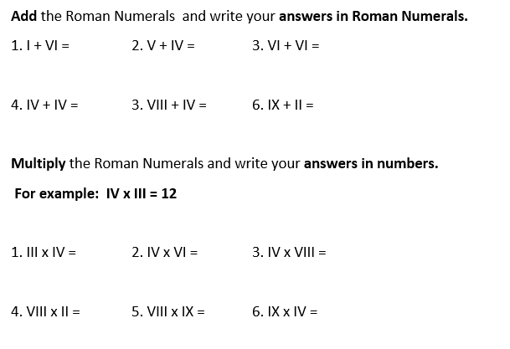

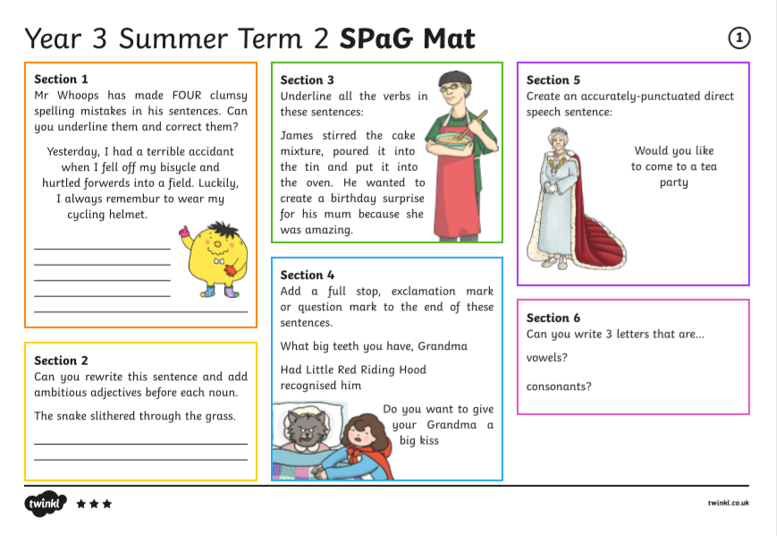
English Activity 1. Spelling, punctuation and grammar.

