Year 2 Home Learning
Week Commencing 29 June 2020- Wednesday
Please send your work to- year2@highworthcombined.co.uk
We always look forward to seeing your work. Please let us know if you need any help or have any questions.

English Task  Following our story- Catch It  https://www.literacyshed.com/catchit.html  Wednesday-  Plan your own story still called ‘Catch It’  Who or what is going to be catching?  Who is going to be throwing? Why?  What are they going to be throwing and catching?  Who will end up with it in the end?  In your story you will want to use different words or synonyms for the word ‘throw’. You could say toss, launch, hurl... How many other words can you think of that you could use in your story instead of ‘throw’?  Thursday-  Write up your story. Remember to use full sentences with capital letters and full stops. Try and make your story interesting using exciting adjectives (describing words) and verbs (action words). | Maths  Warm up-  - 43+ 43= ___  - 21- 12 = ___  - 5 x 7 = ____  - Half of 24 is ___  Measure-  https://www.bbc.co.uk/bitesize/articles/z9dp7yc  Have a look at the following link and watch a lesson about comparing lengths.  Don’t worry if you can’t print the pages out. You can just write the date and the answeres in your book or on a separate piece of paper.  You will use < (less than) and > (greater than) in your independesnt work. Imagine the symbols as an alligator mouth with the numbers on each side being little fish. The alligator will always want to eat a larger number of fish. Whichever number is larger, the alligator mouth is opened towards that number.  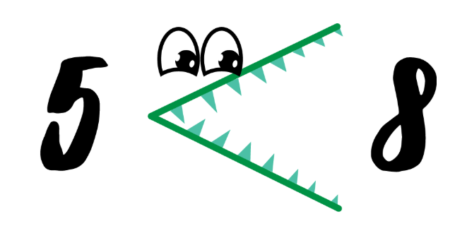
Reading  The First Sunrise-  Read a traditional story from Australia about how the Sunrise came to be. Carefully read the passage below and answer the questions in full sentences.  Challenges- Draw a picture of all the different animals in the story. Do you know what they all look like? | SPAG  Suffixes- look at the words and suffixes on below. Can you join them together to make new words and write them in a list? Are there any root words which match with more than one suffix? How many more suffixes can they think of?  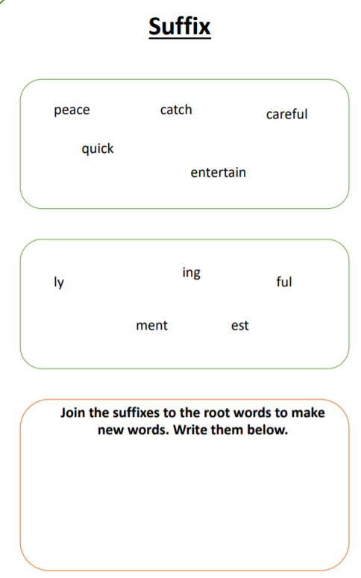
Science  Ice Investigation  Today we will investigate a scientific hypothesis with this simple science experiment!  What is a hypothesis?  A hypothesis is a theory about something happening, based on limited evidence or knowledge, made before conducting an experiment. Basically a hypothesis is an educated guess.  Your task it to work out the quickest way to melt an ice cube. Use the page below to record your findings. In the ‘other’ box see if you can think of your own idea on how to melt the ice. Ideally you will need at least 6 ice cubes and the materials listed below. Don’t worry if you don’t have all of the materials, you can make adaptations as needed. | Game  https://www.bbc.co.uk/bitesize/topics/zd63xyc/articles/zdp4pg8  Can you become a Karate black belt? Spend some time improving your English skills and see how many levels you can complete. Let us know what colour belt you work up to!  