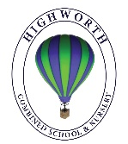
Year 1 Home Learning – Monday 8th June

Below, you will find 6 home learning tasks. You may choose the tasks that you wish to complete and do them in any order. Please do not hesitate to contact us if you have any queries or would like to share the work you have been doing.
year1@highworthcombined.co.uk
English  Today we are learning about conjunctions. Conjunctions are joining words that link different parts of sentences.  We would like you to try to write sentences with the word and in.  E.g. I listened to the weather forecast and put an umbrella in my bag.  We would like you to pretend that you were going to become Queen or King for the day. Write about the things you would do.  What would you do on that day?  Where would you go and why?  What would you like to change in the world and why?  What would you have fun doing and with who?  What rules would you change and why?  What would you eat?  Do you think you would like it or not?  - Write as many sentences as you can about you being King or Queen for the day.  - Use the word and in some of your sentences.  - Remember to think, say, write and then read your sentences as this will help you make sure it makes sense.  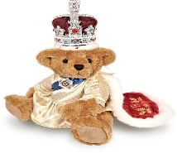  Challenge  - Can you use any of these words from the table below to join your sentences?  when or  if but  that so  because yet  after nor | History  The Queen uses many different methods of transport, some are very old and some are new. Look at the two pictures below, of a car the Queen uses and a carriage.  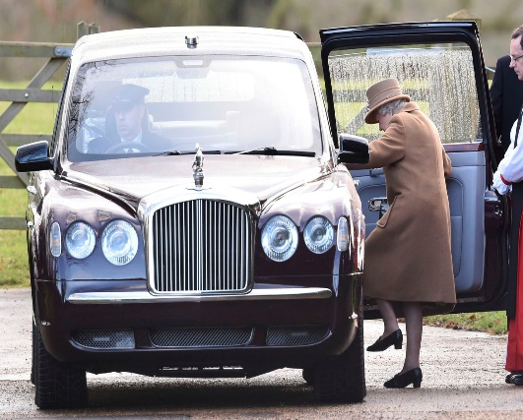  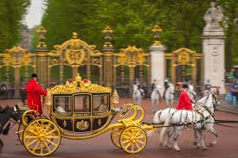  Then complete these activities.  - Write a sentence to explain which you think is the older method of transport the car or the carriage and why.  - Write a sentence to explain when you think the Queen uses the carriage and when she uses the car.  - What method of transport do you think the King and Queens of the future will use, can you draw it or write a sentence to describe it?  - What would your new method of transport need to have if it was for a Queen or King and why?
Geography  With an adult, look at the links below first, then complete today’s tasks.  https://www.bbc.co.uk/bitesize/topics/zyhp34j/articles/z4v3jhv  https://www.twinkl.co.uk/resource/t-g-115-our-country-the-uk-facts-powerpoint  This link has some information about landmarks from each UK country. https://www.bbc.co.uk/teach/class-clips-video/pshe-eyfs-ks1-go-jetters-uk-places-and-landmarks/zkyjkmn  Look at the world map below and colour in the UK. 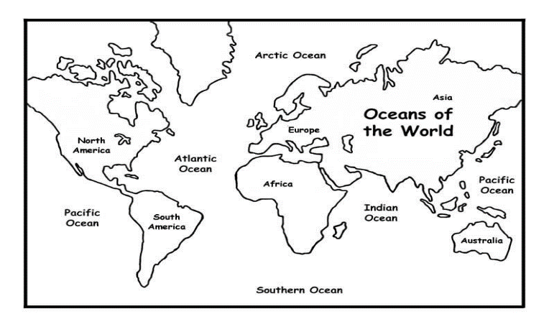  The United Kingdom is made up of Northern Ireland, Wales, England and Scotland.  - Look at the map of the United Kingdom below, draw your own map of the United Kingdom.  - Label Northern Ireland, Wales, England and Scotland.  - Label the capital cities of each country in the United Kingdom ( London, Cardiff, Belfast, Edinburgh)  - Label the seas around the UK  - Draw the flag for each country in the UK.  - Draw the flag for the United Kingdom  - Make an information book about the UK with information that you know about the four countries. This could include places you have been to or have found out about from the links at the top of the page, perhaps you could include your maps and flags in your non-fiction book.  Challenge  - Try to include these key geographical words in your information book, beach, cliff, coast, forest, hill, lake, loch, mountain, sea, ocean, river, valley, season, city, town, village, port, and harbour. | Art and Design and English  Go to the school website below and watch Mrs Day reading the story ‘The Queens Knickers’ by Nicholas Allan.  https://www.highworth.bucks.sch.uk/web/story_time_with_highworth_staff/478292  We are going to pretend that the Queen in the story is coming to our school. She needs a special pair of knickers.  Design the most exquisite, special pair of pants for her Majesty to visit Highworth in.  Draw them, colour them in and then describe their design features.  What fabrics and patterns will you use?  Will they have a special feature? What would it be and why? They could have a hidden pocket for snacks, or play music? In the story, she had a pair with a parachute in!  When you describe the knickers please remember to use adjectives, and try to use the word and or because to join your sentences.  E.g. This pair of knickers is made from the finest, softest, golden silk because they need to be comfortable for the Queen.  These stunning knickers are made to measure because the Queen has to have beautiful underwear that fits perfectly!  Let your imagination run wild and create the most incredible underwear design for the Queen in the story.  Don’t forget to send us a photo of your work!  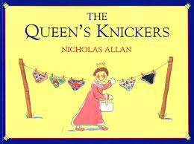  Challenge  - The Queen’s V.I.P knickers in the story are top secret!  - What do you think they might look like?  - What are they made from?  - What design features make them so special? And why do they have to be kept secret?  - Draw a picture of them and write a description.
Maths
Today we are going to think about sharing using objects into two equal groups. This is the division symbol. Division means splitting or sharing something into equal parts.

We are going to pretend that the Queen is having ice creams as a special treat to celebrate her birthday. The Queen will have an ice cream and you will have an ice cream.
- Draw two ice cream cones.

- Make 20 cherries by drawing 20 circles and cutting them out.
- Now make number cards with the numerals 2,4,6,8,10,12,14,16,18,20 on.
- You are now ready to play.

- Turn a card over
- Now share that amount of cherries between the two ice creams so that it is fair.
- How many cherries do you have on each ice cream?
- Can you record this.
- Repeat the game each time physically sharing into two equal groups.
Challenge
Can you make three ice cream cones and cards with all the numbers to 20 on, which amounts can you share fairly into equal groups between 3 ice creams and which ones can’t you share?
Wellbeing and PE
This week we are thinking about being active, being active can help you feel good and keep you healthy and boost your wellbeing. We are going to make an active party game.
Make cards with the letters of the alphabet on (A-Z) and on each card write the letter and a physical activity to do see the examples below.
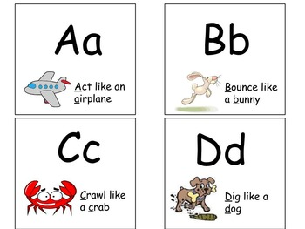
Then select the cards to spell these words and perform the physical activities you wrote on your cards:
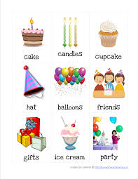
What other words could you spell and perform the activities from your alphabet cards e.g. your name, your friend’s names, the Queen’s name.

