Year 5 Home Learning – Friday 25th June 2020
We’d love to see your work! Please send it to: Year5@highworthcombined.co.uk
ENGLISH Writing: Wizards  On Wednesday, you planned your advert for your own school and now you’re going to write the advert.  Scroll down for the Write away! task sheet, which gives you full instructions and has some prompts for persuasive writing.  Remember to use your plan and the advert for the School of Wizardry to help you as well. Scroll down for copies if you need them.  We’re really looking forward to reading your finished adverts!  So, off you go … Write away! |  | MATHS: Kilograms and Kilometres  This week we are working on measurement.  Scroll down to look at the knowledge organiser and learn the key words.  Take careful note on how to convert between the units – it may seem tricky but it is only multiplying and dividing by 10,100 and 1,000.  There are two problem solving worksheets for you to choose from. Or you could challenge yourself and do both of them! Try your best and refer to your knowledge organiser for help.  The answers are included so, when you have finished, you can mark your work.  If you have any incorrect answers, look back over your work, check your calculation and see if you can spot your mistake.
WONDERFUL WORDS
Look at the Year 5 & 6 Words List. You can find it as a link on our Coronavirus Closure, Home Learning Matrix, Year 5 tab: https://www.highworth.bucks.sch.uk/web/year_5/460996
Choose 4 or 5 words to practise at a time.
- Look up the definition in a dictionary to check the meaning of each word.
- Learn the correct spelling by using: Look, Say, Cover, Write, Check.
- Write a sentence which includes the word to show that you understand its meaning.
4. Challenge yourself to use expanded noun phrases in each of your sentences.
Scroll down for the Help Sheet and Practise Activity to get you started.
COMPUTING  Use this link to learn about coding, program bugs and how to fix them.  https://www.bbc.co.uk/bitesize/articles/z6rhnrd  There are some videos for you to watch, activities to try and also links to Kodu or Scratch for creating your own computer games.  We hope you have fun! | ART Relax, enjoy, create!  Here are some art ideas to think about and maybe try to create. You don’t need any fancy art materials to try these out, simply a pen/pencil and a sheet of paper.  1. Favourite animal  2. Something viewed from above  3. Landscape  4. Your name  5. Somewhere you’d like to visit  Don’t worry about creating amazing works of art, just let your mind wander and your hand doodle.  You can try the ideas in any order and do as many as you want in a day, or you can really challenge yourself and stick to the order and do one a day for the week. |  | FUN ACTIVITIES  Now design your own one-minute-challenge activity for yourself and see if you can get better at it.  You could make up an activity for someone in your family to try.
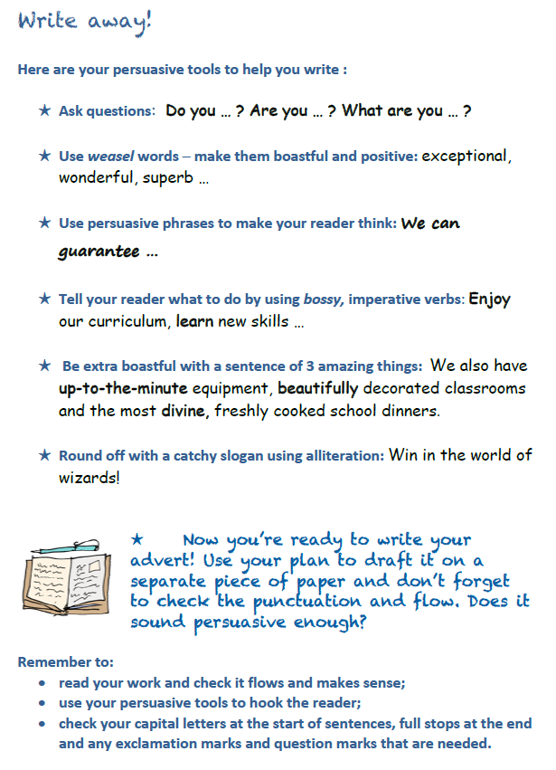

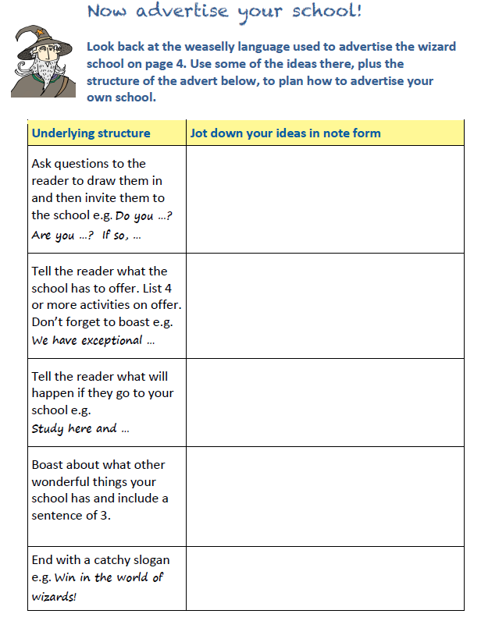

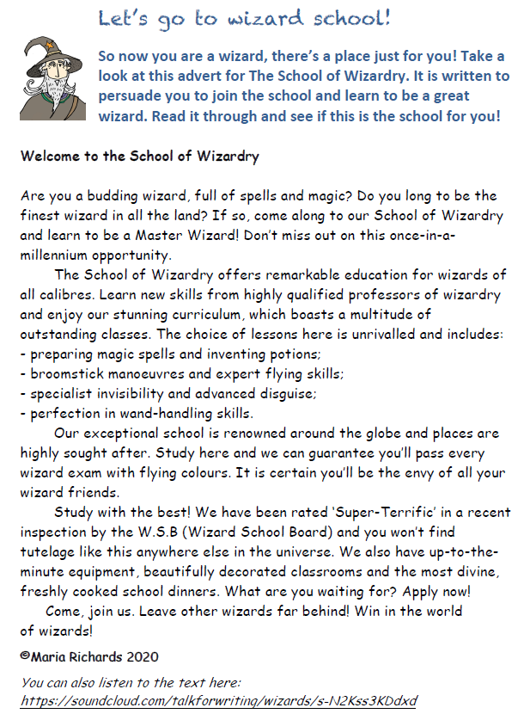
ADVERT FOR THE SCHOOL OF WIZARDRY

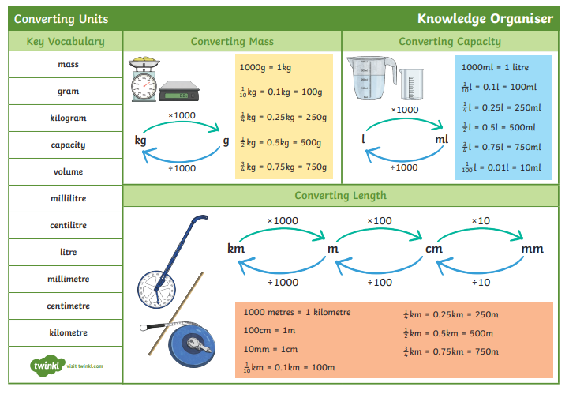

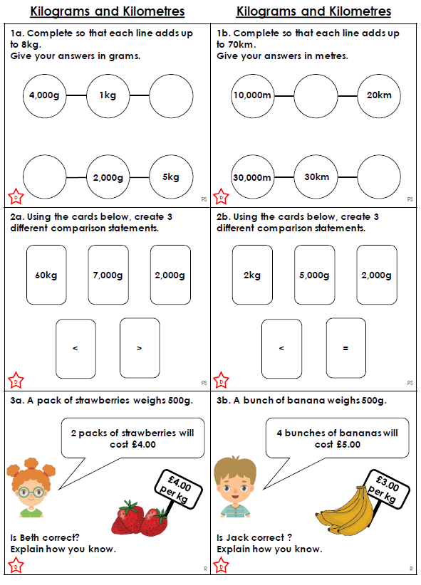
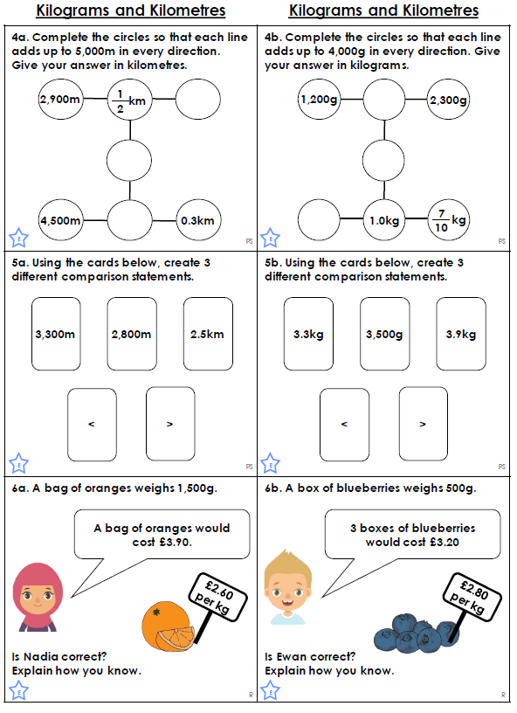

ANSWERS
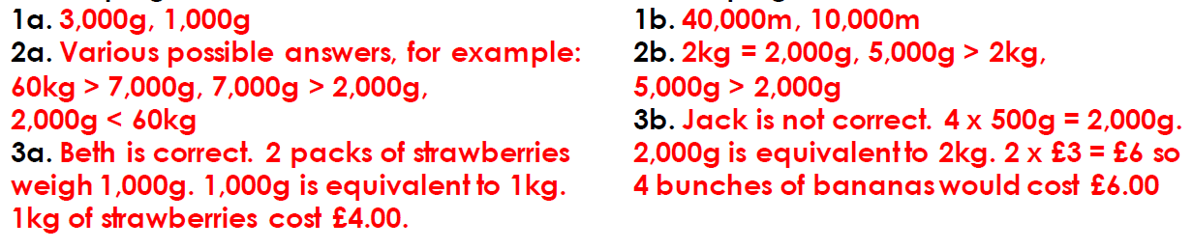

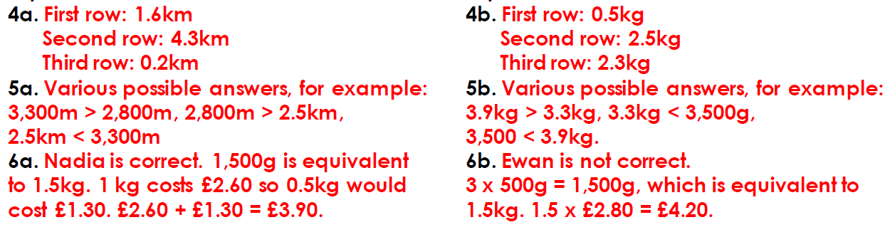

Help Sheet
Expanded Noun Phrases

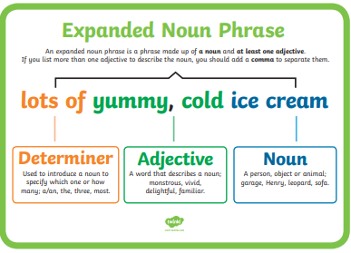
Scroll down for the practise activity.
