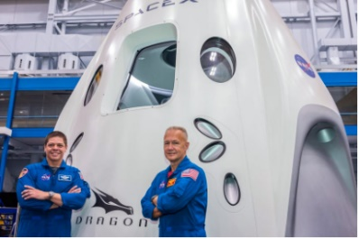
Year 4 Home Learning – Monday 8th June 2020
Please email us your work to:
Year4@highworthcombined.co.uk
You will have seen that on May 30th 2020 a SpaceX Falcon 9 rocket was launched with astronauts on-board. After a 19 hour trip, the astronauts landed on the International Space Station. For this matrix we are going to focus on space and astronauts. Apologies for the long document, but we have attached most of the things you need here!
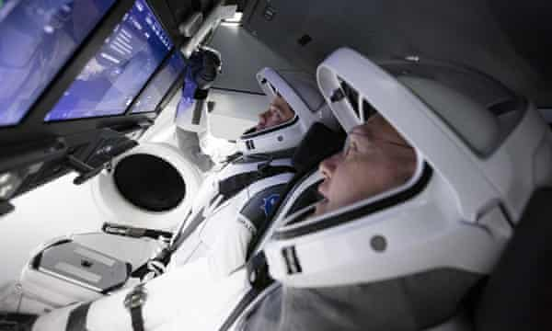
REMARKABLE WRITING!

How many of you would like to be an astronaut? It certainly seems like an awesome job!

You can watch the highlights of the recent Space X rocket launch here:
https://www.youtube.com/watch?v=K_IjoAdYIco
There is some more information here:
https://www.bbc.co.uk/newsround/52526849

We would like you to write a NEWSPAPER REPORT telling people all about the rocket launch.

Here are some tips to help you …
- Gather information from watching the links above.
- Look at the newspaper article example below. This is fiction rather than fact, but it clearly shows you a wide variety of features you can include in your own writing. The second row of boxes provide the extra challenge!
- Use the link called Year 4 Newspaper Writing that is with today’s matrix on the website to help guide you through writing your newspaper article. You do not have to use the writing frame provided, but it will give you some ideas for your own presentation.
- Use the checklist (attached below) when you edit your work!

Challenge: using the newspaper article example below, how would you explain the difference between direct speech and reported speech?

MARVELLOUS MATHS!

Keep going with your times tables and division practice, as well as practising other
mental maths skills like number bonds to 100 and rounding!

Today you have a variety of number puzzles to solve. They each practice different skills and you will need to think carefully about how to tackle each one! There are 5 puzzles attached below, or you can find them in a pdf document with the matrices on the website.

Challenge: create your own number puzzle, based on one of these ideas (make sure you have a separate answer sheet). Send it to us to have a go at solving and we may also attach yours to a future matrix for others to try.

SPLENDID SPAG!

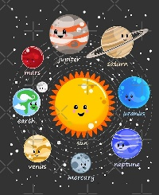
Attached below is a solar system themed word search which we hope you will enjoy. You could then:
Find the definition of words that are new to you.
Put the words in alphabetical order, which helps you become better at using a dictionary
or thesaurus.
Create a crossword with these words, using the definitions you have found to help write the clues.
Create your own Space X themed wordsearch or crossword with different words.

SUPER SCIENCE!
Coming home from space!
When it is time for the astronauts to come home, they are usually sad to leave, but they look forward to seeing their families again. They pack up their things and climb into the spacecraft that will bring them back to Earth. Then they “undock” which means that the spacecraft is no longer attached to the Space Station. The Space Station travels fast and goes round the entire Earth in just 1.5 hours, so the crew sees the Sun rise and set 16 times every day! At first, the spacecraft is going as fast as the Space Station, but then it slows down and starts its journey through the Earth’s atmosphere – slowly, bit by bit. The return takes about three and a half hours before the parachutes pop out to slow down the spacecraft enough to land safely.
Why does the spacecraft need to deploy parachutes? How does this help?
When two surfaces rub against each other, friction is caused.
Experiment
Friction will arise when you rub your hand over your thighs.
- Rub your hands over your thighs.
- Vary the speed.
- What do you experience?
Friction also slows down things, and friction varies according to the surface.
Experiment
- Decide where to try out your experiment. You should try it out on different surfaces – for example, a smooth corridor, on a pavement, on grass.
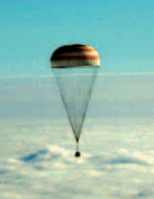
- Roll the ball and/or push the skateboard/ toy car over the different surfaces.
- Describe what happens.
One type of friction is friction against the air. This is called air resistance.
Experiment
- You need 2 A4 sheets of paper.
- Crumple up one of the sheets into a ball.
- Drop both from the same height. 3. Do they fall at the same speed?
- Describe what happens:
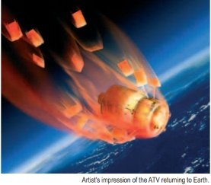
Thinking about the information you have been given and the experiments you have carried out, what do you think happens to a spacecraft as it travels back to earth?
Do you understand now why the parachutes are deployed?

Air resistance is what spacecraft experience on their return to Earth. The temperatures
rise, and the faster the spacecraft travels, the higher the temperatures get. Therefore,
the spacecraft goes slowly on its way back to Earth and it needs special heatshields to
keep the astronauts safe. The temperatures can still rise to 1600 degrees Celsius!
WONDERFUL WELLBEING!  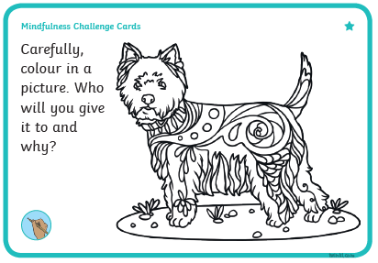 | TERRIFIC TOPIC!  Imagine you are a newspaper reporter. Your Editor has just told you that you are going to interview an astronaut who has recently returned from the International Space Station.  Can you write a list of at least 5 questions you would ask? Please think of sensible questions, because once you have written your questions, we would like to research the answers. Please ask an adult to do this with you and remember the importance of internet safety. There is a Be Smart Online poster attached below.  We look forward to seeing your questions and answers!  THIS IS A LINK TO AN ONLINE SESSION ON TUESDAY AT 3PM (SEE PICTURE AT THE TOP OF THIS MATRIX)  https://www.youtube.com/channel/UCa7e55mYI2xQAoV_0hRmL-g
