Year 1 Home Learning – Monday 1st June 2020
Below you will find 6 home learning tasks, you can choose which and how many you do. A number of the activities use internet links please remember the importance of only using the internet with an adult and our school internet rules to help keep you safe https://www.highworth.bucks.sch.uk/web/children/295423

Please do not hesitate to contact us if you have any queries or would like to send the work the children have been doing at home:
year1@highworthcombined.co.uk
We hope you all had a lovely half term, and would like to welcome you back to the second half of the summer term.
English  Today we are going to do some writing using exclamation marks. We use exclamation marks for a few reasons; usually they are used to show strong feelings or a raised voice. e.g., “Snap!”, “Wow!”, “Help!”, “Go away!” she shouted.  They can also be used in an exclamation sentence, these sentences usually start with what or how e.g. What a great dancer you are!  Alternatively, you can use them when it is not a full sentence and just a phrase e.g. How fun!  - First practise writing exclamation marks so that you know the shape of them when you come to use them in your writing. Make a colourful exclamation mark page like the one below.  - Watch the story ‘Fidgety Fish’ by Ruth Galloway read by Mrs Lipkinski on story time with Highworth staff https://www.highworth.bucks.sch.uk/web/story_time_with_highworth_staff/478292  - Write down all the words that use exclamation marks in the story ‘Fidgety Fish’.  - Now go to the BBC bitesize (14th May English) link below about how to use exclamation marks , watch the video and complete the three activities. (Highlight where an exclamation mark should go, create a poster about how to be safe near a pond and a short quiz) https://www.bbc.co.uk/bitesize/articles/zvyvbdm  - Now write these sentences with the exclamation mark in the correct place.  - The Fidgety fish story was amazing  - Wow That fish was delicious  - What a lovely smile you have  - Snap went the big fish  - “Help ” shouted the tiny fish.  - Challenge  Write your own sentences or story that include exclamation marks. | Art and History  Today we are thinking about famous artists. Below is a selection of paintings made by a famous artist called L.S. Lowry. Make your own version of one of the pictures based on the images below.  Write a sentence about when you think the pictures were drawn? Is it now or in the past? Please give reasons for your thoughts.  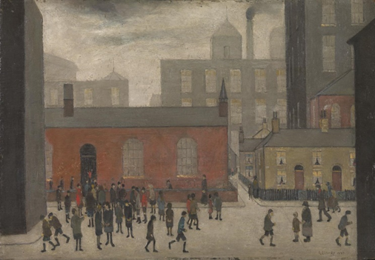Coming out of school  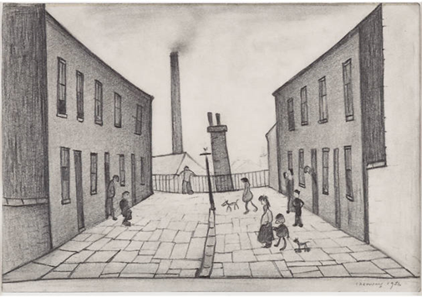  Francis Terrace  Challenge  - Watch this clip about L.S Lowry https://www.bbc.co.uk/bitesize/clips/zc9jxnb and look at the information on twinkl https://www.twinkl.co.uk/resource/tp-ad-012-planit-art-ks1-ls-lowry-lesson-1-who-is-ls-lowry-lesson-pack  - Now make a fact sheet about L. S. Lowry  - Draw your own street in the L.S Lowry style
Maths

Today we are going to be finding different combinations of coins that equal the same amounts of money.
We will be using the coins below.

- Make your own sets of coins; you could do this by making coin rubbings and then cutting them out or drawing your own coins. You will need more than one of each coin.

If I wanted to make 10p, I could do it in a variety of ways. See the table below.

+ = 10p
++ ++=10p

+++++++++= 10p
+++= 10p

- Use the coins you have made/drawn to make 5p in three different ways.
- Use the coins you have made/drawn to make 6p in three different ways.
- Use the coins you have made/ drawn to make 7p in three different ways.
- How many different ways can you make 16p using the coins?

Record your answers in a similar way to the table above, you might want to use a number line or part, part whole model to help you work out the answer.

Challenge
- Mrs Lawrence wants you to help her make another way to make 10p, can you do this?
- Miss Hawes wants to know how many different ways can you make 50p using the coins you have made/drawn?
- Mrs Milner brought a chocolate bar using only silver coins. Her chocolate bar cost 45p. Can you think of a way she paid for her chocolate bar?

Geography  Create a weather journal for a week.  - Make a table like the one below, with the days of the week down the side and morning, afternoon, evening along the top.  - Record what the weather is like, you could describe the weather in words or draw symbols.  - Then answer these questions.  How many days were rainy?, How many days were sunny?, How many days were cloudy?, How many days were windy?, How many days were snowy?, How many days were stormy?, Which type of weather happened the least often?, Which days weather did you like the best and why?, Which day showed the greatest change in weather?, Did any day have the same weather for the whole day?  Challenge  - Can you record the temperature or rainfall for each day?  - Watch the weather forecast is your weather record the same as the forecast for each day. | Wellbeing  Connecting with people can make you and others feel special, it is also important to know who you can talk to in times of uncertain or worry or just to tell them how your day has been.  • Draw a tree with branches on. On each branch write the name of the person or people you can reach out to and talk with if you felt sad or worried – they could be people in your family or friends or neighbours. Even if you can only get in touch with them by phone or video messaging now, that still counts!  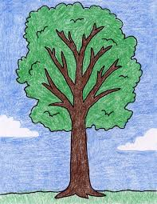  It is your tree so you can have as many or few branches as you would like. Try to talk to at least one person from your tree today.  Challenge  - Find out something new about as many people from your support trees as possible. Try to write the information you know about each person, perhaps talk to them and find out some interesting information about them. E.g., what is their favourite meal? What colour do they like the most etc.  - Put extra pictures up of everyone from your support tree as a reminder of the important people in your life – you could print out some photos or draw your own pictures of them!
Science
Today we are going to identify, name, draw and label the basic parts of the human body and say which part of the body is associated with each sense.
- Draw an outline of a person.
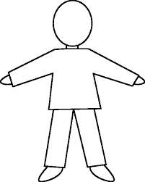
- Label the body parts on your person from the table below. I have left 3 boxes for you to add 3 extra body part names onto your person.
foot | nose | stomach
ankle | eyes | shoulder
knee | hair | leg
leg | ears | teeth
chest | chin | thumb
elbow | hand | toes
wrist | skin | ribs
mouth | arm | tongue
- Now write a sentence for each part of the body that is associated with the 5 senses e.g. I smell with my….., I taste with my….., I feel with my….. , I hear with my….., I see with my….

