Home Learning Ideas for all
Wednesday 13th May 2020

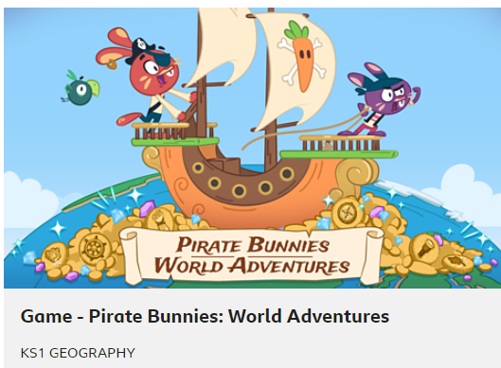
BBC Learning Games
As well as doing daily lessons, BBC Bitesize has a wide variety of games for Early Years, KS1 and KS2 children. Can you become a crystal explorer, a small town superhero, or even a karate cat?
https://www.bbc.co.uk/bitesize/collections/primary-games/1

Cheerios Bird Feeder
Make a bird feeder using cheerios and a pipe cleaner or string! Thread the cheerios onto the pipe cleaner/string and hang outside. Keep an eye on birds coming to have a nibble!

Mountain Rising Wellbeing Card
Can you follow the instructions on the wellbeing card below to take mindful breaths? There are lots more cards saved on the wellbeing part of our school website. https://www.highworth.bucks.sch.uk/web/wellbeing/476538

