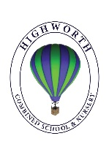
Home Learning Ideas for all
Friday 22nd May 2020
Find out more about Ramadan
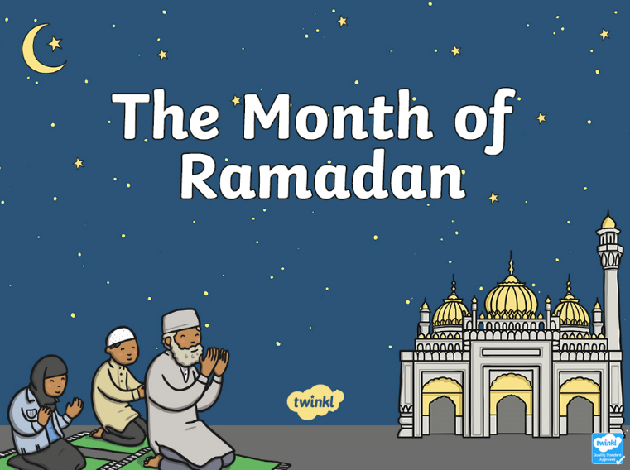
Our Muslim families have been fasting for nearly 30 days now throughout the month of Ramadan. It is an exciting time for Muslims as Eid will be here this weekend! For those families who are not Muslim, open the link on our Home Learning Ideas section of the Coronavirus Closure page to see a PowerPoint for young children, explaining a little about Ramadan.
Wind in the Willows the Musical
Make a hanging moon!
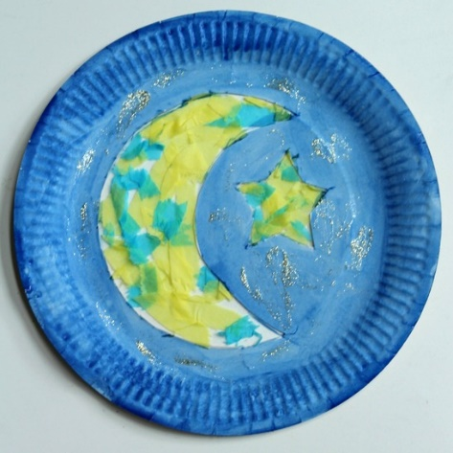
The moon has a lot of significance in Ramadan, so this paper plate moon and star idea is a perfect craft for this season! Even toddlers can help with this craft, although adult assistance is required. All you need is a paper plate and some colourful tissue paper, glue and string. Make the craft and hang it high!

Oak National Half Term Activity Club
https://www.thenational.academy/online-classroom
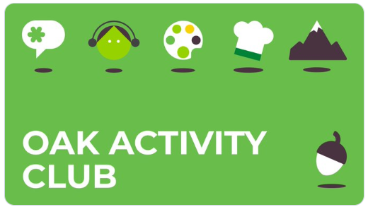
This half term, Oak National are running a series of fun activities to do at home.

