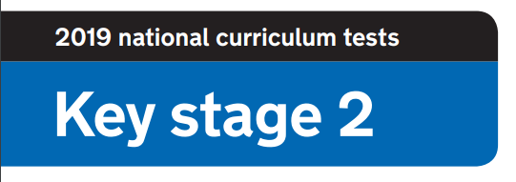

**2020 National Curriculum Tests**

**KS2 Lockdown SATs**

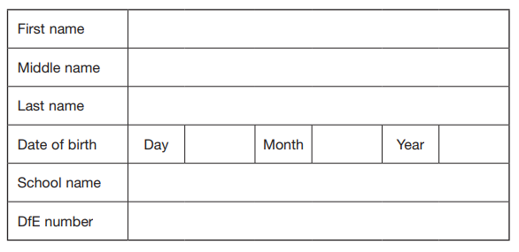

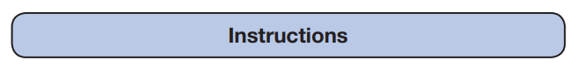

**Questions and Answers**

You have until ***4pm Thursday 14th May*** to complete the booklet and send us your answers and times.

Work as quickly and as carefully as you can.

If you cannot do a question, go on to the next one. You can come back to it later, if you have time.

If you finish before the end, go back and check your work.

**Marks**

The number under each question at the side of the page tells you the number of marks available for each question.

All scores will be converted to a standardised score .

**Results**

You will be notified of your results once all papers are marked.

All participants will be awarded with a **‘Lockdown SATs’ certificate.**

Paper 1: How well do you know your school?

1. What is the Highworth Combined School emblem?

**1 mark**

1. How many doors (both internal and external) are there in our block?

**1 mark**

1. What 4 school values can be found in every classroom? Bonus point: What image is used to represent them?

**5 marks**

1. Name a display board in the learning lane.

**1 mark**

1. Can you name three of the desired alphabet things we’d like to see in year 6 on the display between the two classrooms.

**3 marks**

1. Next to the year 6 toilets there are two display boards.  What are on them?

**1 mark**

1. What is the name of the garden behind the Reception classrooms?

**1 mark**

1. There is an image that has been drawn and coloured in by the year 5 children in Mrs Naidoo’s classroom stuck on her window. What animal is it?

**1 mark**

1. What is on the right hand side when immediately entering Mrs Keating’s classroom?
2. **mark**
3. What is the display of on the doors of the cupboard in 6H and 6S?

**1 mark**

Paper 2: How well do you know chocolate?

**Can you name the chocolate bars below?**

**You will be awarded 1 mark for each correct answer.**

|  |  |  |  |
| --- | --- | --- | --- |
|  |  |  |  |
|  |  |  |  |
|  |  |  |  |
|  |  |  |  |
|  |  |  |  |
|  |  |  |  |
|  |  |  |  |
|  |  |  |  |

Paper 3: Where’s Wally?

**Timed paper. You will need a stopwatch.**

**Time how many seconds it takes to find Wally.**

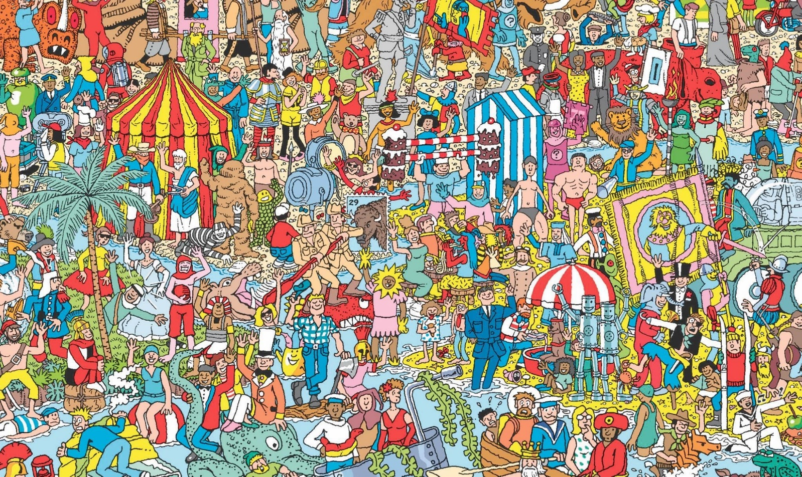

**The times will be ordered and you will receive up to 10 marks.**

Paper 4: How well do you know the teachers?

**Match the boxes to make the sentences true**

**1 mark for each correct answer**

met the actual BFG

loves teaching P.E.

does boxing to keep fit

has climbed a mountain in Austria

used to do ballet and gymnastics as a child

has gone scuba diving

can write both left and right handed

used to be a hairdresser

Mrs Sturgeon

Mrs Dimishky

Mrs Day

Mrs Pankhania

Mrs Naidoo

Ms Kern

Mrs Harris

Mrs Smith

Mrs Keating

Mrs Hastie

Miss Kennedy

Mrs Cunningham

Went on an American road trip for my honeymoon

went to the school Hogwarts was based on

shares the same birthday as Queen Victoria

Once flew on concorde

Paper 5: Scavenger Hunt

**Timed paper. You will need a stopwatch.**

**Starting in the room of your choice, ask a member of your household to time how long it takes to find the objects below. You can find the items in any order. Submit your time and if possible a photograph of the objects found. Add a 10 second penalty for any objects not found.**

**FIND THE FOLLOWING OBJECTS:**

* An unused toilet roll
* An item of clothing that is the colour you would get if you mixed blue and yellow together
* An item of clothing that has at least 4 buttons on
* A pen, pencil or crayon that is the top colour of a rainbow
* The word ‘**SCHOOL**’ - look in a book, magazine or newspaper
* Your favourite toy
* Your school jumper
* A spoon
* A picture of yourself or someone in your family
* Something that will hold everything you’ve found

**The times will be ordered and you will receive up to 10 marks.**

Paper 6: Spelling Test

**You will need a member of your household to read the spelling list attached separately.**

1. ____________________ **1 mark**
2. ____________________ **1 mark**
3. ____________________ **1 mark**
4. ____________________ **1 mark**
5. ____________________ **1 mark**
6. ____________________ **1 mark**
7. ____________________ **1 mark**
8. ____________________ **1 mark**
9. ____________________ **1 mark**
10. ________________ **1 mark**

Paper 7: Art

There

**‘Everyday object’ art challenge. Select an object to include in a drawing. Your drawing will be assessed by a panel of adjudicators and given a score out of 5 for each area: creativity, artistic style and humour!**

**15 marks**

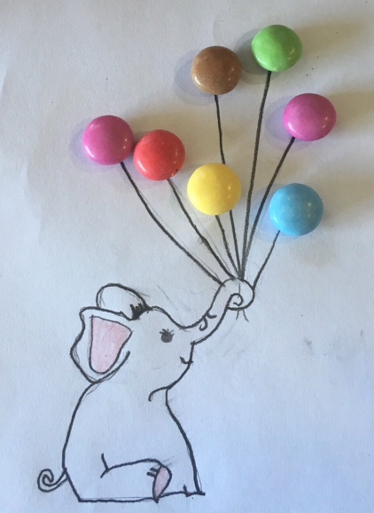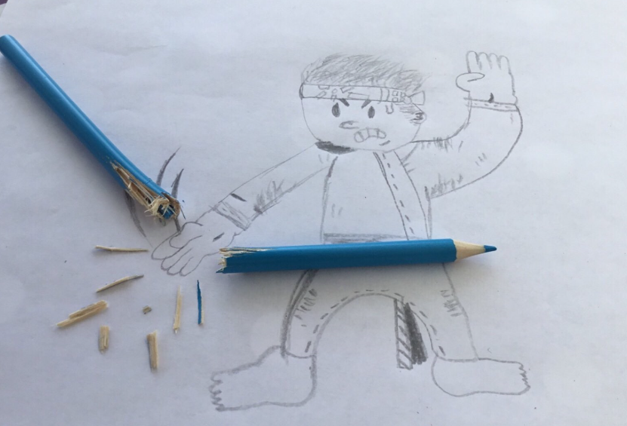

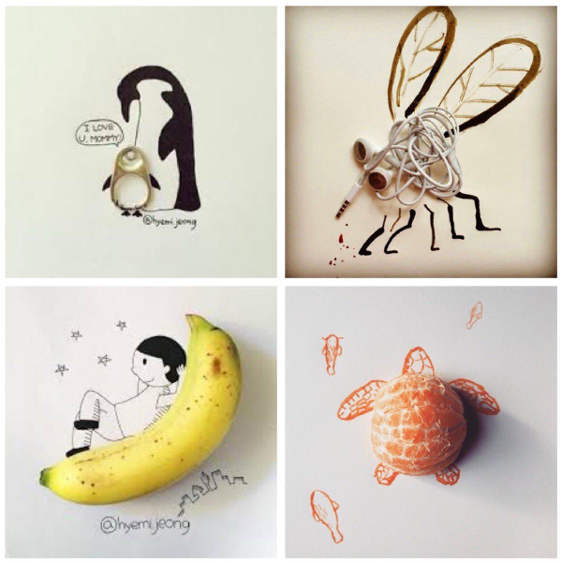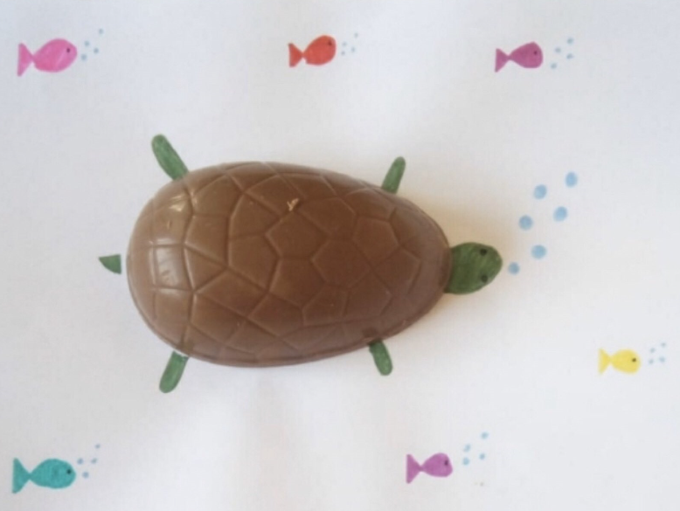

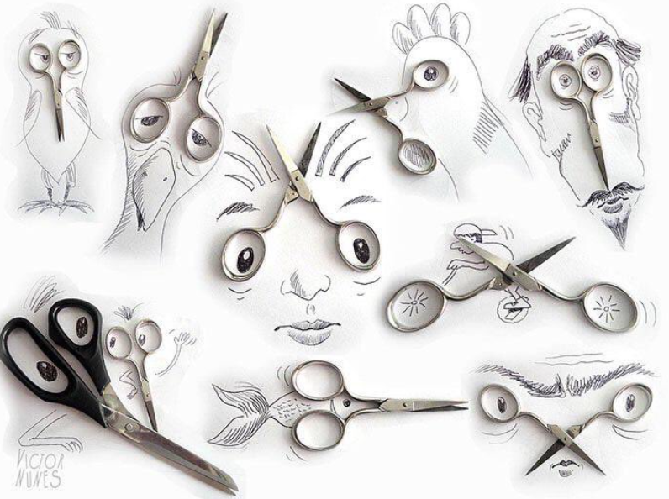

Paper 8: Maths

**Solve the maths problems**

1. Crossing the River

A farmer is trying to cross a river. He is taking with him a rabbit, carrots and a fox and he has a small raft. He can only bring 1 item a time across the river because his raft can only fit either a rabbit, the carrots or the fox. How does he cross the river? (You can assume that nothing is eaten or escapes!)

**3 marks**

1. You are driving a bus to St Barnabas. You drive through Hanham and pick 1 child up, you drive through Kingswood and pick 1 child up, you drive through Oldland Common and pick 5 children up, you drive through Cadbury Heath and pick 4 children up. You drive through Warmley and pick up 10 children. 6 children get off because they decide to walk the rest of the way. Before reaching school, you pick up 14 children from North Common. Who is the bus driver?

**1 mark**

1. How many squares are in the picture?



**3 marks**

Paper 9: Reading

**Name the books using the emoji clue**

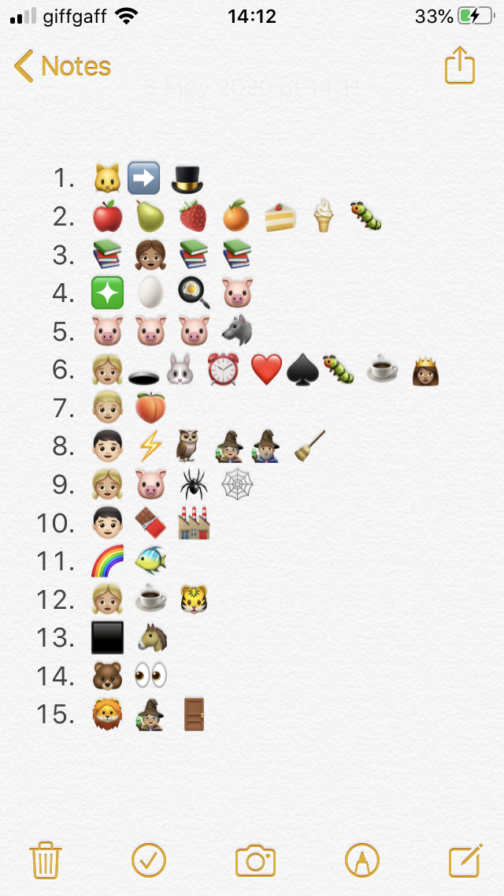

**1 mark**

**1 mark**

**1 mark**

**1 mark**

**1 mark**

**1 mark**

**1 mark**

**1 mark**

**1 mark**

**1 mark**

**1 mark**

**1 mark**

**1 mark**

**1 mark**

**1 mark**

Paper 10: Secondary School

**Visit your secondary school’s website and answer the following questions.**

1. What is your secondary school’s website?

**1 mark**

1. What is the motto or key values? E.g. St Barnabas is ‘Aspire, Believe, Together Achieve’

**1 mark**

1. What is the principal/ head teacher’s name?

**1 mark**

1. What are the 4 house groups?

**1 mark**

1. Name 3 exciting facts.

**3 marks**

1. Draw the school logo.

**1 mark**

1. What is the school uniform?

**2 marks**

1. Do they have a social media page to share information?

**1 mark**

1. Find a quote from a pupil at your secondary school. What do they think of the school?

**1 mark**

1. What sports facilities does your secondary school have?

**1 mark**

Paper 11: End of SATs celebration

**Crazy hair celebration. Your hair style will be assessed by a panel of adjudicators and given a score out of 5 for each area: creativity, artistic style and humour!**

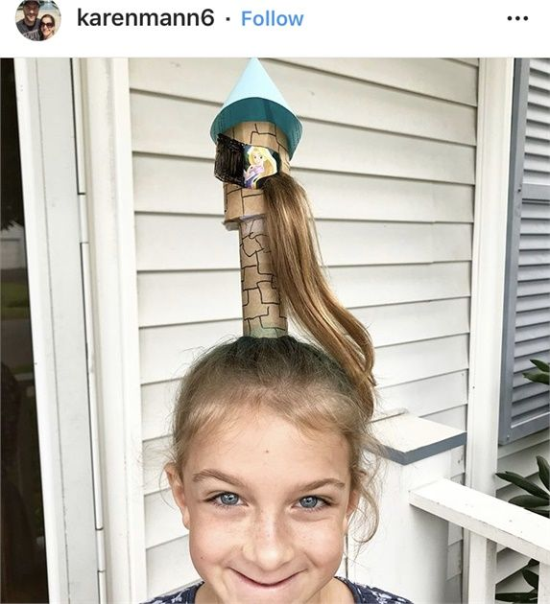**15 marks**

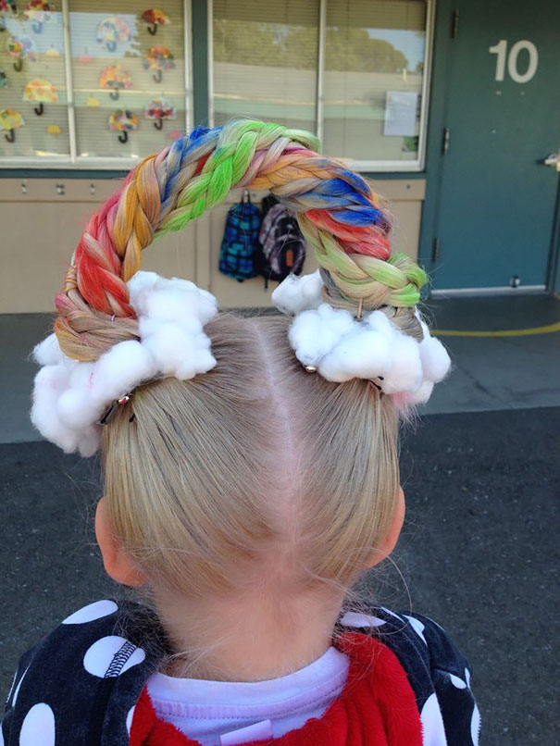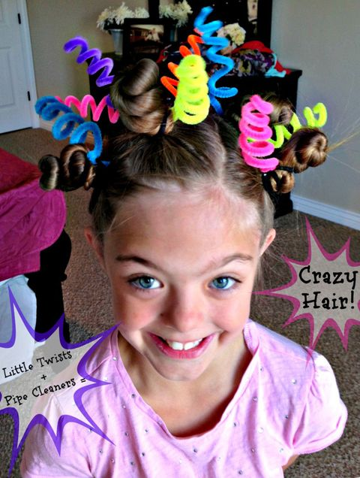

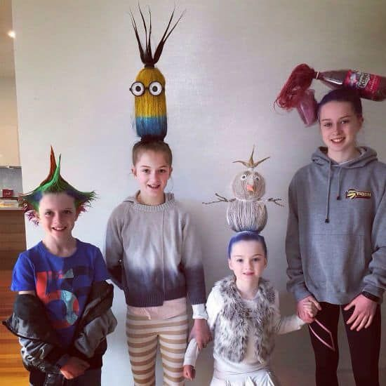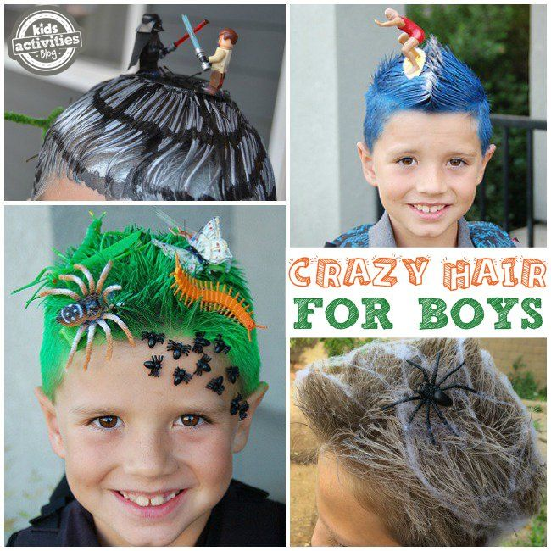

CONGRATULATIONS!

**You have completed the Lockdown SATs – CONGRATULATIONS!**

Year 6, we are proud of what you have achieved so far in Year 6. It’s a pleasure to teach you all. Even though SAT’s was cancelled, we know how hard you worked during the lead up and nothing will take that away. You are a determined year group who have come so far. It’s an absolute pleasure to watch you grow into mature young people with individual qualities and personalities. Although we are not currently at school, we will celebrate your time at Highworth because no one deserves it more than you!



**Keep smiling and stay positive!**

***‘Working hard is important but there is something that matters even more: believing in yourself!***