Extra Home Learning – HID Children No 8 - Monday 8th June

To replace some of the tasks in the class home learning you may wish to try some of these. Parents, please simplify or extend depending on needs and age of children. There’s more signing from Mrs Mills and use this link for more stories:
https://www.longwill.bham.sch.uk/blog-1/categories/storytime
Don’t forget to email me your child’s learning hid@highworthcombined.co.uk

Signed Story and Reading Book From Mrs Mills  Watch the signed story from Mrs Mills called ’Danger’ on the school website  Read the Power Point of the story. There are tasks at the end of the power point and below. | Scientific Wordsearches:  Some fun word searches related to the science topics you have been learning. See below for:  - Yr2 Sunflower Life Cycle Wordsearch  - Yr3 Friction/Force Wordsearch  - Yr4 Parts of a Daisy Wordseach  Can you remember the signs for the words?
Signed Story – ‘Jack and the Beanstalk ’  Watch the signed story by going to the site:  https://www.longwill.bham.sch.uk/blog-1/categories/storytime Scroll down to find the story. Here are some tasks you can chose from:  - Draw or paint a picture of a huge beanstalk with the castle at the top.  - Retell the story. You can write, sign or draw pictures  - Draw a beanstalk and label the parts of the plant. What goes into the ground? | Looking and Thinking Activity - ‘Accident’  Look carefully at the picture below about an accident and answer the quiz. There are 2 quizzes, A and B. Start with A and if you can, you can do B as well.  See below for the picture and the questions A and B
HID Afternoon Activity:
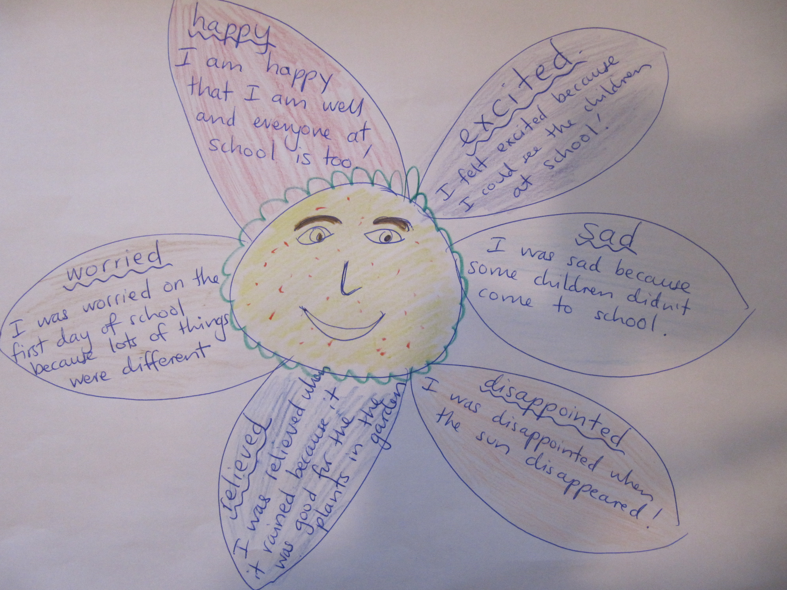
Make a ‘Feelings’ Flower

Draw a huge flower with 6 petals.

Draw your face in the middle of the
flower and on the petals draw or write
how you have been feeling in the last
2 weeks. Sign the feelings.
See my flower as an example.

You can decorate your flower any way you
like and draw pictures inside the petals

See 7 more pages below:
- Activities for story, ‘Danger’
- Sunflower Lifecycle Word search
- Friction/Forces Word search
- Parts of a Daisy Word search
- Looking and Thinking picture for ‘Town Centre’
- Questions A for ‘Town Centre’
- Questions B for ‘Town Centre’

Questions for ‘Danger’

- Where did Ben go?

- Why was it dangerous to go to the next cove?

- Why was Tim worried?

- Why did they wave to the fishing boats?

- How did the rescue helicopter know where the children were?

- How did Ben feel at the end?

Match the words with their meanings:

cove |  | movement of the sea going in and out
wind up |  | bay
tide |  | smiling
grinning |  | tease
hovered |  | saw
spotted |  | hold
grip |  | floated above in the air in one spot

2 – Life Cycle of Sunflowers

p o l l i n a t i o n

b i g z m x w a t e r

h o v a l l e a v e s

r a d f h m o r g j h

o p e n p e t a l s o

o y b c g i n i p t o

t q u f v w o z m e t

a z d e e s t n a l p

y e l l o w m q s s r

d r o p s e e d s f p

soil plant seed
root shoot
water oval leaves
bud big
yellow open petals
pollination drop seeds

3 – Science Wordsearch- Friction/Force

t y r e s o n r o a d s z c

f p h a l I n o c k y b q h

r u t q o p v u b c g r n a

y l b x w a c g o k p j h n

s l i d e m x h y e n e j g

j k x c f i l o t q s v t e

a d h m x o q t r c x w k o

k m s m o o t h v r t s a f

f a k h z a e o I f h q t s

o g z x p h j g m o t f t u

r h c k r n b a e s k b g r

c q d m a t e r i a l s x f

e s u g I p k h w o v y n a

l k o t r a u n j x r q l e

p h b l p u s h f p d y e e

carpet lino
fast slow
pull push
force slide
rough smooth
change of surface
tyres on roads

4- Science Parts of Daisy/plant

g p a z b y d c x d

m e h i s u q e q a

p t r o p c i b e i

d a f m r g s p o s

r l u c i w y l i y

n s u d n n f a x c

s h e v g o a n c h

t t s p r o o t m a

a q a n a j s h e i

m h u l e l t u d n

e c q a k o v c f w

n s x r f l o w e r

daisy plant
flower root
petals sepal
stamen stalk
seed daisychain
spring germinate

Picture for Looking and Thinking Activity: ‘The Accident’
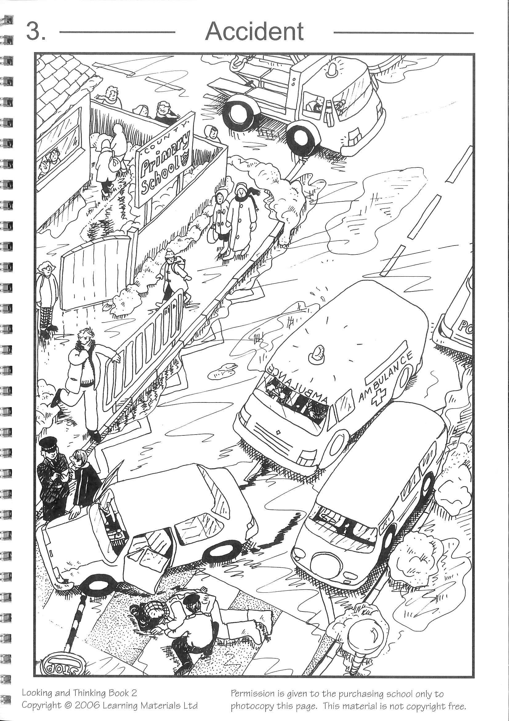

See below for Questions A then Questions B for ‘Accident’

Questions A for ‘Accident’
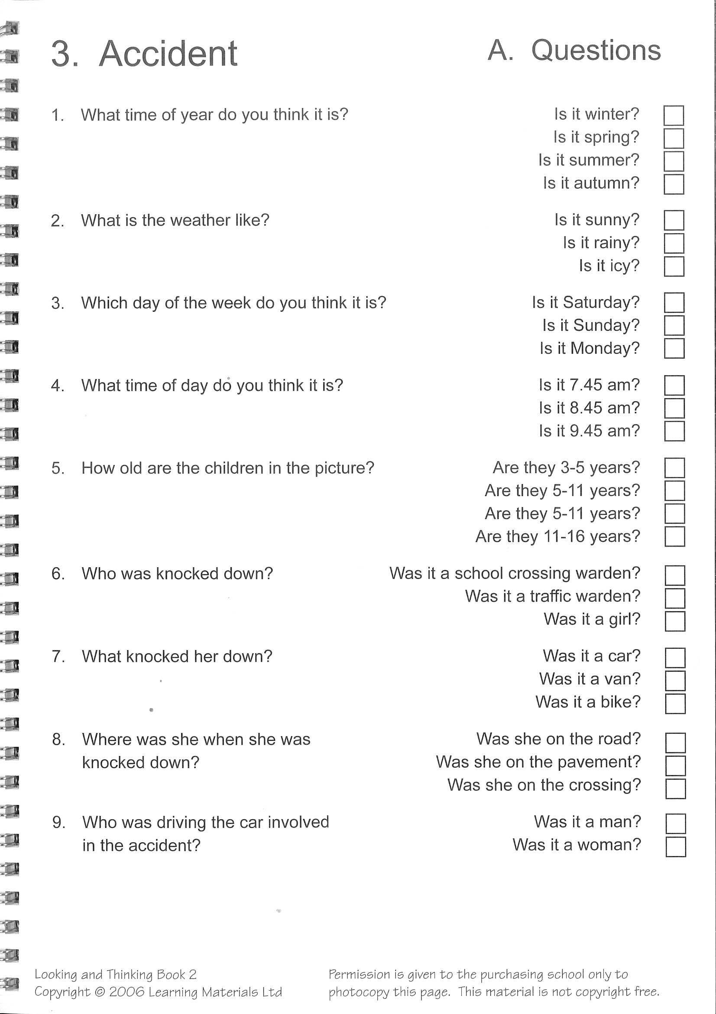

Questions B for ‘The Accident
