Year 2 Home Learning Week Commencing 30/03/2020 - Friday 3rd April
Use the book sent home or a blank piece of paper to record your work.
Maths Task 3D Shapes Complete the table below.  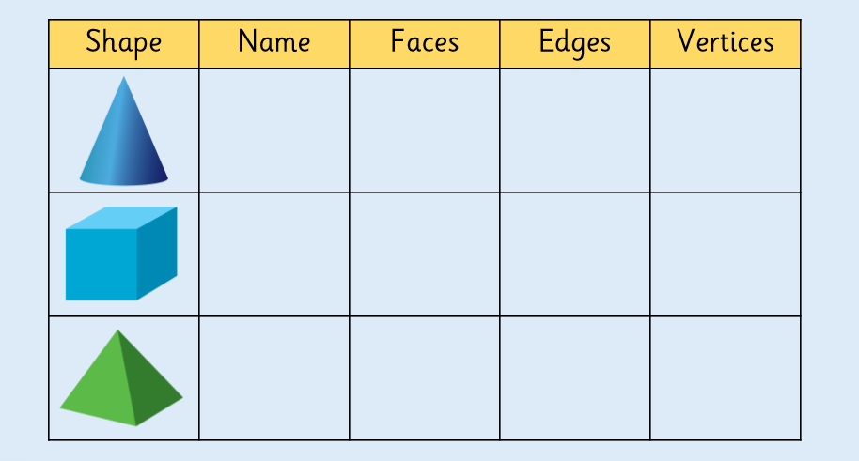  You can continue the table for other shapes.  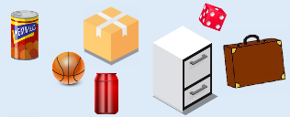  How could you sort these objects? Can you find some other objects around the house to add to each set?  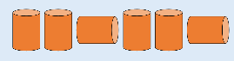  How many times does the pattern repeat? What will the 10th cylinder look like? | SPaG/ Spelling  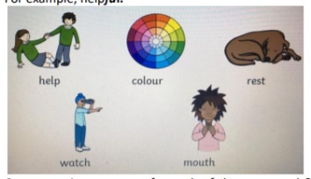  Can you make 5 new words by adding the suffix ‘-ful’ to end of the root word in each of the pictures shown below?  Write sentences for each of the new words?  What other words can you think of?
Science: In Science, earlier in the year, we discussed the importance of eating healthily. Watch the following videos:  Five types of food: https://www.bbc.co.uk/bitesize/clips/zbsmhyc  Eating a varied diet: https://www.bbc.co.uk/bitesize/clips/zwgnvcw  Food needed by the human body: https://www.bbc.co.uk/bitesize/clips/z43hfg8  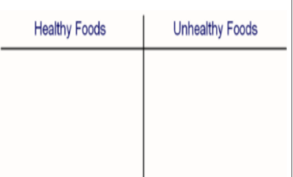  Can you create a table of healthy and unhealthy foods? How many can you find for each?  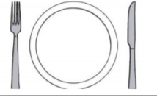  Can you add which food group they belong to? For example, are they a fat, protein or carbohydrate? Can you design a healthy, balanced meal for dinner? | English Task  Using the picture prompt below, can you write your own story? How did Gerald get to the moon? What happened next? Try to include words that end with ‘-ful’; ‘-fully’  For example: ‘Gerald the giraffe stepped carefully over the crater….’  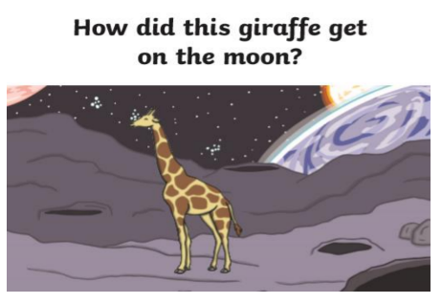  Illustrate your story.
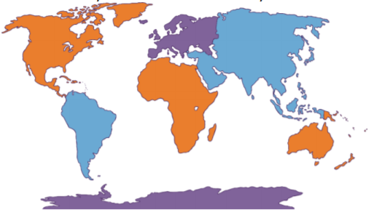  Geography: A continent is a massive piece of land that is often separated from other areas of land by water or another feature, such as mountains. Planet Earth has seven continents. Do you know the names of any of them?  Europe is one of the world’s continents.  https://www.bbc.co.uk/teach/class-clips-video/psheeyfs-ks1-go-jetters-continent-of-europe/zvsd47h (click on Europe). Around 10% of the world's population lives in Europe. Can you find out and list which countries make up the continent of Europe? How many are there?  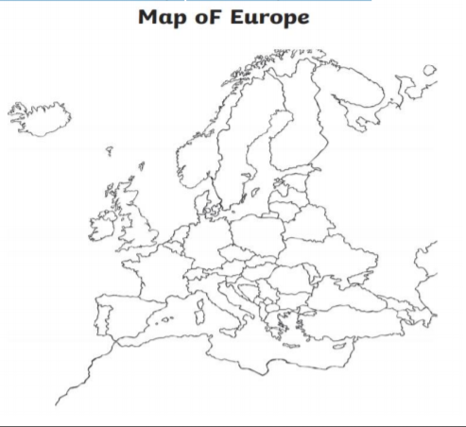 | App/ game  Geography  Follow the link: https://world-geography-games.com/world.html  Then click on ‘Europe’ on the top right corner of the page.  Then choose Europe: countries.  You can also learn names of capital cities and kinds of flags in Europe.

