Year 5 Home Learning – Wednesday 8th July 2020
We’d love to see your work! Please send it to: Year5@highworthcombined.co.uk
ENGLISH:  The Game  You had to predict what was going to happen next in the story.  Scroll down to refresh your memory and read the rest of the story.  How close were your predictions?  Use this link https://soundcloud.com/talkforwriting/game/s-7MBlxRcz8zL  to listen to the story.  Complete the activities:  - to understand what the words mean.  - to write down your likes, dislikes, puzzles and surprises. |  | MATHS:  You are going to be using all of your knowledge about Number and Place Value to solve some problems.  We have also included some Rapid Reasoning questions.  Scroll down and try to answer the quiz and the coin problem.  The answers are included so, when you have finished, you can mark your work.  If you have any incorrect answers, re-read carefully to make sure you’ve understood the question, check your work and see if you can spot your mistake.
WONDERFUL WORDS
Look at the Year 5 & 6 Words List. You can find it as a link on our Coronavirus Closure, Home Learning Matrix, Year 5 tab: https://www.highworth.bucks.sch.uk/web/year_5/460996
Choose 4 or 5 words to practise at a time.
- Look up the definition in a dictionary to check the meaning of each word.
- Learn the correct spelling by using: Look, Say, Cover, Write, Check.
- Write a sentence which includes the word to show that you understand its meaning.
4. Challenge yourself to include speech in each of your sentences. Scroll down for a reminder
about accurate punctuation using the KNOWLEDGE ORGANISER: Writing Dialogue.

HISTORY  Use this link for our next lesson in History. We will be learning about Henry VIII, one of the most famous monarchs in English history!  https://classroom.thenational.academy/lessons/how-did-henry-viii-initiate-the-reformation  You will need a pen, paper and your brain! | SCIENCE: Lifecycles  Can you remember what a lifecycle is?  Watch this clip to check if you were right.  https://www.bbc.co.uk/bitesize/topics/zgssgk7/articles/zwn6mnb  Let’s look at the stages of a plant’s life cycle. You can watch this video or have a look at the worksheet below.  https://www.bbc.co.uk/bitesize/topics/zgssgk7/articles/zyv3jty  Write down all the new vocabulary that you have learnt. Make sure that you understand what they mean.  Use these words to write down the lifecycle of plants in order and full sentences. |  | READING:  Martin Luther King Jnr  Read the comprehension on Martin Luther King Jnr and answer the questions that follow.  Be sure to mark and correct your work once you’re done.
THE GAME 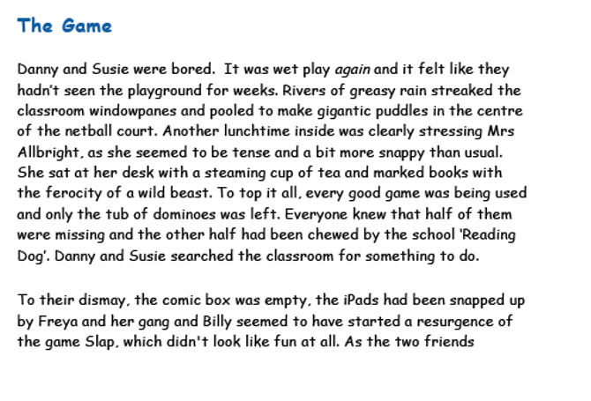
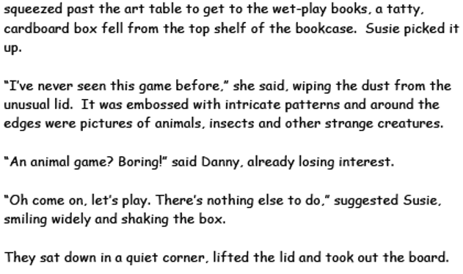

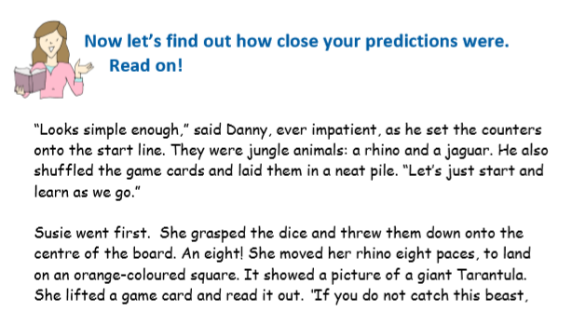
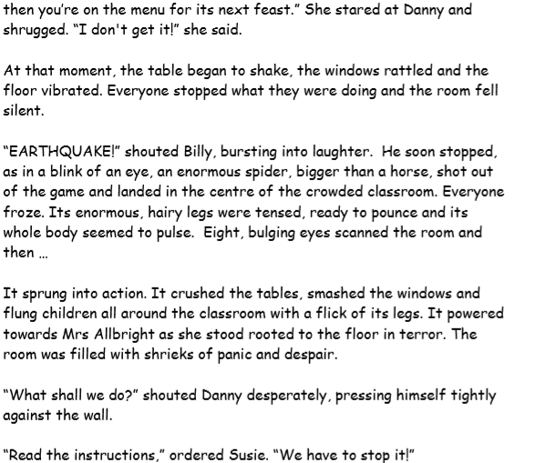
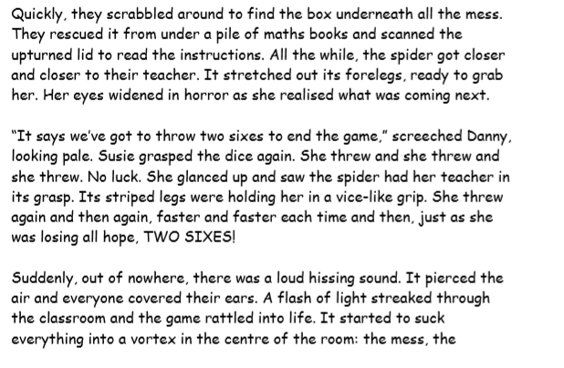
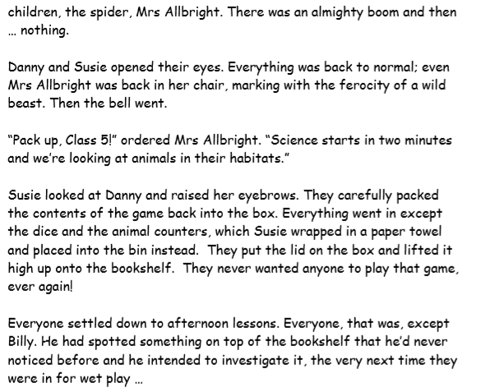

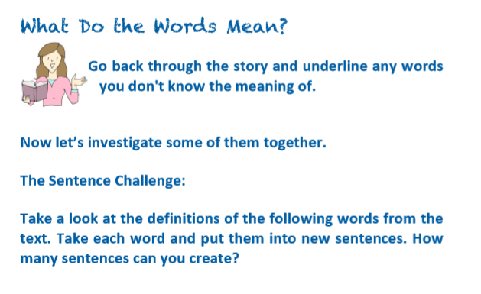
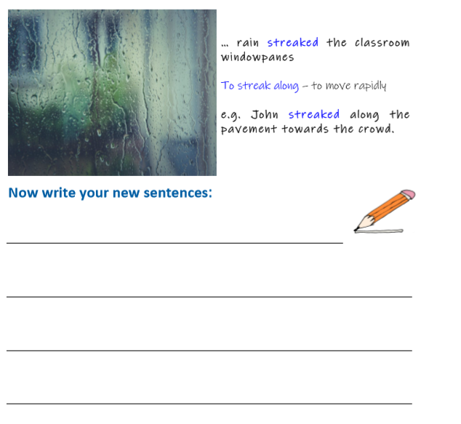
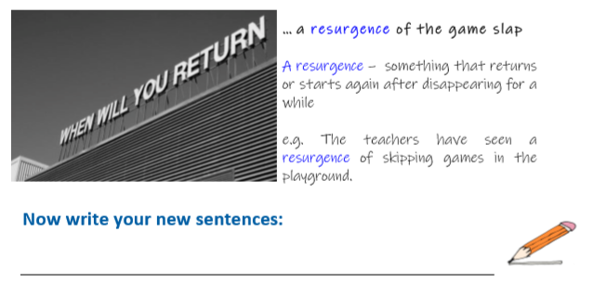
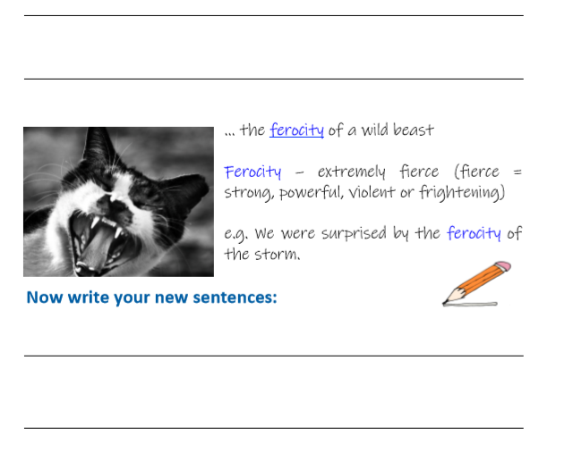

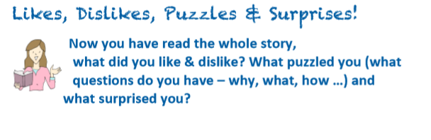
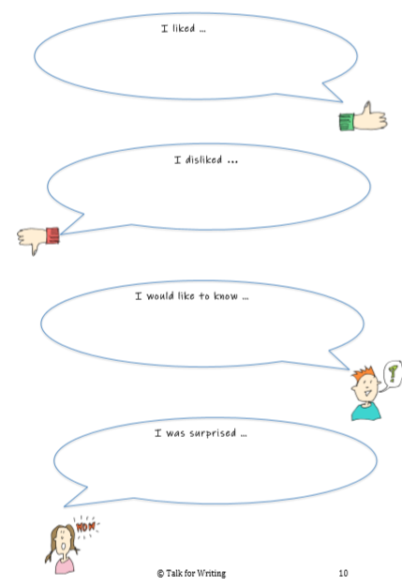
NUMBER AND PLACE VALUE

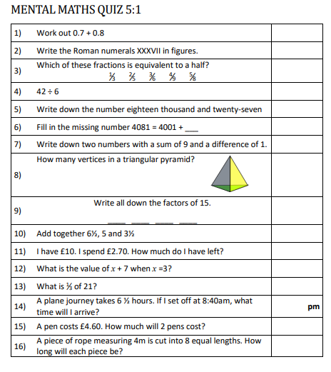

Quiz Answers
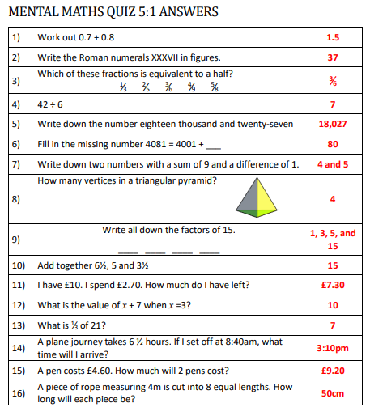

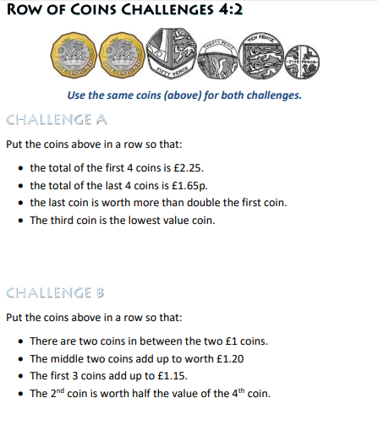

ANSWERS: Row of Coins Challenge
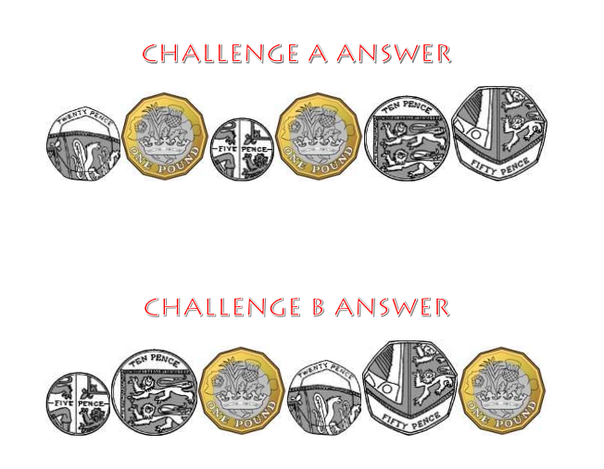
RAPID REASONING
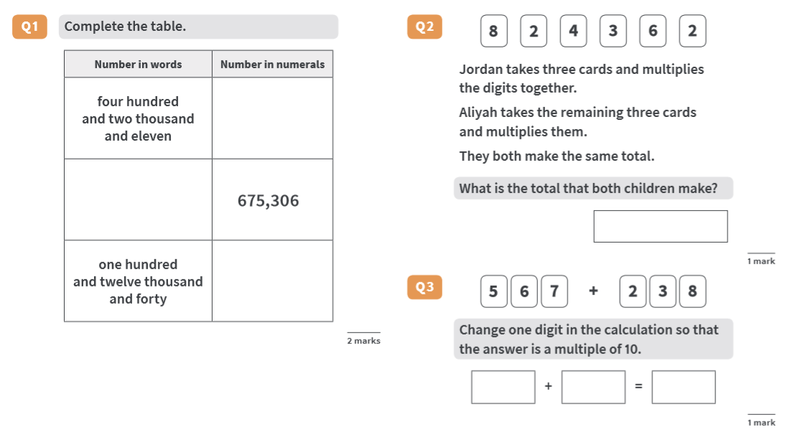

ANSWERS RAPID REASONING

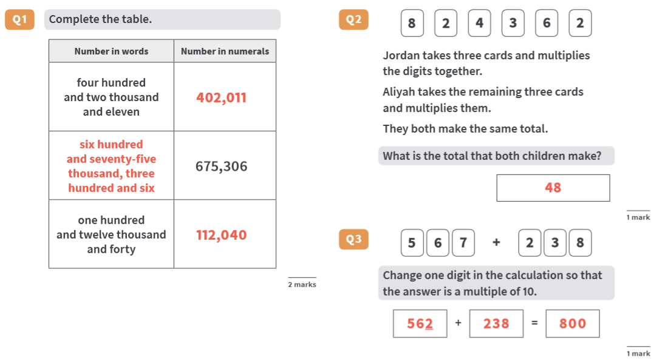

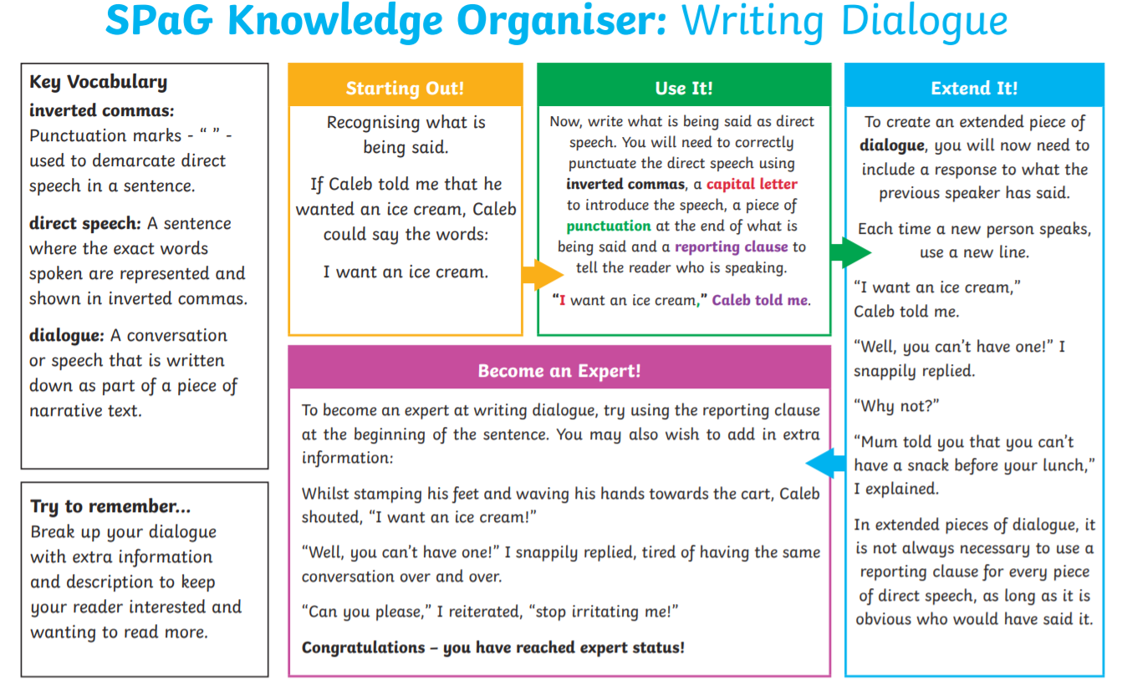

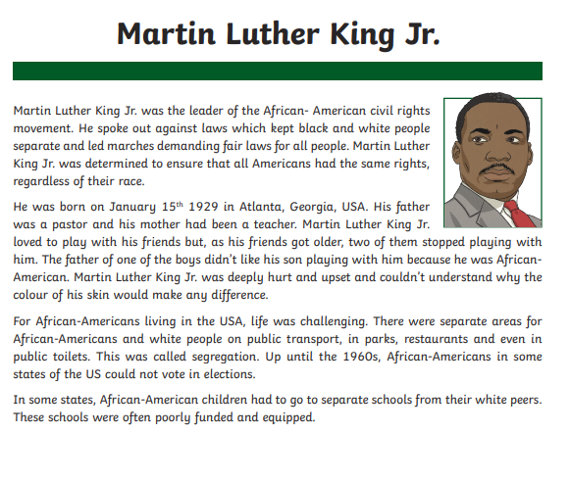
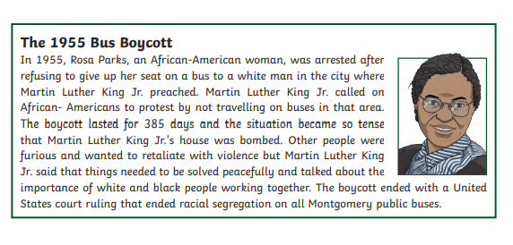

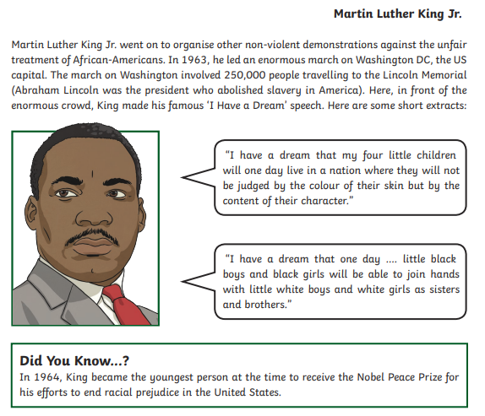
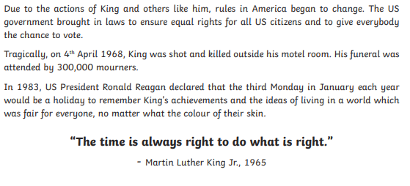

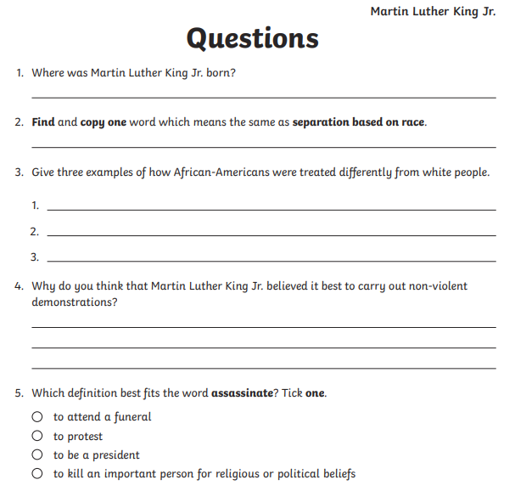
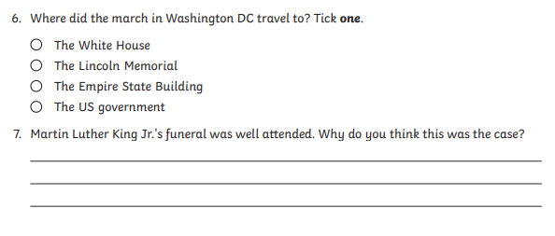
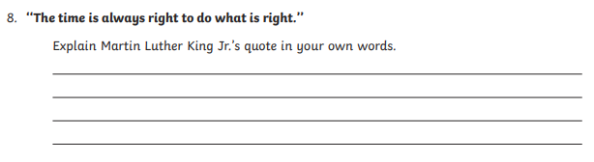

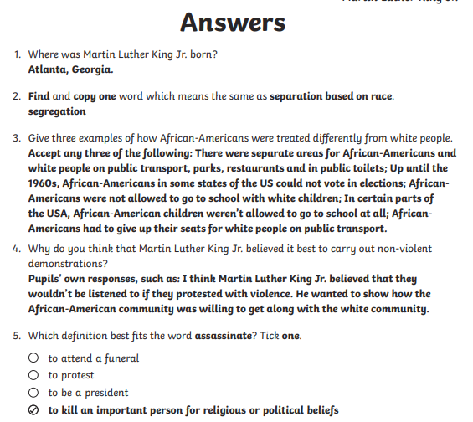
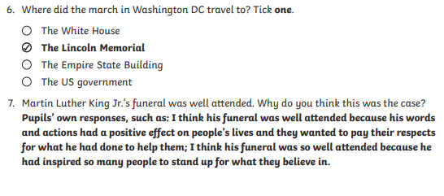
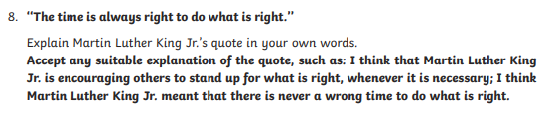

Life cycle of a flowering plant
