Year 5 Home Learning – Monday 13th July 2020
We’d love to see your work! Please send it to: Year5@highworthcombined.co.uk
ENGLISH:  The Game  Now for some grammar!  Scroll down to read the text again.  Use this link https://soundcloud.com/talkforwriting/game/s-7MBlxRcz8zL  to listen to the story.  You could watch the trailer again (with adult permission) for movie Jumanji (1995) - https://www.youtube.com/watch?v=yLyXEQPuLJo  Complete the activities on relative clauses, sentence imitation and adjectives. |  | MATHS:  You are going to be using your knowledge about Number and Place Value to solve the 5-digit number challenge.  You will need some paper for working out.  We have also included some Rapid Reasoning questions and a fun cross number.  Scroll down and try to answer the questions.  The answers are included so, when you have finished, you can mark your work.  If you have any incorrect answers, re-read carefully to make sure you’ve understood the question, check your work and see if you can spot your mistake.
WONDERFUL WORDS
Look at the Year 5 & 6 Words List. You can find it as a link on our Coronavirus Closure, Home Learning Matrix, Year 5 tab: https://www.highworth.bucks.sch.uk/web/year_5/460996
Choose 4 or 5 words to practise at a time.
- Look up the definition in a dictionary to check the meaning of each word.
- Learn the correct spelling by using: Look, Say, Cover, Write, Check.
- Write a sentence which includes the word to show that you understand its meaning.
4. Challenge yourself to include relative clauses and adjectives in each of your sentences.
HISTORY  Medieval Monarchs  Use this link for the next lesson 7 in History.  We will be planning and writing the first half of an essay on Medieval Monarchs.  https://classroom.thenational.academy/lessons/to-plan-and-write-an-essay-about-medieval-monarchs  You will need a pen, paper and your brain! | Science/Reading  Read the comprehension and answer the questions on Sir David Attenborough.  He is very famous and all of us would have seen his documentaries or parts of them.  https://www.youtube.com/watch?v=2vwY1bN6bx8  Can you do some research (internet or books) on a sea creature (dolphin, whale…) and perhaps make a video (with your adult’s permission), a Power Point or create a poster telling us what you have learnt. |  | Geography:  Flags of the World  All countries of the world have a flag. They are national symbols and show that we belong to a community.  Complete the activity on flags of the world and create your own flag. The symbol and colours are significant as they represent what the country finds important.  Think about what symbol you will use and the colours.
THE GAME
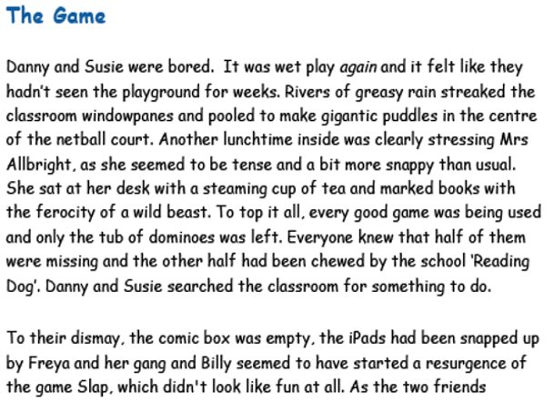
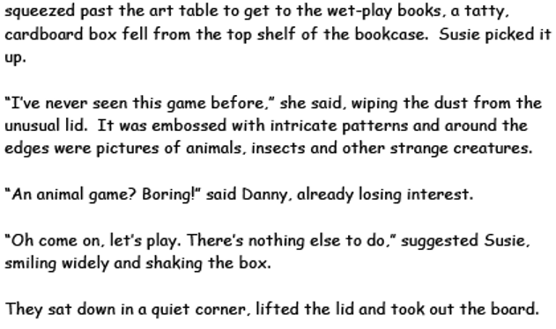

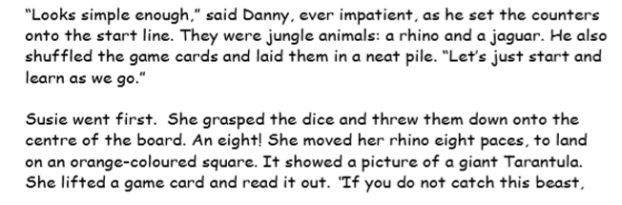
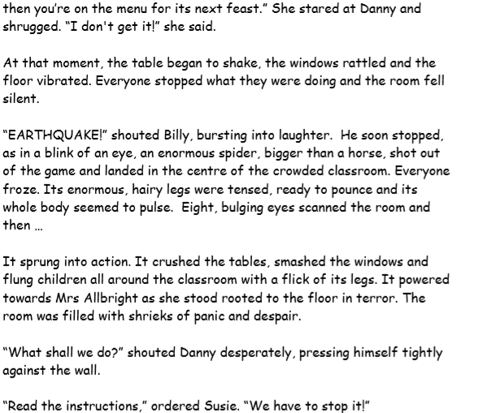

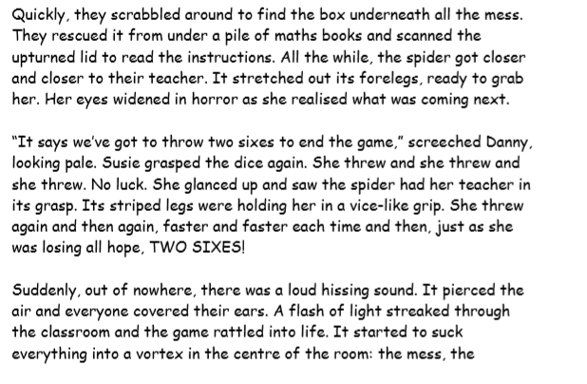
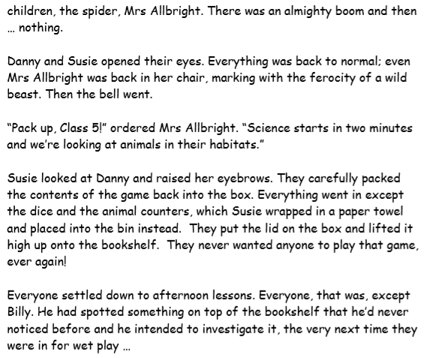

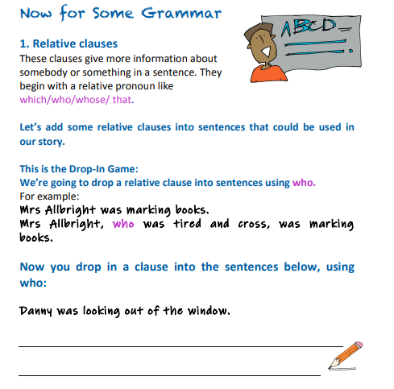
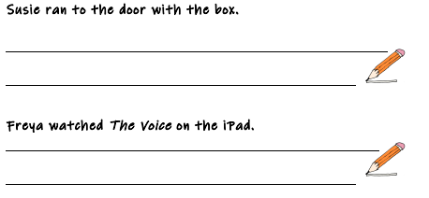
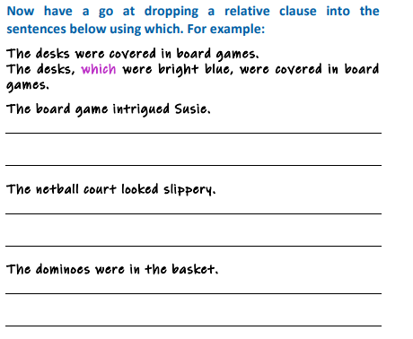
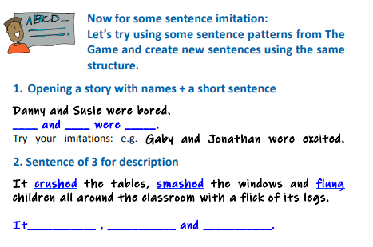

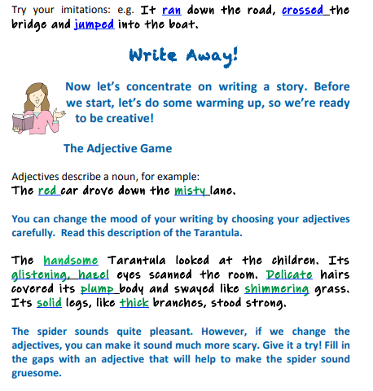
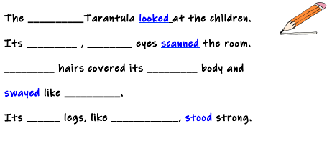

NUMBER AND PLACE VALUE
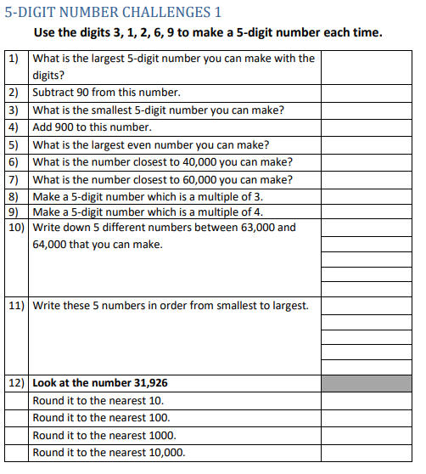

Rapid reasoning
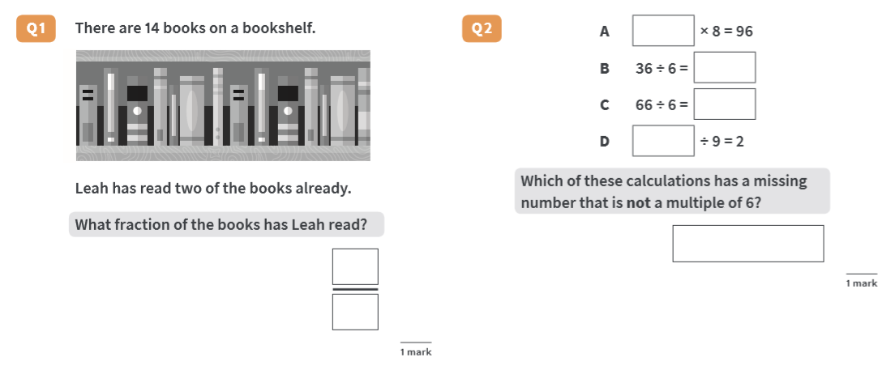
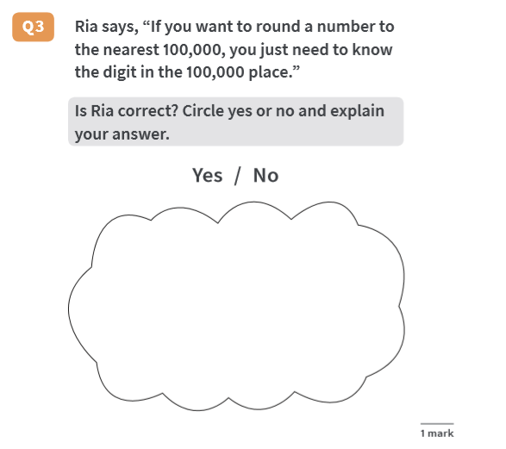
Answers
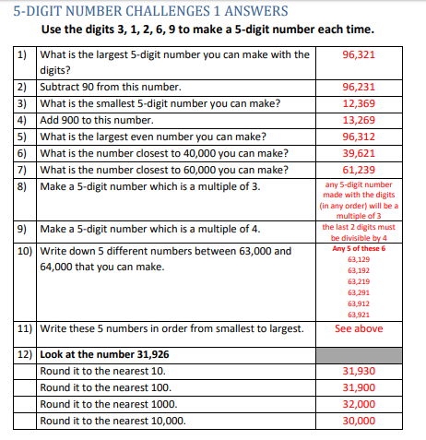

ANSWERS RAPID REASONING
