New Words for Mayan Civilisation – Farmers, Priests and Nobles
New Words | Meanings
Noble | A very important, rich person
sacrifice | to give up, to kill and give to the gods
human | people
captured | Caught (to capture means to catch)
warriors | soldiers
thatched | straw
loincloth | a short cloth around the waist (see picture of farmer)
forbidden | not allowed
Family celebration | Party for a birthday, wedding, special event in the family
Religious festivals | Party for a religious reason – e.g. Easter, Eid
tools | Things to use to do jobs (scissors, hammer)
temples | Religious buildings
estates | Large houses for rich people (the nobles)
produce | Things that grew e.g vegetables or fruit to sell
trade | To sell and buy produce or goods e.g. one person can give some corn to a person and they give back some tools
Life of luxury | Have a lot, like a rich person
ancient | Very old, long time ago
Servants/slaves | A servant works for free, does all the work in the house for nothing. A slave usually works harder outside.
Personal sacrifice | To give up something, to give to the gods a gift, sometimes to kill an animal to make the gods happy
astronomy | Space, stars, planets, moon
medicine | The body and how to look after it
elaborate | a lot of decoration, not boring or plain
palaces | A very large house, like a castle for nobles to live in  (The queen lives in a palace – Buckingham Palace)
entertainment | What you do to have fun (e.g. party, watch TV)  Nobles have festivals
lifestyle | How you live your life
government | The group of people that run the country, tells people what they must do, make the rules, (in the UK the prime minister is the boss of government)
headdresses | Very large hats with feathers and jewellery
plait | Make patterns with your hair

See pictures for some words below:

Mayan Farmers, Priest and Nobles

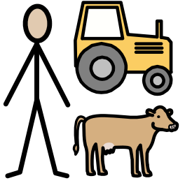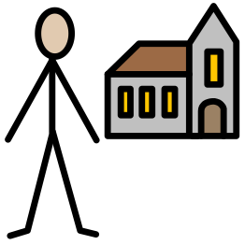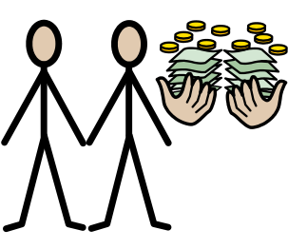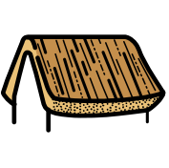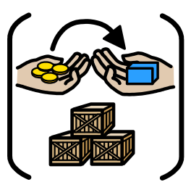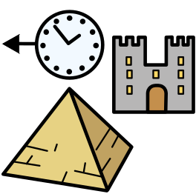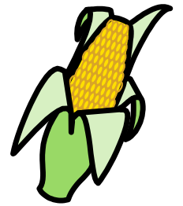
farmers
priests

nobles

celebrations

sacrifice

religious

temples

estates
thatched

roof
trade

ancient

maize

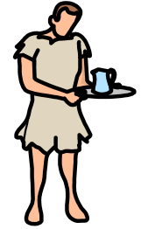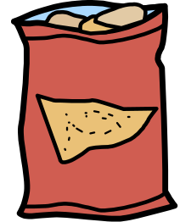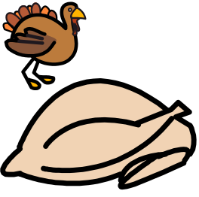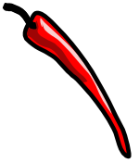
slave
astronomy

government

medicine

costume
tortillas
turkey
chilli

peppers

