Year 1 Home Learning – Wednesday 20th May 2020
Below, you will find 6 home learning tasks. You may choose the tasks that you wish to complete and do them in any order. Please do not hesitate to contact us if you have any queries or would like to share the work you have been doing.
year1@highworthcombined.co.uk
We have attached several internet links but please always follow the school internet safety policy and always use the internet with an adult. https://www.highworth.bucks.sch.uk/web/children/295423
Maths  Today we are thinking about subtraction and the different methods we use to solve subtraction problems including number lines, objects, part, part whole models.  There were 18 ladybirds in Mrs Lawrence’s garden 3 of them flew away how many are left?  - Draw a picture to show this.  - Draw a number line and show how you have worked this out by jumping backwards on the number line.  - Show this on a part, part whole model (remember the whole would be 18 and one part would be 3 and the other part is what you are finding out)  - Solve the subtraction using objects  - Write the equation.  - Can you think of and use any other methods we have learnt in class?  Repeat these methods for these questions:  - Poppy has 12 sweets she gives 5 of them to James how many does Poppy have left?  - Oreo the dog had a box of dog biscuits with 27 biscuits in, the children of Highworth gave him 7 biscuits how many does he have now?  - Miss Hawes has a jar of 20 marbles she drops 3 of them in her car on the way to school, and then loses another 7 in the classroom, when she takes the jar home how many does, she have?  Challenge – We would like you to be the teacher, tick the number sentences if they are correct and mark a cross against them if they are wrong and write the correct answer.  14-6=7 20-10=10 15-7=8  18-8=9 11-4=7 17-9=9 | Science  Today we would like you to carry out a science investigation/ experiment.  We would like you to design your own experiment involving paper aeroplanes. e.g.  You might want to explore if the size of a paper aeroplane makes the plane fly further. Or if the material you make the plane out of makes a difference to how far it travels, or if the shape and design effects how well it flies. It is your choice think carefully about what you want to investigate.  This is your experiment and we are focusing on whether you can carry out an investigation and record the results independently.  - You will need to write what the experiment is? Title of the investigation.  - Prediction- What you think the result will be and why.  - Equipment- What you will use.  - Method- What you are going to do and how will you make it fair (remember to only change one thing – the size, the material, the shape and design)  - Results- How will you measure your results, how will you record this?  - Conclusion – What did your results tell you? Was your prediction correct? Do you know any reason for your results?  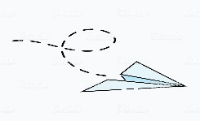
English and Wellbeing
Lots of the Mr Men and Little Miss stories talk about feelings. It is important to talk about your feelings and emotions, to know the names of them and how or when you might feel them along with how to control them.

Look at these Mr Men characters:
- For each character think about: When you felt the same as the character? What made you feel that way? What happened before or after? Did you tell someone how you felt? Did you need help or what could you do next time you felt that emotion? Don’t forget it is okay to feel sad or cross, but it is how you react to these emotions that is important. Think carefully about what you can do when you feel different emotions.

- Talk your answers through with an adult.

- Make a list of as many different emotions as you can think of.

- Pick four of the emotions from your list and design a Mr Man or Little Miss Character for these emotions. (It doesn’t need to be a real character you can make your own one up.) Think about what shape, colour and expression might be appropriate for each character. Draw them in a line like the picture above and cut your strip of paper out.

- Display the characters you have made in your house and ask to borrow a clothes peg. Place the peg on the character that you are feeling most like today, keep your characters up for a few days and move the peg to the different emotions as you feel them, perhaps ask another family member to do the same with a different coloured peg. Don’t forget to share with an adult about how you feel and why.

- Now pick one of the characters you have made and make your own Little Miss or Mr Man book. You could make the story as silly or as fun as you like. We look forward to reading your stories.

Design Technology and Art  Today we would like you to design and make a form of air travel or create a picture showing a form of air travel. This can be a flat image or a 3D design. Or you could make a background for your 3D design to go on!  Use materials from around your home to make your air travel model or picture. Below are some images of ideas to help you.  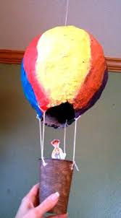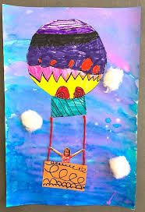  Paper Mache -Hot air balloon Hot air balloon drawing  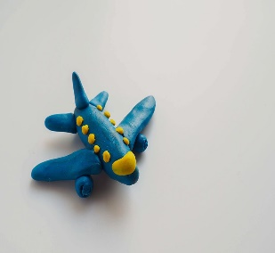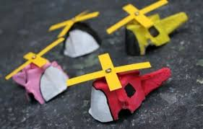  Aeroplane made from  play dough Egg carton helicopter | History and Geography  You will need to use the Twinkl website - it is currently free please scroll to the bottom of this link to see the offer code and how to log on if you haven’t already. https://www.highworth.bucks.sch.uk/web/home_learning_ideas/459242  On 20th May 1932 Amelia Earhart became the first woman to fly non-stop across the Atlantic Ocean.  With an adult, as you will need to use the internet, we would like you to create a fact file about a famous figure in aviation e.g. Amelia Earhart, Amy Johnson or the Wright brothers. The links below should help or perhaps you could research someone different on Twinkl?  In your fact file you could include places that they flew to, where they were from or what they were famous for. Please try and include either a flag of a place they flew to or were from or a map to show where they travelled to or were born.  https://www.twinkl.co.uk/resource/all-about-amelia-earhart-t-h-284  https://www.twinkl.co.uk/resource/ks1-amy-johnson-differentiated-reading-comprehension-activity-t-e-2549484  https://www.twinkl.co.uk/resource/t-h-064-the-wright-brothers-information-powerpoint
Reading and Phonics
- Today we are thinking about reading. First we would like you to watch one of the Read Write Inc. phonics lessons with an adult. This is the link to get to them and the timings for the different phonics sounds , please complete the word time and spelling activities https://www.youtube.com/channel/UCo7fbLgY2oA_cFCIg9GdxtQ
New films are released at the times shown below from Monday to Friday. Each film is approximately ten to fifteen minutes long and will be available on YouTube for 24 hours.

- Then read a book or listen to a story being read to you, this can be a book you have at home.

Or you could use this link to hear a story read by one of the Highworth staff members. https://www.highworth.bucks.sch.uk/web/story_time_with_highworth_staff/478292
If you want to read a book that is similar to the phonics reading book we use in class these books are free to read online, an adult will need to login but there are lots of books of different levels you can look at and read. https://www.oxfordowl.co.uk/library-page?view=image&query=&type=book&age_group=&level=&level_select=&book_type=&series=Read+Write+Inc.#

- When you have read a book or had a story read to you, we would like you to complete a book review about the book like the one below.

