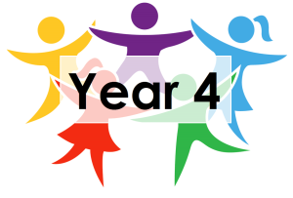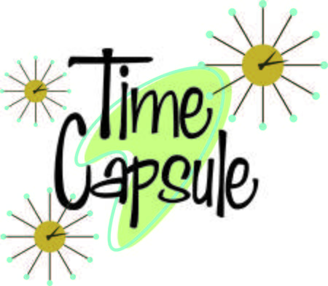**Year 4 Home Learning – Wednesday 20th May 2020**

**Please send us your work to:**

**Year4@highworthcombined.co.uk**



**EXCITING NEWS! HAVE YOU GOT THE POWER IN YOU?** Young Voices are inviting you to be part of the largest children’s choir at home. The song is going to be The Power in Me so you will all know it from singing it at school (and 4NS we used it in our class assembly!). Go to the Young Voices website and find the Power in Me Singing Challenge tab to read all about how you can join in.

***SAVE THE DATE:*** 2 June 2020 at 2.30pm. We will be there and hope you will too!

Here is the next instalment for your Time Capsule Project!

Just a reminder, you will find a document called ‘Time Capsule Project’ in the Home Learning section of the school website that includes some of the activities for all of this week and includes an overview of what we hope to achieve.

|  |  |
| --- | --- |
| **TIME CAPSULE ACTIVITIES** | |
| **Wednesday 20.5.20**  **Day 3: How I stay connected**    Today you are going to collect together ideas of how you have stayed connected during lockdown. Think about who you have stayed connected with and how you have managed to do this.  You can present your thoughts in any way you choose, for example a table or a colourful mind map / poster.  **Think about who, how and why (what you do when you connect).**  ***Challenge:*** What would you recommend to someone who was new to lockdown? Are there things you would do differently if you went back in time? Why is staying connected so important? | **Thursday 21st May**  **Day 4: How I learn**    Can you write a diary entry about your learning during lockdown? How has the way you learn changed? Try to answer questions like:  **What have I learnt? Have you learnt something new? What have you got better at?**  **How have you learnt? What has helped?**  **Who has helped with your learning?**  **When do you learn? How does learning fit into your day?**  **How do you feel about learning in lockdown?**  ***Challenge:*** What is your biggest highlight with learning during lockdown? What would you recommend to someone who was new to lockdown? |

|  |
| --- |
| **OTHER ACTIVITIES** |
| ***REACH OUT REPORTER***  Watch this clip then answer the questions that follow. Read the questions before watching the clip so you know what to listen out for.  <https://www.reachoutreporter.com/news-update/paper-microscopes-underwater-archaeologists-and-new-uses-for-old-mattresses/>  Underwater Archaeology Field School**Underwater Archaeologists**   * What do archaeologists do, and why? * Why do you think archaeologists record the things they find using a variety of methods – for example, drawings, X-rays and photos? * What could archaeologists learn from studying objects found in the wreck of HMS Erebus.   To find out more about the job of an archaeologist, you can click on the link below or read the text at the end of this matrix. <https://ask.mrdonn.org/archaeology/>  **The Archaeological Jigsaw**  **We are going to think about how archaeologists do their work.**  **What can we learn from a group of objects?**  Look at these jigsaw pieces and choose one that stimulates your curiosity.  • What you can tell from your chosen piece?  • What questions would you like to ask to find out more?  **Activity**  Archaeologists piece together clues to form a picture about what life was like in the past. Flint is one of the most common materials that survives from prehistory.   * Draw a picture of yourself in the clothes you are wearing. * Include any objects you have with you, for example a pencil case. * From the drawing make a list of all the things that might survive 5000 years into the future (skeleton, plastic buttons, metal zips). * What would a person in the future learn about us from the things we leave behind?   You could include this in your time capsule. |

**MAGNIFICENT MATHS**

Chilli pepper challenge time!

|  |  |  |
| --- | --- | --- |
| Yellow Chili Pepper Images, Stock Photos & Vectors | Shutterstock   1. **34 x 3** 2. **53 x 5** 3. **27 x 4** 4. **81 x 3** 5. **18 x 4** 6. **56 x 5**   **In the PDF files attached, do Green Multiplication question 3 - end** | Yellow Chili Pepper Images, Stock Photos & Vectors | Shutterstock   1. **45 x 7** 2. **372 x 8** 3. **84 ÷ 3** 4. **224 ÷ 4** 5. **672 ÷ 7** 6. **384 ÷ 8**   **In the PDF files attached, do Multiplication question 3-6**  **In the PDF files attached, do Division question 3-6** | Yellow Chili Pepper Images, Stock Photos & Vectors | Shutterstock  **Think carefully about what calculation you would do to find the missing answer.**   1. **_____ = 136 x 8** 2. **____ X 7 = 161** 3. **529 x 9 = _________** 4. **_____ = 252 ÷ 4** 5. **6 x ______ = 384** 6. **_____ ÷ 8 = 72**   **In the PDF files attached, do Multiplication question 5- end.**  **In the PDF files attached, do division question 5- end.** |

Double click on the PDF documents to open them. If they do not open from here , they are available in the home

learning section on the website.

 

Use a written method to multiply and divide.

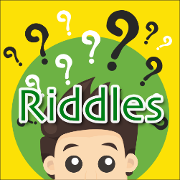**Here are 3 riddles to solve. Thank you Florence for creating and submitting them.**

1. I am liquid but turn to stone. Very rare am I. Sometimes you can see me getting

ready. What am I?

1. I am very tiny, never alone. You describe me as a pebble or a stone. What am I?
2. Treasures I hold. Dig deep down, I may just tell the time of old. What am I?

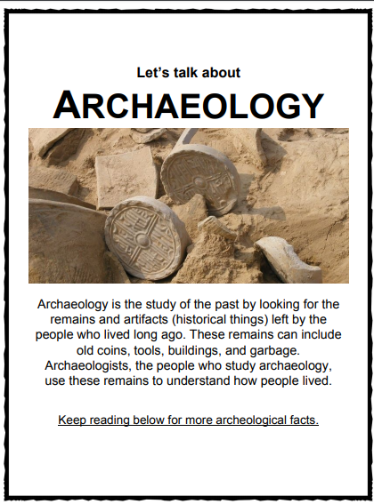

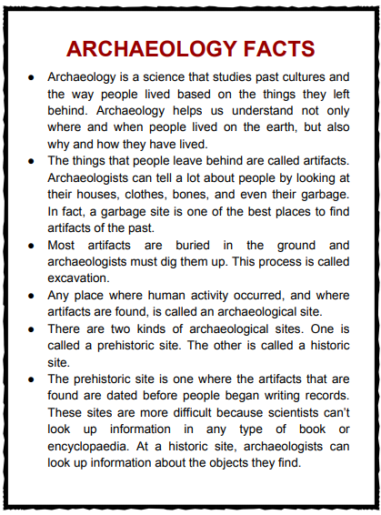

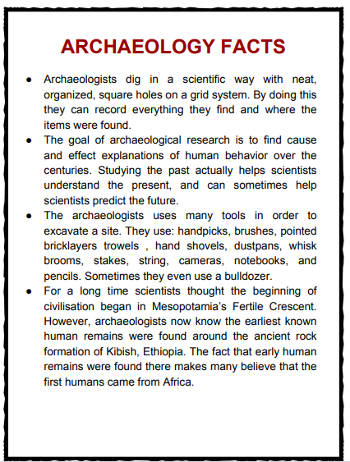

KidsKonnect