Year 1 Home Learning – Wednesday 29th April

Below, you will find 6 home learning tasks. You may choose the tasks that you wish to complete and do them in any order. Please do not hesitate to contact us if you have any queries or would like to share the work you have been doing. year1@highworthcombined.co.uk
Today you may need to use the internet to complete some of the tasks please always remember to use the internet with adult supervision, and use the school internet safety rules and advice. https://www.highworth.bucks.sch.uk/web/children/295423

English  Today we are going to focus on past present and future tense.  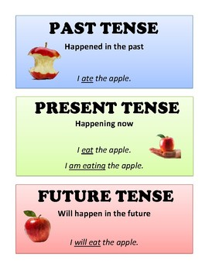  Think of some things that you do every day e.g. waking up, watching TV, brushing your teeth, eating your breakfast, washing your face, having a drink, kicking or throwing a ball, playing a game, reading a book, writing a sentence , phoning a family member etc.  Get three pieces of paper on the top of the paper write PAST TENSE-YESTERDAY on one piece  write PRESENT TENSE- TODAY on another and on the third one write FUTURE TENSE – TOMORROW.  Now on the first piece of paper write at least 5 simple sentence to explain what you did yesterday e.g. I wrote a sentence.  Then think of those same activities and write them on the today piece of paper as if you were doing them e.g. I am writing a sentence.  On the last piece write about the same activities as if it is happening tomorrow. e.g. I will write a sentence. | Maths  You will need to:  Collect 21 toys from around your house Lego blocks would be ideal, and a bag that you can’t see in (your book bag would be perfect).  Now make two cards, on one write ONE MORE and on the other write ONE LESS.  Cut up 20 pieces of paper and make your own set of number cards (don’t forget to think carefully about how you write your numbers).  And finally draw your own number line to 20.  One more and one less toys in the bag game.  - Pick a number card and place that amount of toys in the bag. ( e.g. if you pick the number 5 place 5 toys in the bag)  - Circle that number on your number line.  - Pick one of the cards that you have written one more or one less on and either put ‘one more’ toy in the bag or take one toy out for ‘one less’  - Show this on your number line by jumping forwards or backwards.  - Tell your adult how many toys you now think are in the bag. (e.g “I have added one more toy. There are six toys in the bag because one more than five is six. Five and six have a difference of one and 6 is the number after 5 on the number line. ” Or “ I have taken out this toy. Now there are four toys in the bag because one less than five is four. Five and four have a difference of one. I know this because 4 is the number before 5 on the number line”)  - Now take out the toys in your bag and count them carefully . Were you correct?  - Can you record what you have found out on a number line.  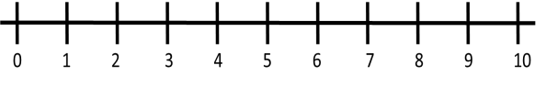  Repeat this as many times as you can each time picking a different amount to go in your bag.  - Challenge- Make cards that say TWO MORE and TWO LESS. Can you play this game with  50 toys?
Science

The web link should help you, but please remember internet safety and always only use the internet with an adult.

Watch this video clip with an adult showing the parts of a plant and their functions.
https://www.bbc.co.uk/teach/class-clips-video/science-ks1-ks2-ivys-plant-workshop-parts-of-a-plant/zvdkpg8

Talk with an adult or older sibling about the parts of a plant the stem, leaves, root, and flower. Can you talk about what the functions of each part are?

Draw a picture of a plant and label the parts.
- Can you write a sentence about the function of each part of a plant?

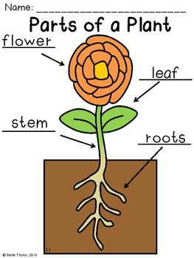

Wellbeing - yoga  Sometimes to help relieve stress and anxiety a calming form of exercise called yoga can help.  Try a child friendly yoga or mindfulness session using this link. Remember that you must always only use the internet with an adult.  https://www.cosmickids.com/category/watch/?energy=calm&changed=energy | Geography  Draw a map of a room in your house.  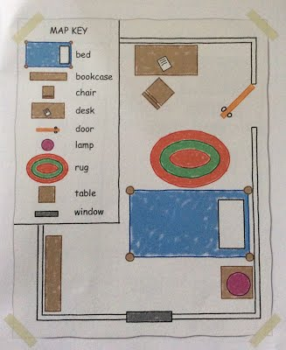  Include a key, to explain the features of the room e.g. this might represent a door.  As a challenge try to map the whole of the downstairs or upstairs of your house.  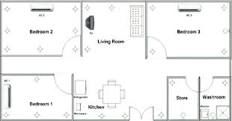
Design Technology

Today we would like you to be an engineer and design and make a bridge.
What materials do you have at home that would be good to make a bridge from? E.g. Lego, wooden blocks, newspaper, straws, cardboard rolls, boxes, folded paper, junk modelling materials.

Now, design a bridge that you would like to make. Don’t forget to label your design with your materials that you will use, and the key design features.

Draw a river on some paper and make sure your bridge crosses the water.

Try and follow your design to make your bridge! Send us a picture if you can!

Now evaluate your bridge. What was good about it? How could you improve it? Can you place any toys on your bridge without it collapsing, can you make your bridge wider?

