Year 5 Home Learning – Friday 12th June 2020
We’d love to see your work! Please send it to: Year5@highworthcombined.co.uk
ENGLISH  We are going to continue our work on  Wonderful Wizards!  In order to understand a text, it’s necessary to find out the meaning of new words.  First, scroll down and read the advert for The School of Wizardry.  Then complete the activities to help you learn the meanings of some of the words in the text.  Finally, re-read the advert. You’ll find that you understand it even better now. |  | MATHS  LONG MULTIPLICATION  How have you been getting on with multiplying  2-digit and 3-digit numbers by a 2-digit number?  Now it’s time for a challenge! Scroll down to practise multiplying 4-digit by 2-digit.  As always, make sure that you align the digits according to their place value and use a 0 place holder when multiplying by the tens digit.  The answers are included again so, when you have finished, you can mark your work.  As before, if you have any incorrect answers, look back over your work, check your calculation and see if you can spot your mistake.
WONDERFUL WORDS
Look at the Year 5 & 6 Words List. You can find it as a link on our Coronavirus Closure, Home Learning Matrix, Year 5 tab: https://www.highworth.bucks.sch.uk/web/year_5/460996
Choose 4 or 5 words to practise at a time.
- Look up the definition in a dictionary to check the meaning of each word.
- Learn the correct spelling by using: Look, Say, Cover, Write, Check.
- Write a sentence which includes the word to show that you understand its meaning.
4. Challenge yourself to include a RELATIVE CLAUSE in each of your sentences. Scroll down to the
REVISION CARD for a reminder about them.
RE  We are continuing our lessons on Buddhism  Why do Buddhists meditate?  Click on the link below to complete lesson 3. There are some videos, fun activities, and quizzes.  If you haven’t done the previous lessons, don’t worry about the Introductory Quiz - just have a go  https://classroom.thenational.academy/lessons/why-do-buddhists-meditate | HISTORY  From the invention of the canoe in 8,000 B.C. to the recent rise of self-driving cars, watch this video about how humans have travelled from here to there through the centuries:  https://thekidshouldseethis.com/post/an-animated-history-of-transportation-through-the-centuries  Choose at least 6 of the modes of transport, research them and present them on a timeline, writing a brief description for each one, explaining what it was and who would have used it.  As an extra challenge, include the inventors’ names! |  | WELLBEING  Here’s an idea for an arty snack (scroll down for a larger image).  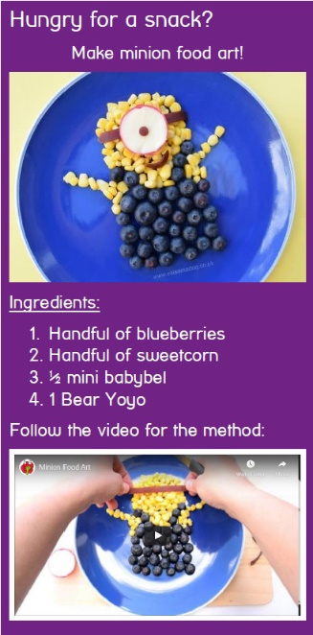  Think about  what foods  you could use  and have a go  at designing  your own  tasty snack.  You could  even try  making  it but please  ask an adult  for help.  BON APPETIT!  We’d love to see a photograph of your creation!  You can watch the video here:  https://www.youtube.com/watch?v=c9f7jWQ6t5w&feature=youtu.be
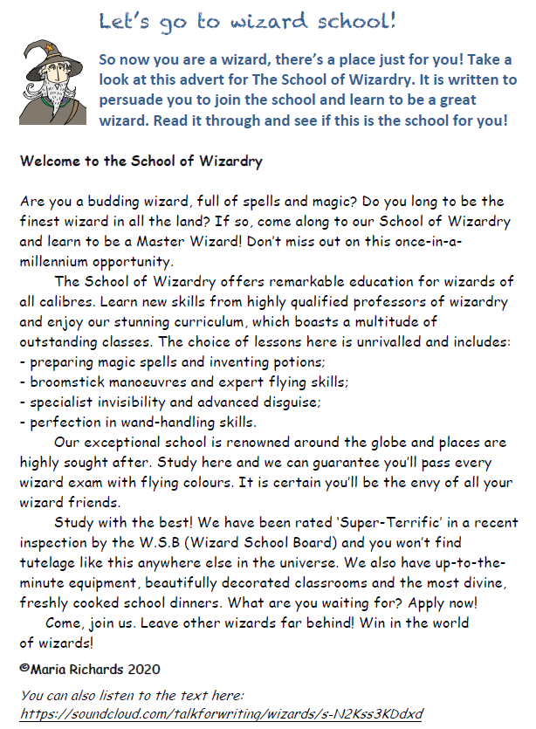

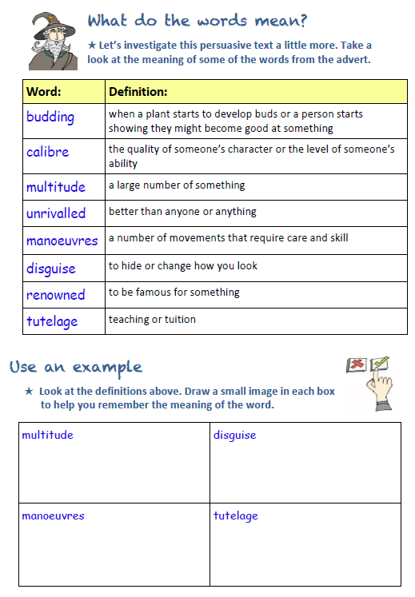

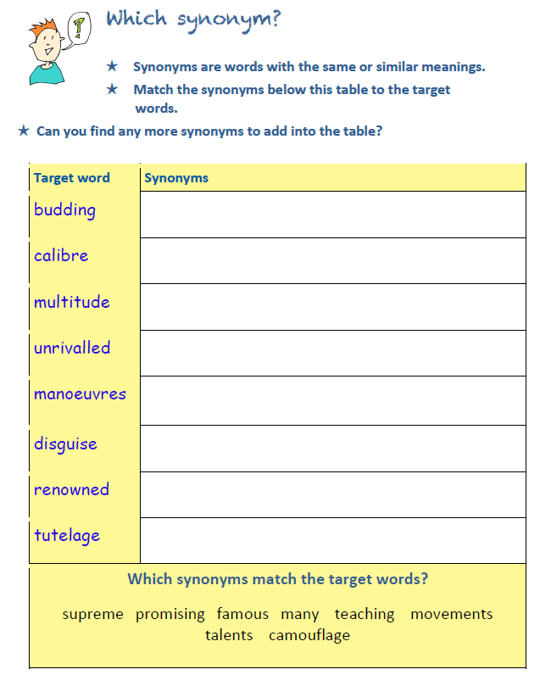

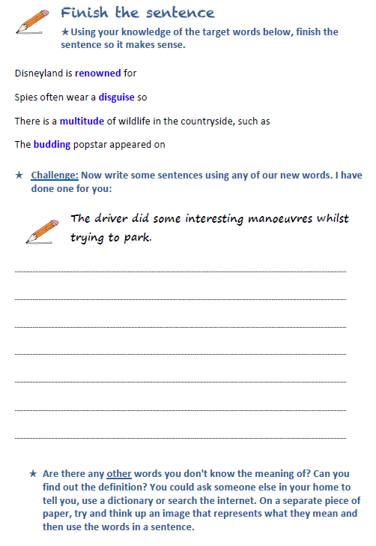

LONG MULTIPLICATION
Remember that ‘multiplicand’ is a quantity which is to be multiplied by another.
e.g. 2154 is the multiplicand in the calculation 2154 x 32 = 68,928
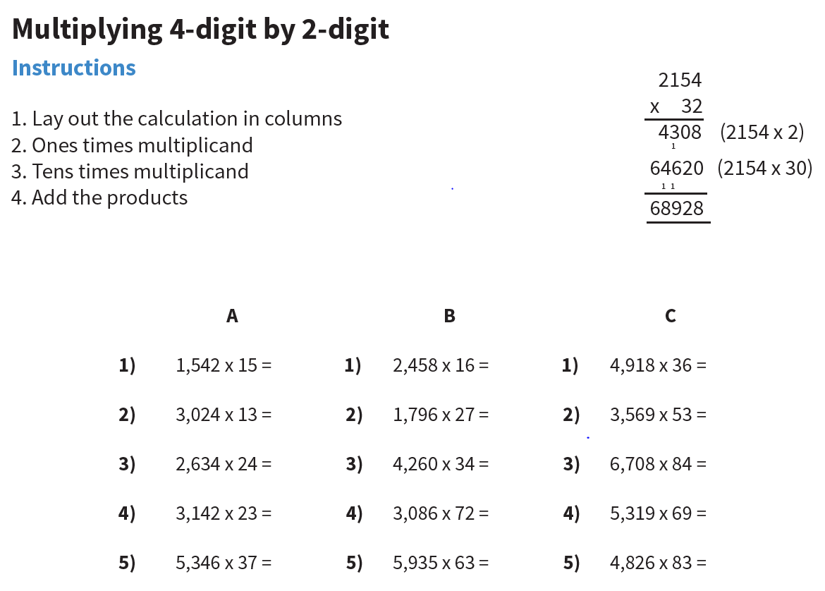

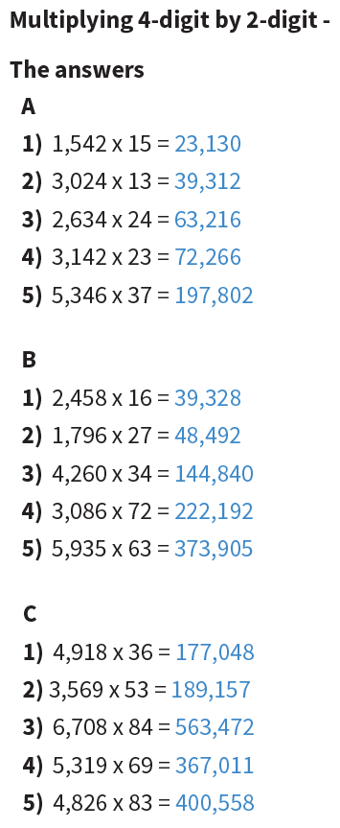
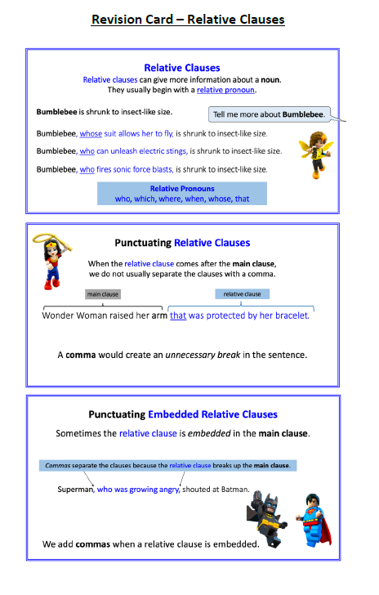
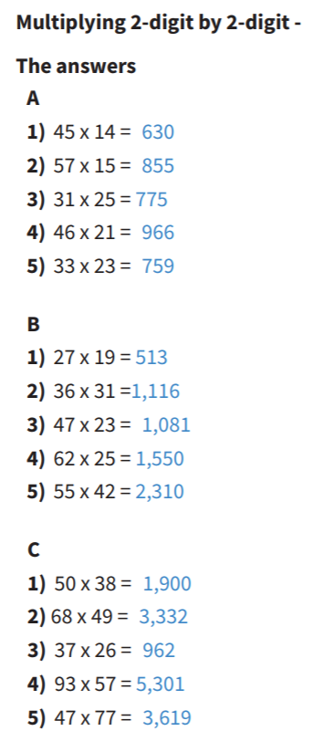
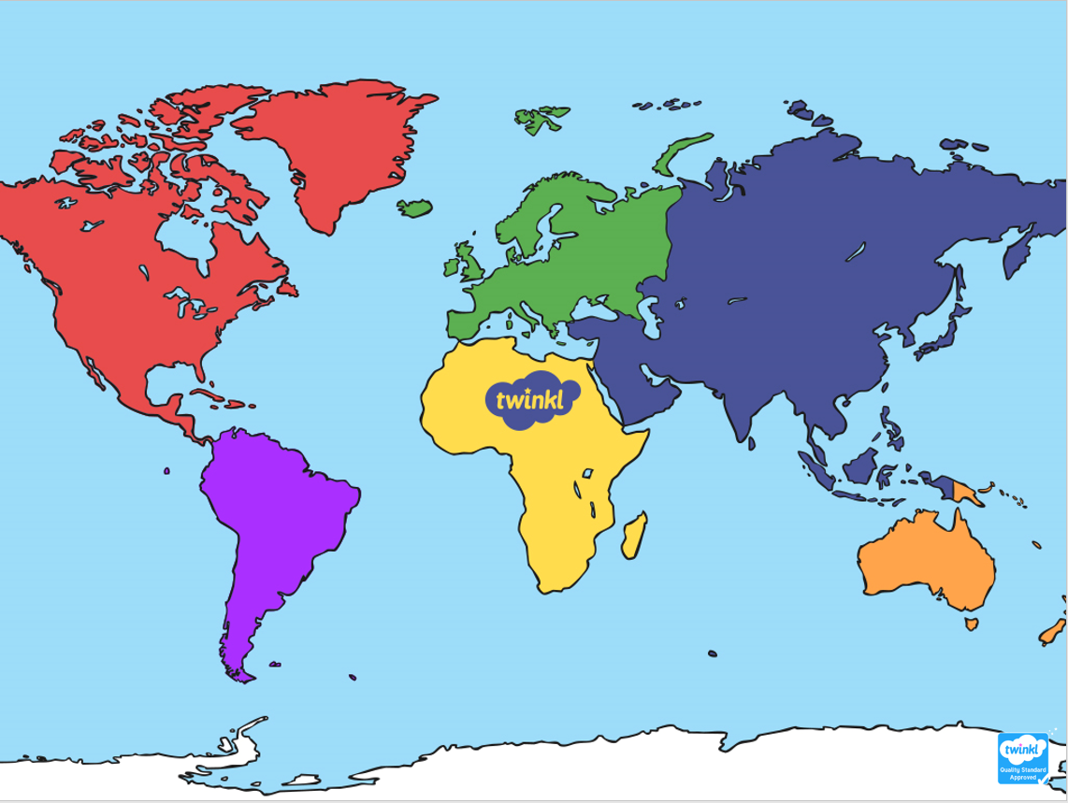

You can watch the video here:
https://www.youtube.com/watch?v=c9f7jWQ6t5w&feature=youtu.be
