Extra Home Learning – HID Children No 2

To replace some of the tasks in the class home learning you may wish to try some of these. Parents, please simplify or extend depending on needs and age of children. Have fun! There is an email address prepared for you to use. To watch the signed story of the Gruffalo parents need to create an account with the RAD (The Royal Association for the Deaf)*
There is a range The Gruffalo activities on Twinkle

Signed Story Favourite Character  Watch a signed story and draw a picture of your favourite character,  Describe your character and why you like them.  You can video it and send it to me  You can send me a picture of your character. | The Gruffalo in Sign Language*  Watch ‘The Graffalo’ in BSL with the link below:  https://www.facebook.com/1019788514740928/posts/2802884526431309/?vh=e&d=n  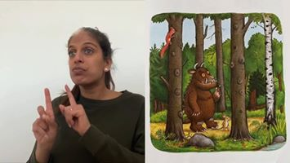
Toys Big and Small  Get 5 of your toys  and put them in a row  from smallest to biggest.  Draw them and explain:  - which one is the smallest?  - which one is the biggest?  You can sign and/or write a sentence. | Make a Card  Make a Thank You Card for someone in your family.  Write:  To…………..  Thank you for………  Love from……….  You can draw the nice things they do for you or you can write a kind message.  Decorate it with things they like.
Guess Which Toy  Play ‘Guess Which Toy’ with people in your family. Choose 3-5 different toys and put them on a table. Pick one and describe it to someone in your family and they have to guess which one you are describing. Don’t tell them which one it is. They have to guess.  Then others can have a turn and you guess which toy they are describing.  You can describe:  - Colour  - Size  - Parts of the body, eyes, nose, ears, legs  You can video this and send it to me so I can guess which toy you are describing.  You can write a description using cloud words and ask someone to guess which toy. | Hide and Seek (Practicing our ‘where words’)  Hide an object in a chosen room and ask an adult to guess where it is by asking questions.  Is it on the table?  Is it under a chair?  Is it next to the TV?  Is it behind the chair?  Is it in front of the shelf?  Is it near or far away from the door?  When they find it, they can hide it and you can ask questions to find it!  You can time each other and see who wins!  You can write a sentence saying where you found it!

