Year 1 Home Learning – Monday 30th March

Below, you will find 6 home learning tasks. You may choose the tasks that you wish to complete and do them in any order. Please do not hesitate to contact us if you have any queries or would like to share the work you have been doing.
year1@highworthcombined.co.uk
This animal fact file will help you with several of today's activities:
https://www.marwell.org.uk/media/other/new_ks1_animal_factfile.pdf
English  With an adult look at the animal fact file above and this one from WWF:  https://www.wwf.org.uk/sites/default/files/2019-08/Species_Fact_Sheets.pdf  You could also look at any non-fiction books that you have at home about animals.  Discuss with the adult about some of the different animals you have found out about and talk about your favourite animal.  Make a page for a non-fiction animal book about your favourite animal.  You could include labels, captions, key facts, and simple sentences about the animal.  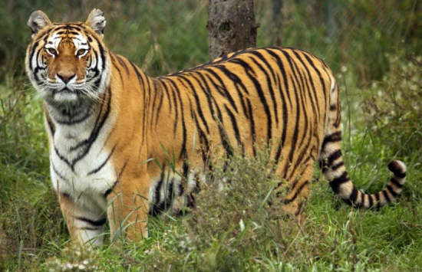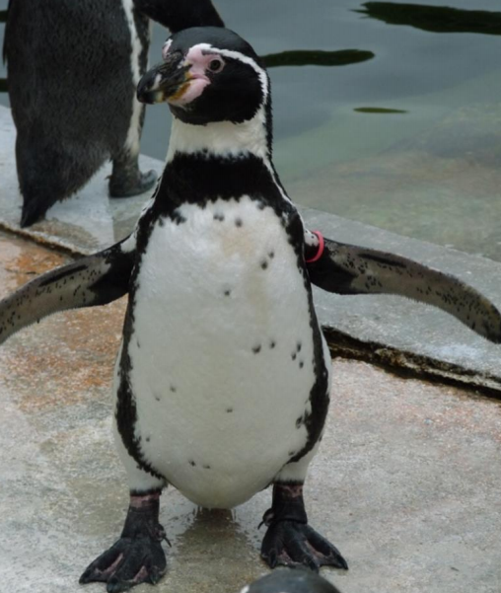 | Science  Animals that eat other animals are called carnivores.  Animals that eat plants are called herbivores.  Animals that eat both plants and other animals are called omnivores. https://www.youtube.com/watch?v=3yrikH2QEFA  - Can you name as many carnivores, herbivores and omnivores as possible?  - Can you record your knowledge in a table or with pictures?  Use the animal fact file link at the top of the page to help you, but also use your own knowledge of animals and any information texts that you can find at home or on the internet.  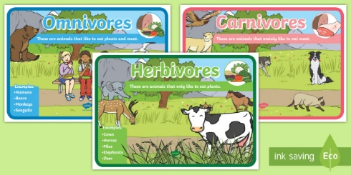
Maths

When we halve something how many equal parts do, we split it into?
Get some scrap paper and cut it into rectangles.
Using your rectangles of paper how can you halve them? Did you need to use a ruler? Or did you use another method?
Use your rectangles to make a paper chain and ask an adult to do the same.
Can you make your paper chain double the length of theirs? How do you know it is double the length?

Challenge: Can you answer these questions about doubling and halving?

- Bob jumped 2 meters in the long jump competition, Dan jumped double the length of Bob how far did he jump?

- Ann got her 20-meter swimming badge and Emma got her badge for swimming half the length of Ann. What swimming badge did Emma get?

- Can you make up your own word problems for someone else to solve?

Music  How many animal songs do you know?  Here are a few to help you:  - Baa Baa Black Sheep,  - Five Little Ducks  - Five Little Speckled Frogs  - Hickory DicKory Dock  - Old McDonald had a Farm  - One Two Three Four Five Once I Caught a Fish Alive  You will find lots more on here: https://www.bbc.co.uk/teach/school-radio/nursery-rhymes-a-to-z-index/z4ddgwx  Practise singing some of the songs.  Can you make props to help you perform he songs?  Can you perform some of the songs to a family member?  Can you learn a new song that you didn’t know before?  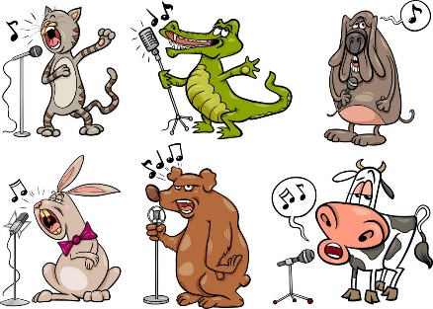 | Art and Design Technology  Look at the fact file from the link at the top of this page and select Africa on the world map.  Look at the photographs of the African animals - tortoise, zebra, cheetah, giraffe, flamingo and ostrich.  Talk with an adult or older sibling about the colours, patterns and textures of the different animals.  Using any art materials that you have at home recreate any of the patterns, colours or textures that you have seen in the photographs.  Once you have explored the variety of patterns of the different animals make a picture of your favourite African animal.  Don’t forget to send us a picture of your art if you can!
Geography

Look at the fact file from the link at the top of this page and find the world map page.
Can you remember the name of the 7 continents? (We learnt about them in 2H’s assembly a few weeks ago!)

Choose one of the continents to find out a little more about - this might be about the animals that live there or the place itself. Here are some good places to look on the internet to help you find out about continents:

https://www.bbc.co.uk/cbeebies/shows/go-jetters

https://www.bbc.co.uk/bitesize/topics/zyhp34j

Make a poster about the continent you have chosen. Things you could include:

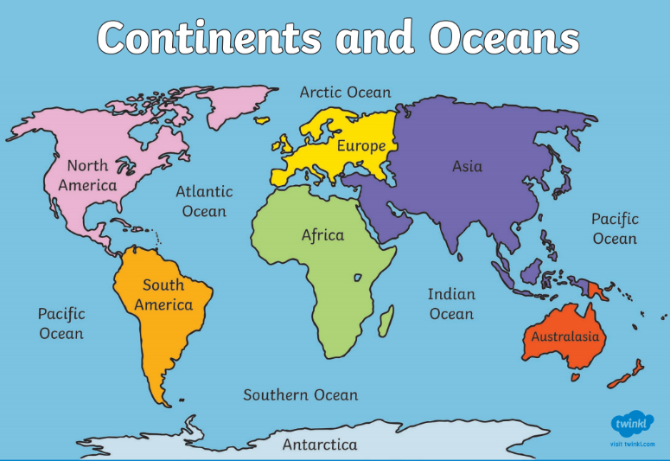
- facts you have learnt
- drawings of animals or landmarks in that continent
- outline of the continent
- how many people live in each continent
- how many countries are in the continent
- photographs of any places you have been

If you can, send us a picture of your poster

