Week 7 Home Activities 3 of 3
Here are some suggested activities you could complete as a family. They are linked to our Early Years Foundation Stage Curriculum and current learning. Have fun and keep well! Please email us your work to:
YearN@highworthcombined.co.uk

Literacy/Communication  Can you go on a letter sound hunt? Choose a sound…wat can you find that starts with the sound a-a-a?  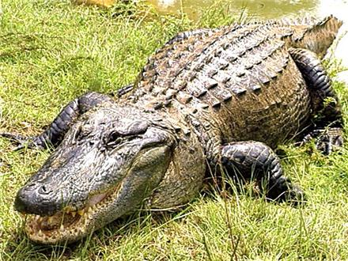 | Mathematical Development  Can you remember the days of the week song? (to the tune of the Adams family –www.youtube.com/watch?v=HtQcnZ2JWsY  Can you sing it to your grown up?  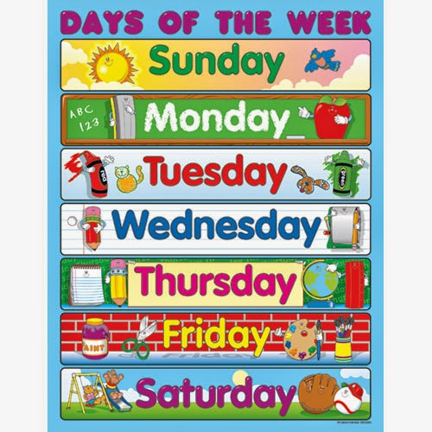 | Knowledge and Understanding of the World  Can make a simple bird feeder to hang outside? Using left over apples, seeds…  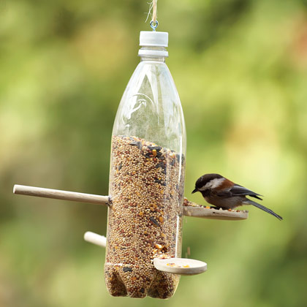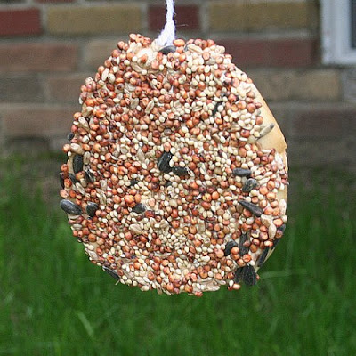
Physical  Please watch the video from Oak National Academy. The children will listen to the story and learn about how germs spread. www.thenational.academy/reception/foundation/germs-reception-wk2-1#slide-2   | Personal and Social  Please watch the video from Oak National Academy. The children will listen to the story and learn about being a kind friend  www.thenational.academy/reception/foundation/kind-friends-reception-wk3-1  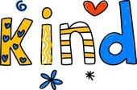   | Creative  Can you have a drawing session with your family? Creating artwork of pets, family members or favourite animals. Can you create a gallery to display artwork?  

