Extra Home Learning – HID Children No 6 - Monday 18th May

To replace some of the tasks in the class home learning you may wish to try some of these. Parents, please simplify or extend depending on needs and age of children. Have fun! There are 5 Attachments. Remember to email me your child’s learning to hid@highworthcombined.co.uk

Signed Story from Mrs Mills  Watch the signed story of ‘Lost and Found’  Read the story on the power point. Do the activities at the end of the power point. They are also listed on the last page below  Year 6: watch the recordings by Mrs Mills on Kensuke’s Kingdom before continuing with English work. The videos are on the website:  - Yr6 KK Chapter 8 (part 1)  - Yr6 KK Chapter 8 (part 2)  - Yr6 KK Chapter 8 (part 3) | Signed Story ‘Ramadan Lantern’  Here is a signed story that links to Ramadan. Click on the link below and scroll down to find the story called ‘Ramadan Lantern’  https://www.longwill.bham.sch.uk/blog-1/categories/storytime  Activities:  - Who do you miss since you have been at home? Make them a card and write/draw why you miss them.  - Can you make a lantern and decorate it?
Game: Guess Which Animal  Get 10 cards and draw an animal on each card. Write the name of the animal as well if you can. Make a head band for each member of your family with a hole on the front to slot in the animal card.  Play the game ‘Guess Which Animal’  - Place all the cards face down and spread out  - Choose one card without looking at it  - Wear your headband and ask a family member to slot the card in so everyone can see it but you can’t  - Ask your family questions about your animal to try and guess what it is | Window  Look at the power point of the story  ‘The Window’  - Watch the power point showing the story.  - Talk about what you can see through the windows to someone in your family  - Choose 3 or more activities from the last page (p15); one has to include some writing.  The power point is on the Website under Hearing Impaired Department
Reading book ‘Hermie the Crab’  Read the power point of the story, ‘Hermie the Crab’ then answer the questions from the story.  There is a BSL story telling video of the story in the Hearing-Impaired section of the website | Looking and Thinking Activity - ‘The Holiday’  Look carefully at the picture below about ‘The Holiday’ and answer the quiz. There are 2 quizzes, A and B. Start with A and if you can, you can do B as well.  See below for the questions and some tasks at the end.
See 5 more pages below:
- Pictures for ‘The Holiday’
- Questions A for the pictures of ‘The Holiday’
- Questions B for the pictures of ‘The Holiday’
- Activities for ‘Window’ and questions for ‘Hermie the Crab.’
- Activities for the signed and power point story, ‘Lost and Found’
Looking and Thinking Activity: The Holiday
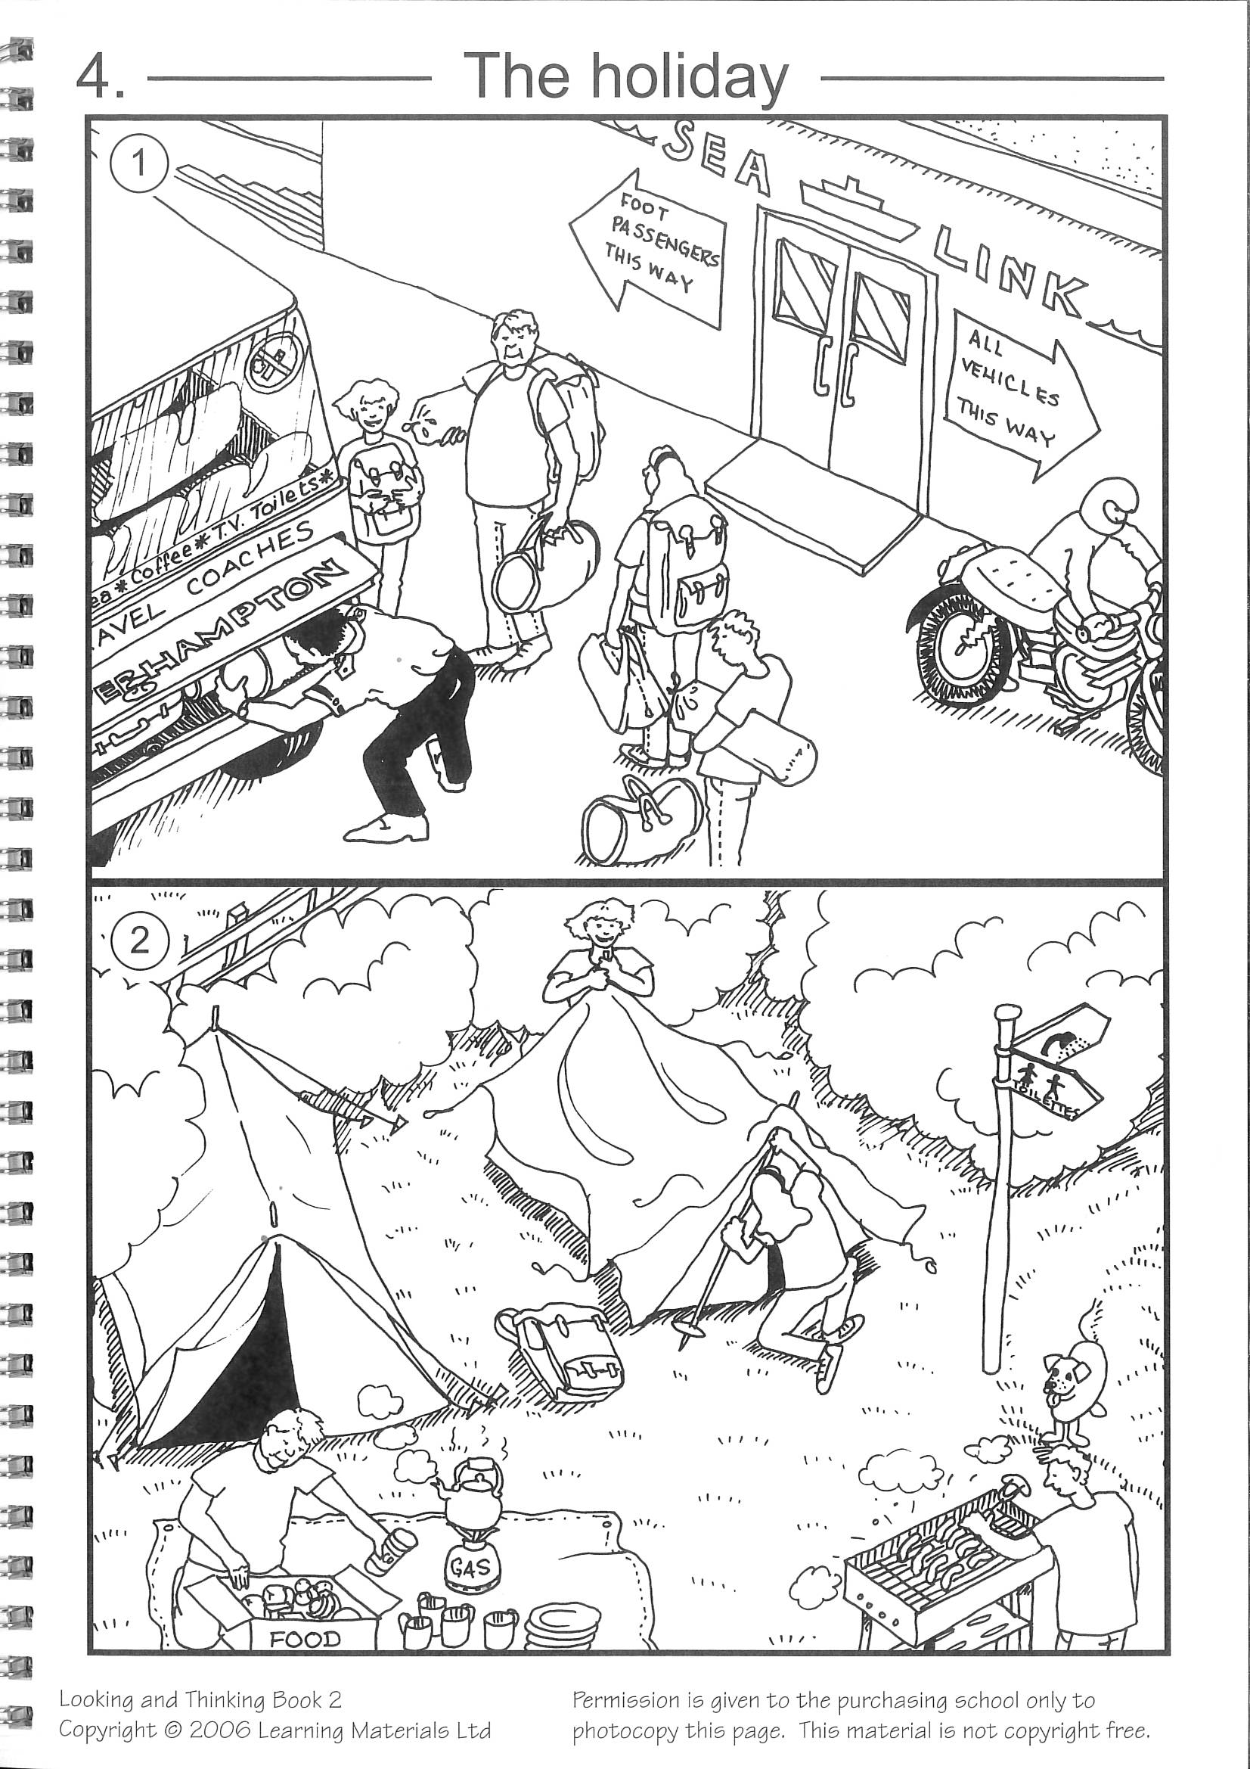

See below for Questions A then Questions B for ‘The Holiday’

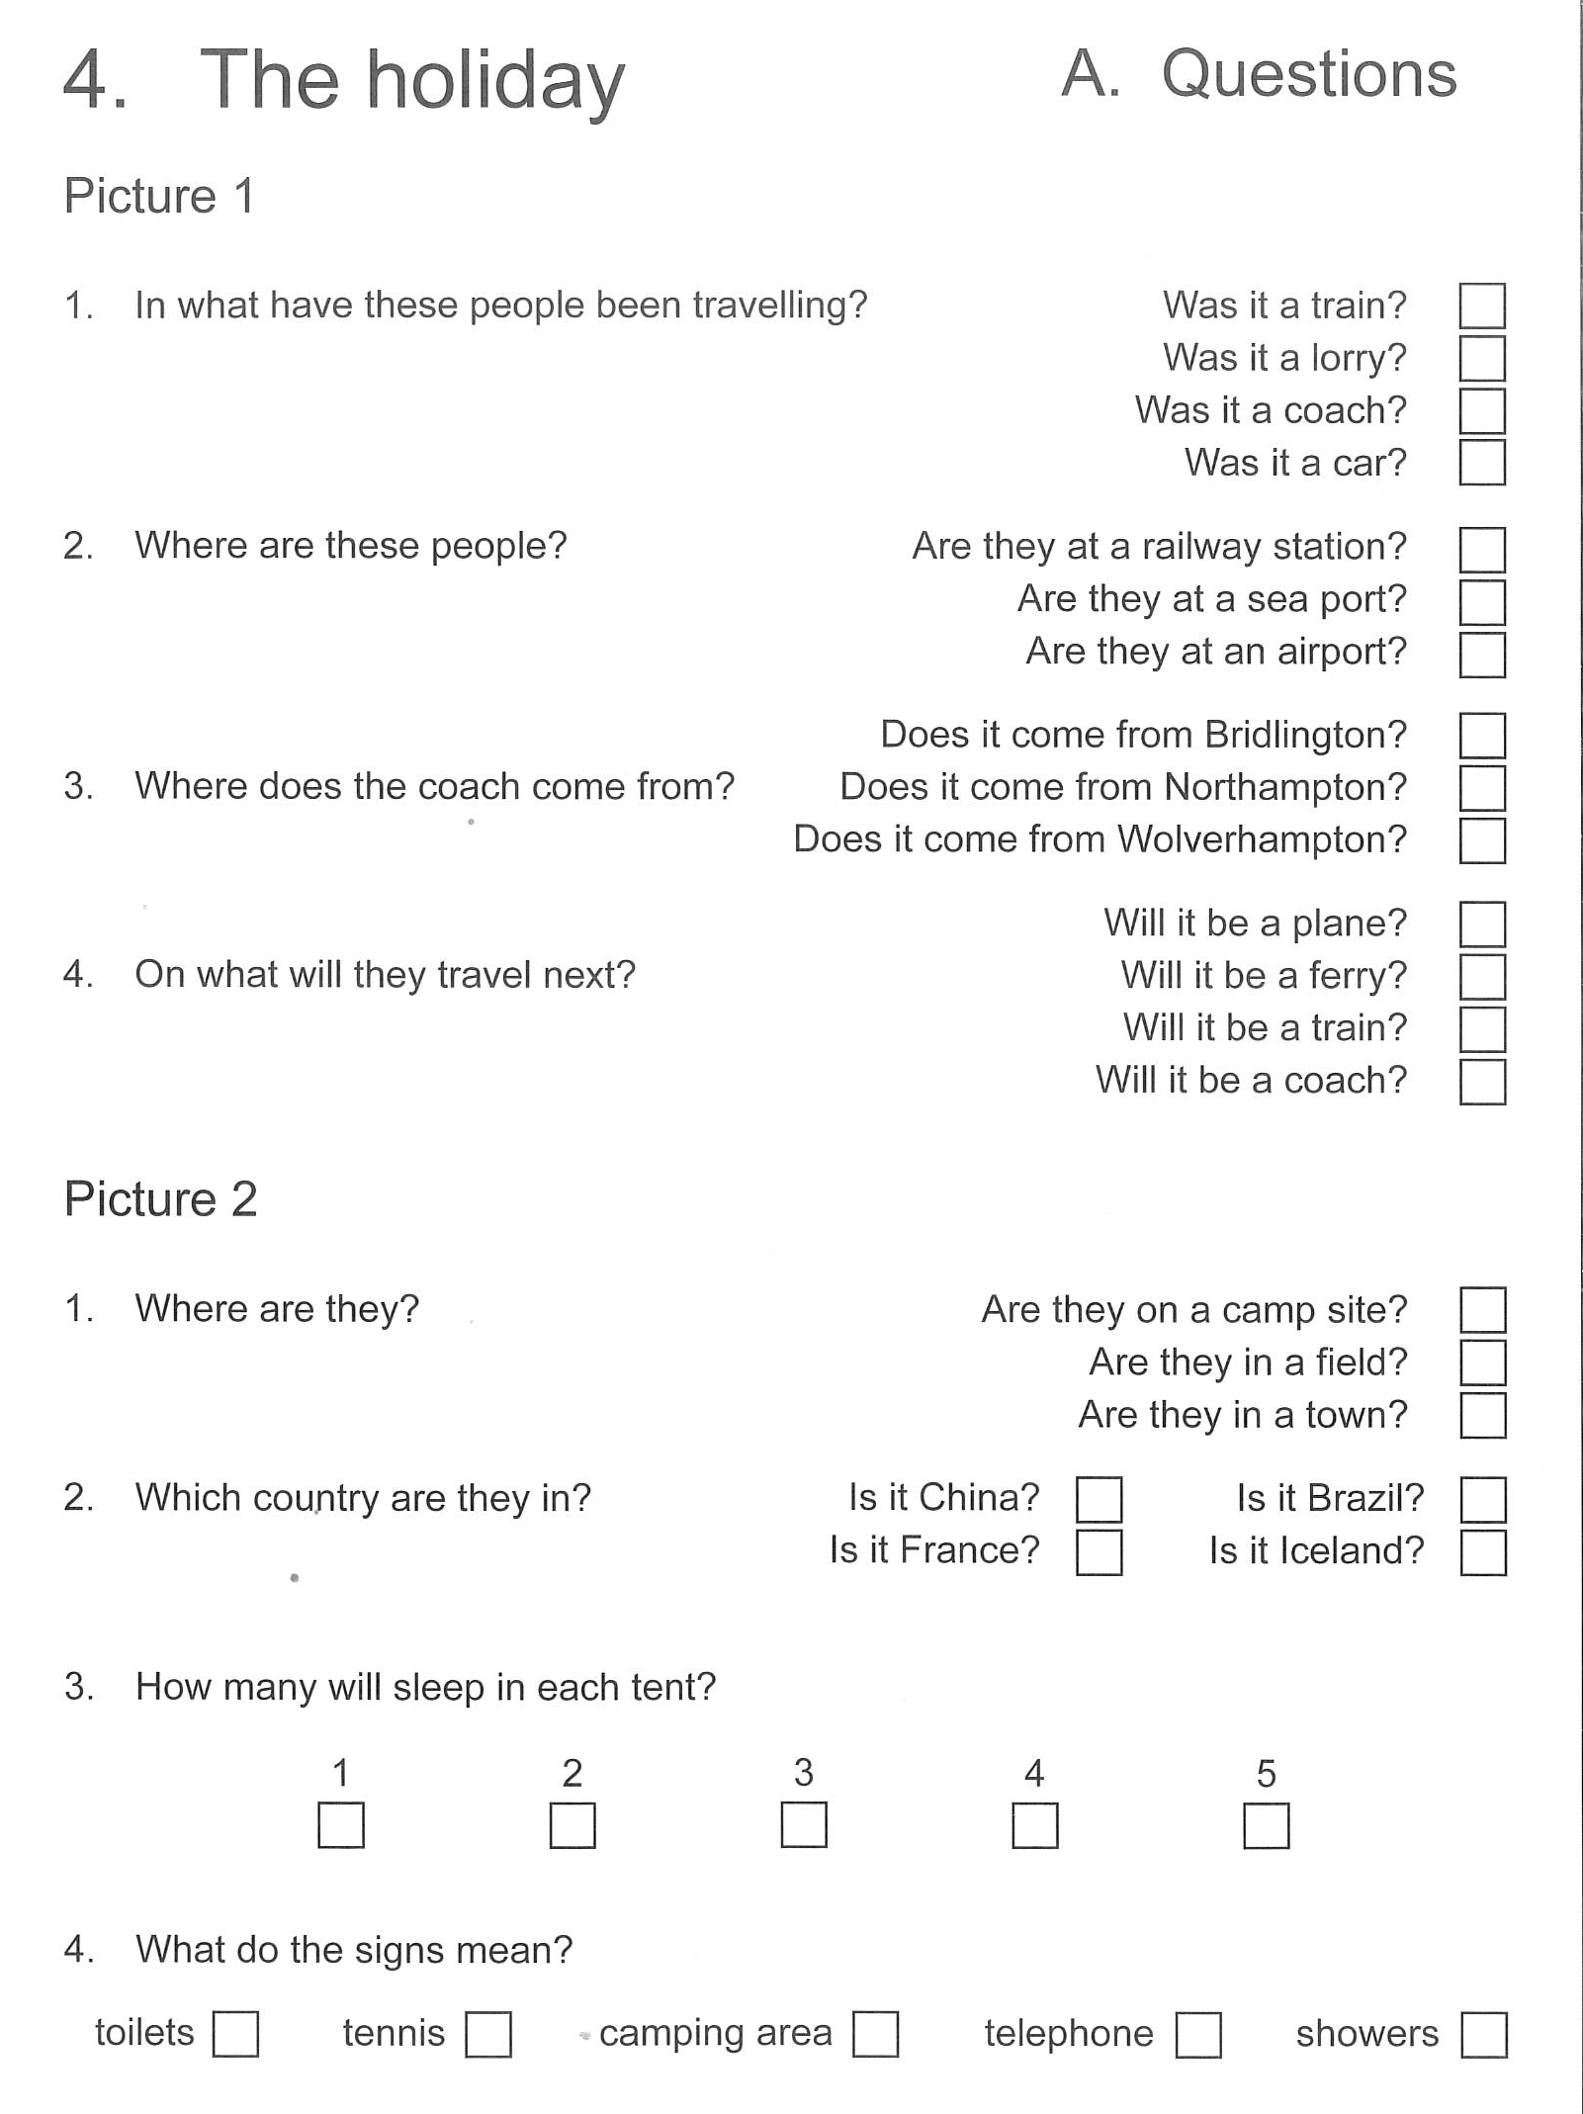

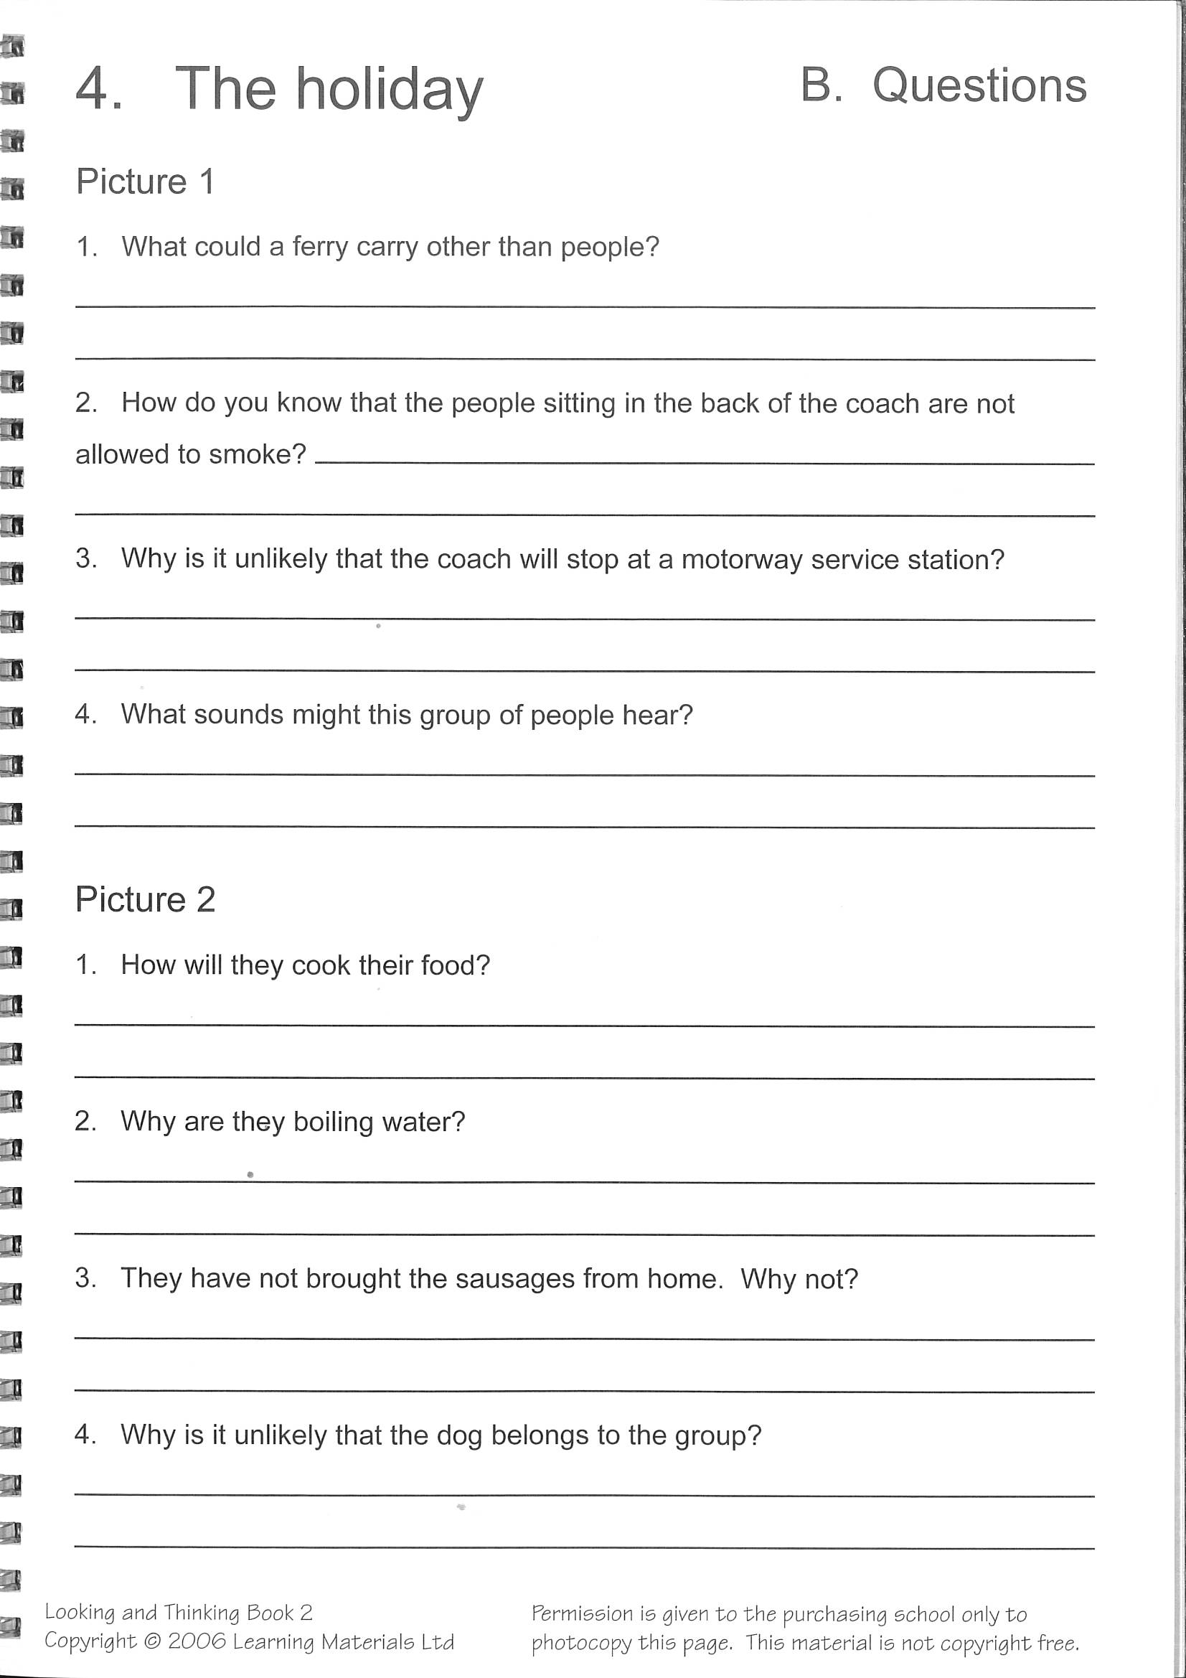

Tasks:
- Make a list of things you need to go on this holiday.
- Make a camp in your garden or lounge. What can you use to make a tent? Draw a picture of your camp site or take a photo.

Activities for the story Window – see Power Point

1) Describe one of the windows by signing and/or writing a description. Send it to me
and I will work out which window it is.
2) Create a picture of the window you like best. You can paint, draw, make a collage…
3) Create a picture of the window you think will come next after the last window in
the book. Show the changes you think will happen.
4) Write one or two sentences for each of the windows saying what is happening outside.
5) Make a time line of the boy in the book and make up dates from when he was born
to his 24th birthday. Draw a long line with dates along the line. Write a caption after
each date to say what has changed where he lives. Take a picture and send it to me.
6) What is outside your window? Create a piece of art showing your window and the
view outside. Include curtains or blinds. Use a variety of materials. Write a
description and/or sign it to me.

Questions for book ‘Hermie the Crab’ –see Power Point and signed story
- Where does Hermie live?

- Where did Hermie come from?

- Who is Alice?

- Why was Alice cross with Ryan?

- What did Alice do?

- Who found Hermie?

What pet would you like? Draw a picture of it and its home, and write a sentence or two about it.

Activities for the story ‘Lost and Found’:

- Making sentences – see below
- Why do you think the penguin went to see Sam? Draw the penguin arriving at Sam’s house and make a huge speech bubble. Write inside what you think the penguin would say to Sam.
- Draw a picture of your friend and around him or her then draw or write the things about your friend that you like.

Cut up the words from these sentences and make the sentences putting the words in order and stick them into your book.
Sentences for Lost and Found Part 1
That night Sam couldn’t sleep.
Sam made a little boat.
The duck didn’t know.
They pushed the boat into the sea.
The penguin helped him.

Sentences for Lost and Found Part 2
One day, they arrived at the South Pole.
The penguin was very sad.
Sam wasn’t happy.
The penguin wasn’t lost.
Sadly, Sam got into the boat.

