Year 2 Home Learning
Week Commencing 18 May 2020- Friday
Ahoy it’s Pirate Day
Please send us your work to: Year2@highworthcombined.co.uk we’d love to see it!

Maths Task
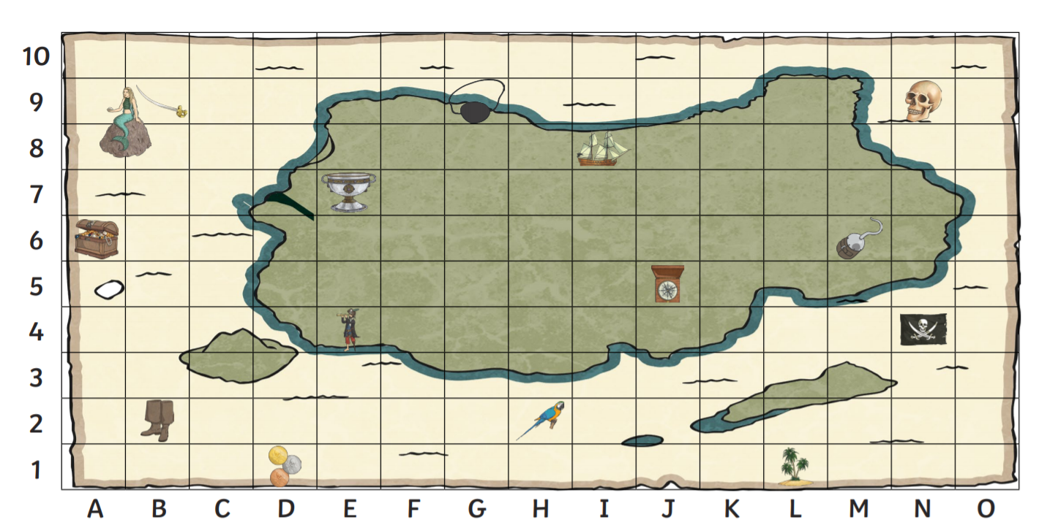
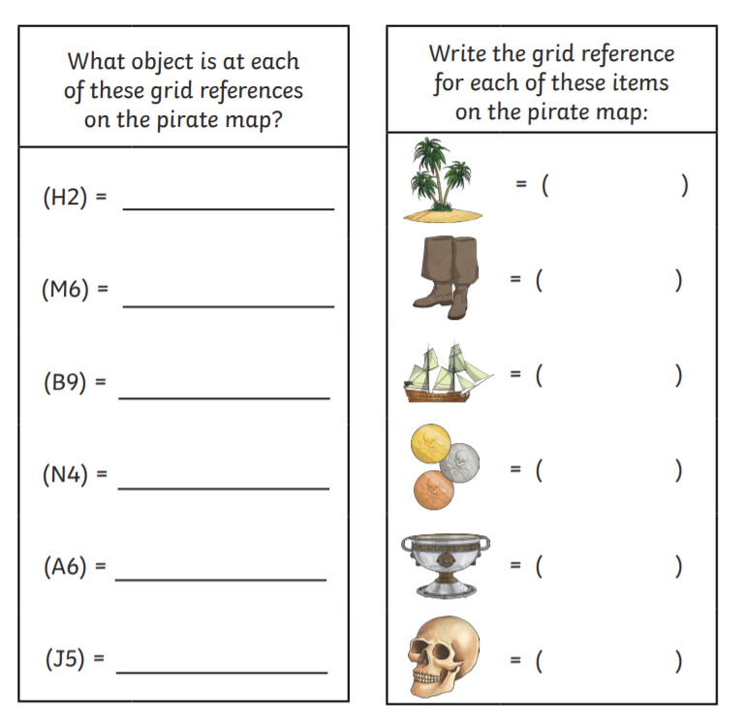

Reading  Alright me hearties, we need to practice our reading. Have a look at the comprehension activity below. Try and read it in your best pirate accent.  https://www.twinkl.co.uk/resource/t-l-53398-60-second-reads-pirates-activity-cards | English  Make a ‘Wanted!’ poster to recruit more pirates for the captain’s crew. Think about the presentation of your poster to make it eye-catching. Make sure you form all of your letters correctly and use lots of adjectives for description.  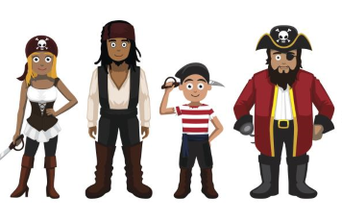
Spelling  Have a look at the words below. Can you spot what suffixes have been added to the words? Write out the different words, put them in sentences, and look for our spelling patterns.  Remember the suffix rhyme:  Is there a letter I need to swap?  Is there a letter to double or drop? 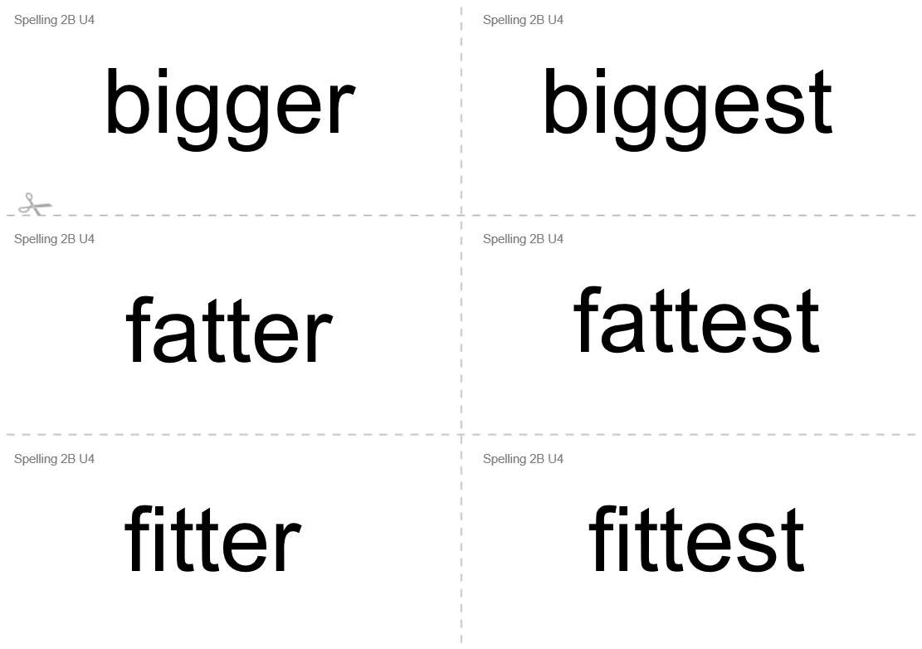 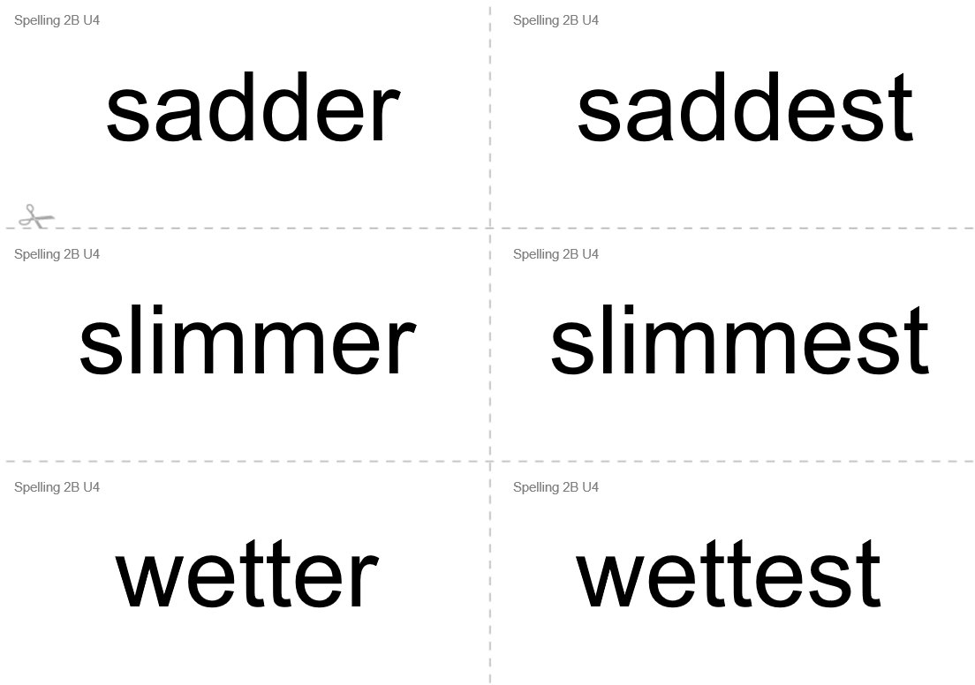  *Pirate Challenge- Go back and look at your English poster. Can you make it better by adding a suffix ‘er’ or ‘est’ to any of your words? | Music  The Pirate Song Tradition  A pirate song would have been chanted, rather than sung, and the words of the chorus would have accompanied a heave or pull for a task such as raising the anchor on the pirate ship.  The Pirate song was known as a sea shanty.  I have attached an example of a song by Jack Hartmann (We listen to lots of his songs in class so have a look at a few others).  *Challenge- can you write you own Pirate song or sea shanty?  https://www.youtube.com/watch?v=cBcrVzY4hDE
Art
Make your own treasure map!
Where will you put your treasure? Is it going to be on an island you create or will you put it in a real place in your house?
What features would there be on the map? You might wish to include a swamp, a lake, a hill or a palm tree.
*Challenge- Now write directions for someone to find your treasure. Can you include at least 5 different spots or hints to direct your person to the treasure?
• Remember to use first, next, then, after that, finally to write instructions.
• Try joining sentences together using words like so, or, but, and.
Family Challenge
Enjoy this Pirate game outside this week.
