Year 1 Home Learning – Friday 15th May 2020
Below, you will find 6 home learning tasks. You may choose the tasks that you wish to complete and do them in any order. Please do not hesitate to contact us if you have any queries or would like to share the work you have been doing.
year1@highworthcombined.co.uk
We have attached several internet links but please always follow the school internet safety policy and always use the internet with an adult. https://www.highworth.bucks.sch.uk/web/children/295423
Design Technology  In a lot of traditional tales food plays an important part in the story.  In Goldilocks and The Three Bears the bears make porridge, in Hansel and Gretel the witch’s house is made out of sweets, in The Enormous Turnip they eat a lot of turnip soup in the end.  Today we would like you to make an item of food. It can be anything you like using the ingredients you have at home. Try and link your food item to a traditional tale.  Don’t forget to follow basic hygiene and cook with an adult to keep you safe.  Challenge –Write the ingredients, equipment and method and tell us which traditional tale your food links to.  Don’t forget to take a photo of what you have made!  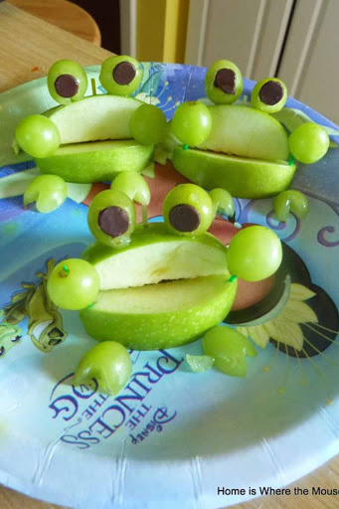  Apple and grape frogs – linked to The Princess and the Frog. | Science  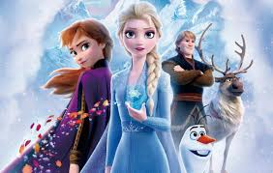  Today we are going to do a science investigation about melting. You will need some ice cubes, warm and cold water, two clear containers (glasses would be good), and a watch or timer.  Make a prediction  Will an ice cube melt faster in hot water or cold water?  The experiment  - Get two clear glasses (containers) of the same size. Fill one glass halfway up with cold water. Fill the second one half way up with warm water.  - Drop an ice cube in each glass.  - Start a timer.  - Watch the ice cubes melt. If you are using a timer, write down the time at which the ice cube in each glass melts.  Results  Which ice cube melted faster? Was your prediction correct? Why do you think this happened?  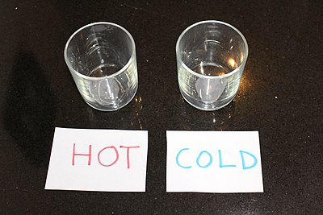  Challenge- what other materials can you think of that melt?
English
Traditional tales are stories about fairies or magical places. They often start with ‘Once upon a time…’, they can have talking animals, princes and princesses, they are often set in a magical kingdom, a land far away, cottage, forest, wood, and end with ‘happily ever after’.

Do you know any traditional tales? e.g. The Three Little Pigs, Goldilocks and the Three Bears, Hansel and Gretel, Jack and the Beanstalk, The Gingerbread Man, The Enormous Turnip, The Three Billy Goats Gruff, Cinderella.

If you have any of these stories at home read them to your adult. You will find some traditional fairy tales on this link with questions to answer about the stories.
https://www.twinkl.co.uk/resource/t-l-52099-traditional-tales-differentiated-reading-comprehension-activity-pack

Now you are familiar with some traditional tales, write your favourite traditional fairy tale. Or make up your own story using the key features of a traditional tale.

Don’t forget a story needs to have a start, a middle an end and needs to make sense.
- Challenge – Can you include some of these words in your writing; enchanted, three wishes, castle, evil, wicked, brave, beautiful, spell.

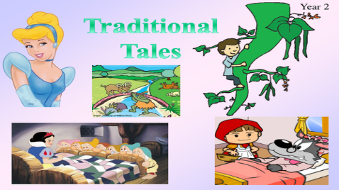

Wellbeing  Breathing activity  - Find a relaxing place, sit comfortably.  - Breathe deeply in and out while paying attention to any sensations you notice or sounds you hear.  - Take another slow deep breath, imagine the air moving down into your lungs and back up.  - Now draw a rectangle in the air with your finger, breath in as you draw the short sides and breathe out as you draw the longer sides. Repeat this drawing other shapes in the air. E.g. hearts, stars etc.  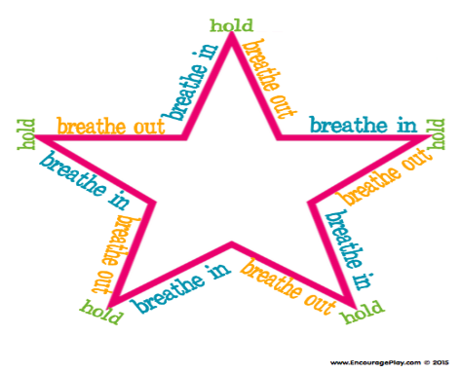 | Maths  Today use the link below to watch the videos and do the activities on BBC bite size maths lesson representing numbers within 50  https://www.bbc.co.uk/bitesize/articles/zb9pnrd
Art

Traditional tales are usually set in magical lands, and make believe kingdoms. We would like you to draw your own magical land. Please be as creative and imaginative as you can.

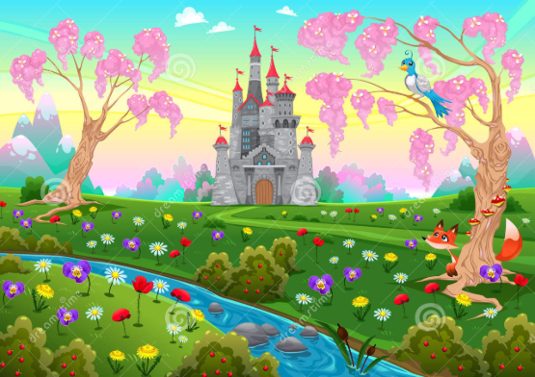

If you can, send us a picture of your magical land !

