Home Learning Ideas for all
Thursday 30th April 2020

Scavenger Hunt
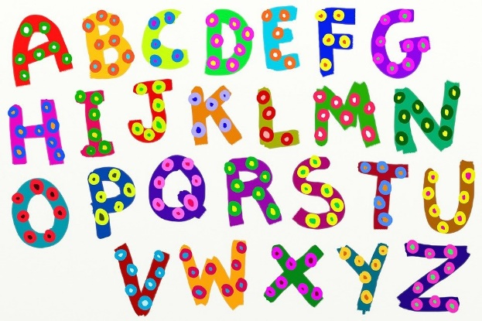
Wind in the Willows the Musical
Do an alphabet scavenger hunt round your house today… can you find 26 items in your house; one for each letter of the alphabet? Good luck finding something beginning with x!

Go for a Hansel & Gretel walk today
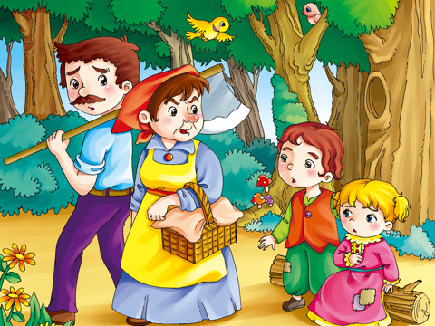
Go for a ‘Hansel and Gretel’ walk. You will need two grown-ups and some bread. Split into two groups. The first group set off and leave a trail of breadcrumbs. The second group wait for ten minutes then set off to follow the trail of breadcrumbs until they find the first group.
This Photo by Unknown Author is licensed under CC BY-NC-ND

Create a Random Sentence!
Use old newspapers, catalogues and magazines to create words and sentences by cutting out different letters and making them into words. If you have glue, you could stick them down onto a piece of paper.

