Year 2 Home Learning – Friday 27th March
For many of our home learning tasks you will need to create a Twinkle account. Please follow the link from our school website.
Use the book sent home or a blank piece of paper to record your work.
Maths Task  See if you can solve the money problems. What would the number sentence look like? Can you show it a different way?  - Ben buys a pen for 34p and a rubber for 12p. How much did he spend?  - Ahmed buys an apple for 15p. He pays with a 50p coin. How much change does he receive?  - Sally has four coins. She has 77p. What coins must she have?  Challenge-  Paul has three 50p coins. He buys two bottles of water for 62p each. How much money will he have left?  Have a go writing your own money word problems. | English Task  I went for a walk with my family, and I spotted a sign. It reminded me of a book. Can you guess what book I was thinking about?  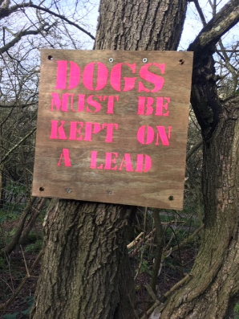  Stickman- That’s right! Have look around and see if you can spot anything that reminds you of a book. Send us a picture of what you spotted and tell us what book you were thinking about.
SPaG/ Spelling  Contractions- Look at the following words. Join them together and write the contraction. Then write a sentence using each one.  Example- He will -> He’ll.  ----- He’ll be happy with his new books.  -I will  -Do not  -I am | Reading Comprehension  Twinkle activity  Spring Comprehension Activity  https://www.twinkl.co.uk/resource/ks1-60-second-reads-spring-activity-pack-t-l-9207  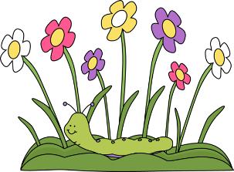
Geography  Watch an episode of Go Jetters. It’s on weekdays on Cbeebies at 8.00am and 4.50pm or download on BBC iPlayer.  Write about the different places visited in the program. What continent did they travel to? What is special about the place they visited? | App/ game  Topmarks  Follow the link below.  Click on ‘Counting’ box, then choose ‘any 5 coins’ box.  https://www.topmarks.co.uk/money/coins-game  Happy playing!

