Extra Home Learning – HID Children No 11 - Monday 29th June

To replace some of the tasks in the class home learning you may wish to try some of these. Parents, please simplify or extend depending on needs and age of children. There’s more signing from Mrs Mills and Longwill School for the Deaf has made an excellent singed presentation explaining to young children about the Coronavirus at this link: https://www.longwill.bham.sch.uk/blog-1/categories/storytime
You will need to click on the image several times to get it started but it is worth it!
Don’t forget to email me your child’s learning to hid@highworthcombined.co.uk

Signed Story and Book from Mrs Mills –  ‘Puppy at the Door‘  Watch the signed story and  then read the story on the  Power Point.  There are activities to do  Below and at the end of  The power point | Topic Wordsearches:  Some fun word searches related to the science topics you have been learning. See below for:  - Yr2 – Geography - Antarctica  - Yr3 – Science Digestive System and Teeth  - Yr4 – Stonehenge  Can you remember the signs for the words on the word searches?
Signed Story ‘Dave The Dog’:  Dave the dog is worried about Coronavirus and he gets some tips from Nurse Dotty who explains what is happening with Coronavirus. Watch by going to the link below:  Click (and press control) to go to the link:  https://www.longwill.bham.sch.uk/blog-1/categories/storytime | Looking and Thinking Activity – ‘The Map’  Look carefully at the picture below of a castle.  There are 2 quizzes below, A and B. Start with A and if you can, you can do B as well.
HID Afternoon Activity: - I Miss You Flower
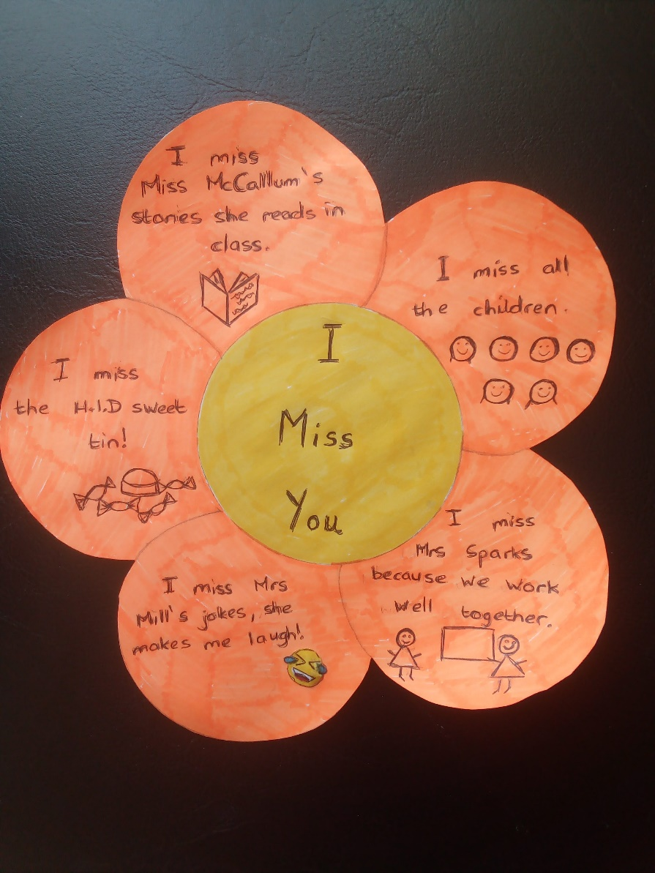

Draw a big flower and write in the middle:
‘I miss you.’
Then think of all the things and people you miss
from Highworth and say what you miss about them.

You can draw pictures or colour it any way you like.

Here is one that Mrs Randall made:

See 7 more pages below:
- Activities for story, ‘Puppy at the Door’
- Antarctica Word search
- Digestive System Word search
- Stonehenge Word search
- Looking and Thinking picture for ‘The Map’
- Questions A for ‘The Map’
- Questions B for ‘The Map’

Activities for ‘Puppy at the Door’ – see Power Point

Questions:

- Why couldn’t Grace and Amy have a pet?

- What did Amy find at the door?

- How did they know who to phone?

- Who came to pick up the puppy?

- Why did Mrs Hope take the puppy to puppy school?

- Why do you think Mrs Hope asked the girls to come to the puppy school?

Activity:
Do you have a pet? Draw a picture and describe your pet. Write about the things you have to do to look after it, where it lives and what it eats, and how you play with your pet.
If you do not have a pet, draw a picture of what you would like to have and write about it.
You can make a poster or a booklet about your pet.

Year 2 – Geography- Antarctica

c e q u a t o r h w

o s n i u g n e p a

n x o t w q a m c r

t k s l y r z i o m

i p j n c v t o l e

n a q t b c r y d r

e v i f r t x u e n

n c z a p o l h r j

t h t u o s e a l s

s n o m l y g p s k

a b l u e w h a l e

antarctica warmer equator
south arctic penguins
pole continent seals
colder blue whale

Year 3 – Science- Digestive System/Teeth

x z s t o m a c h digestive system

r i g a v i l a s stomach

o n h d c k b w e small

s t b t q h x f v large

e e t e s e e r i intestines

n s u e p g s w t saliva

i t c t b r r u s chew

n i p h z a a y e teeth

a n s m a l l f g incisors

c e x q j w o p I molars

f s y s t e m y d cut

i n c i s o r s w canines

Year 4- Science- Stonehenge

h l g c i r c l e n

e e o h s e s r o h

e w c i h q f v z w

l u t f a y a b p i

r s d z p r k m d l

s t o n e a g e w t

w y g v s e n o t s

a g i z b x j v c h

l r c q l u b x f i

e k b y u a l t a r

s t o n e h e n g e

m e w p n e s r a s

Stonehenge Altar Wales shape
Wiltshire Heel River Avon
horseshoe Sarsen Blue
circle stones Stone Age

Picture for Looking and Thinking Activity: ‘The Map’
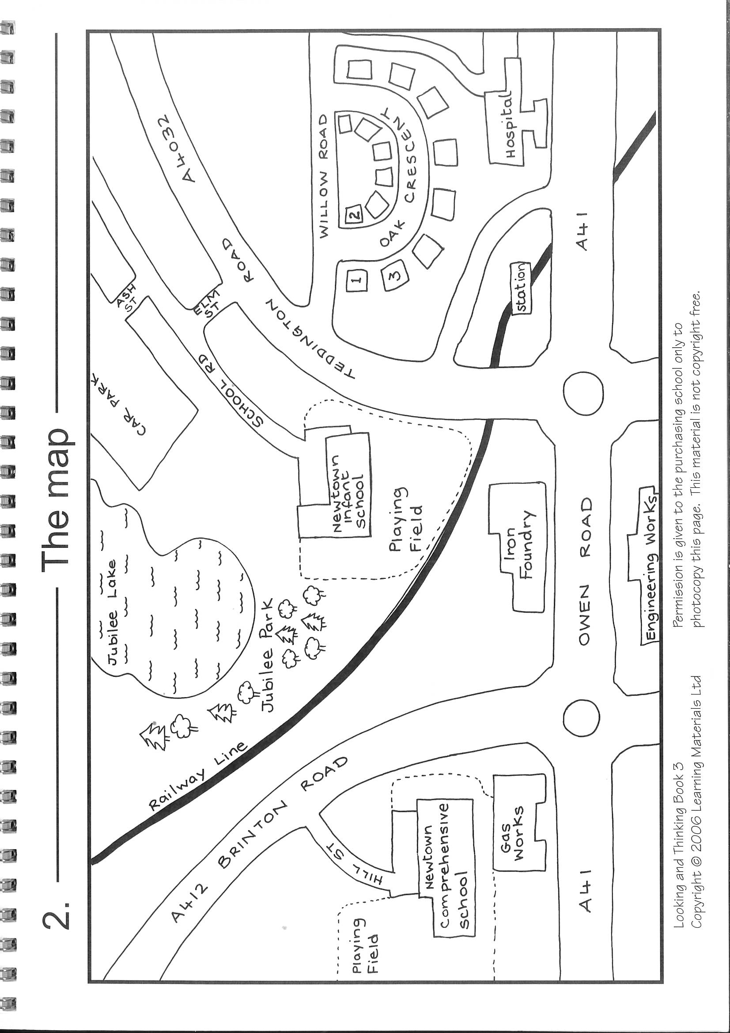

See below for Questions A then Questions B for ‘The Map’

Questions A for ‘The Castle’
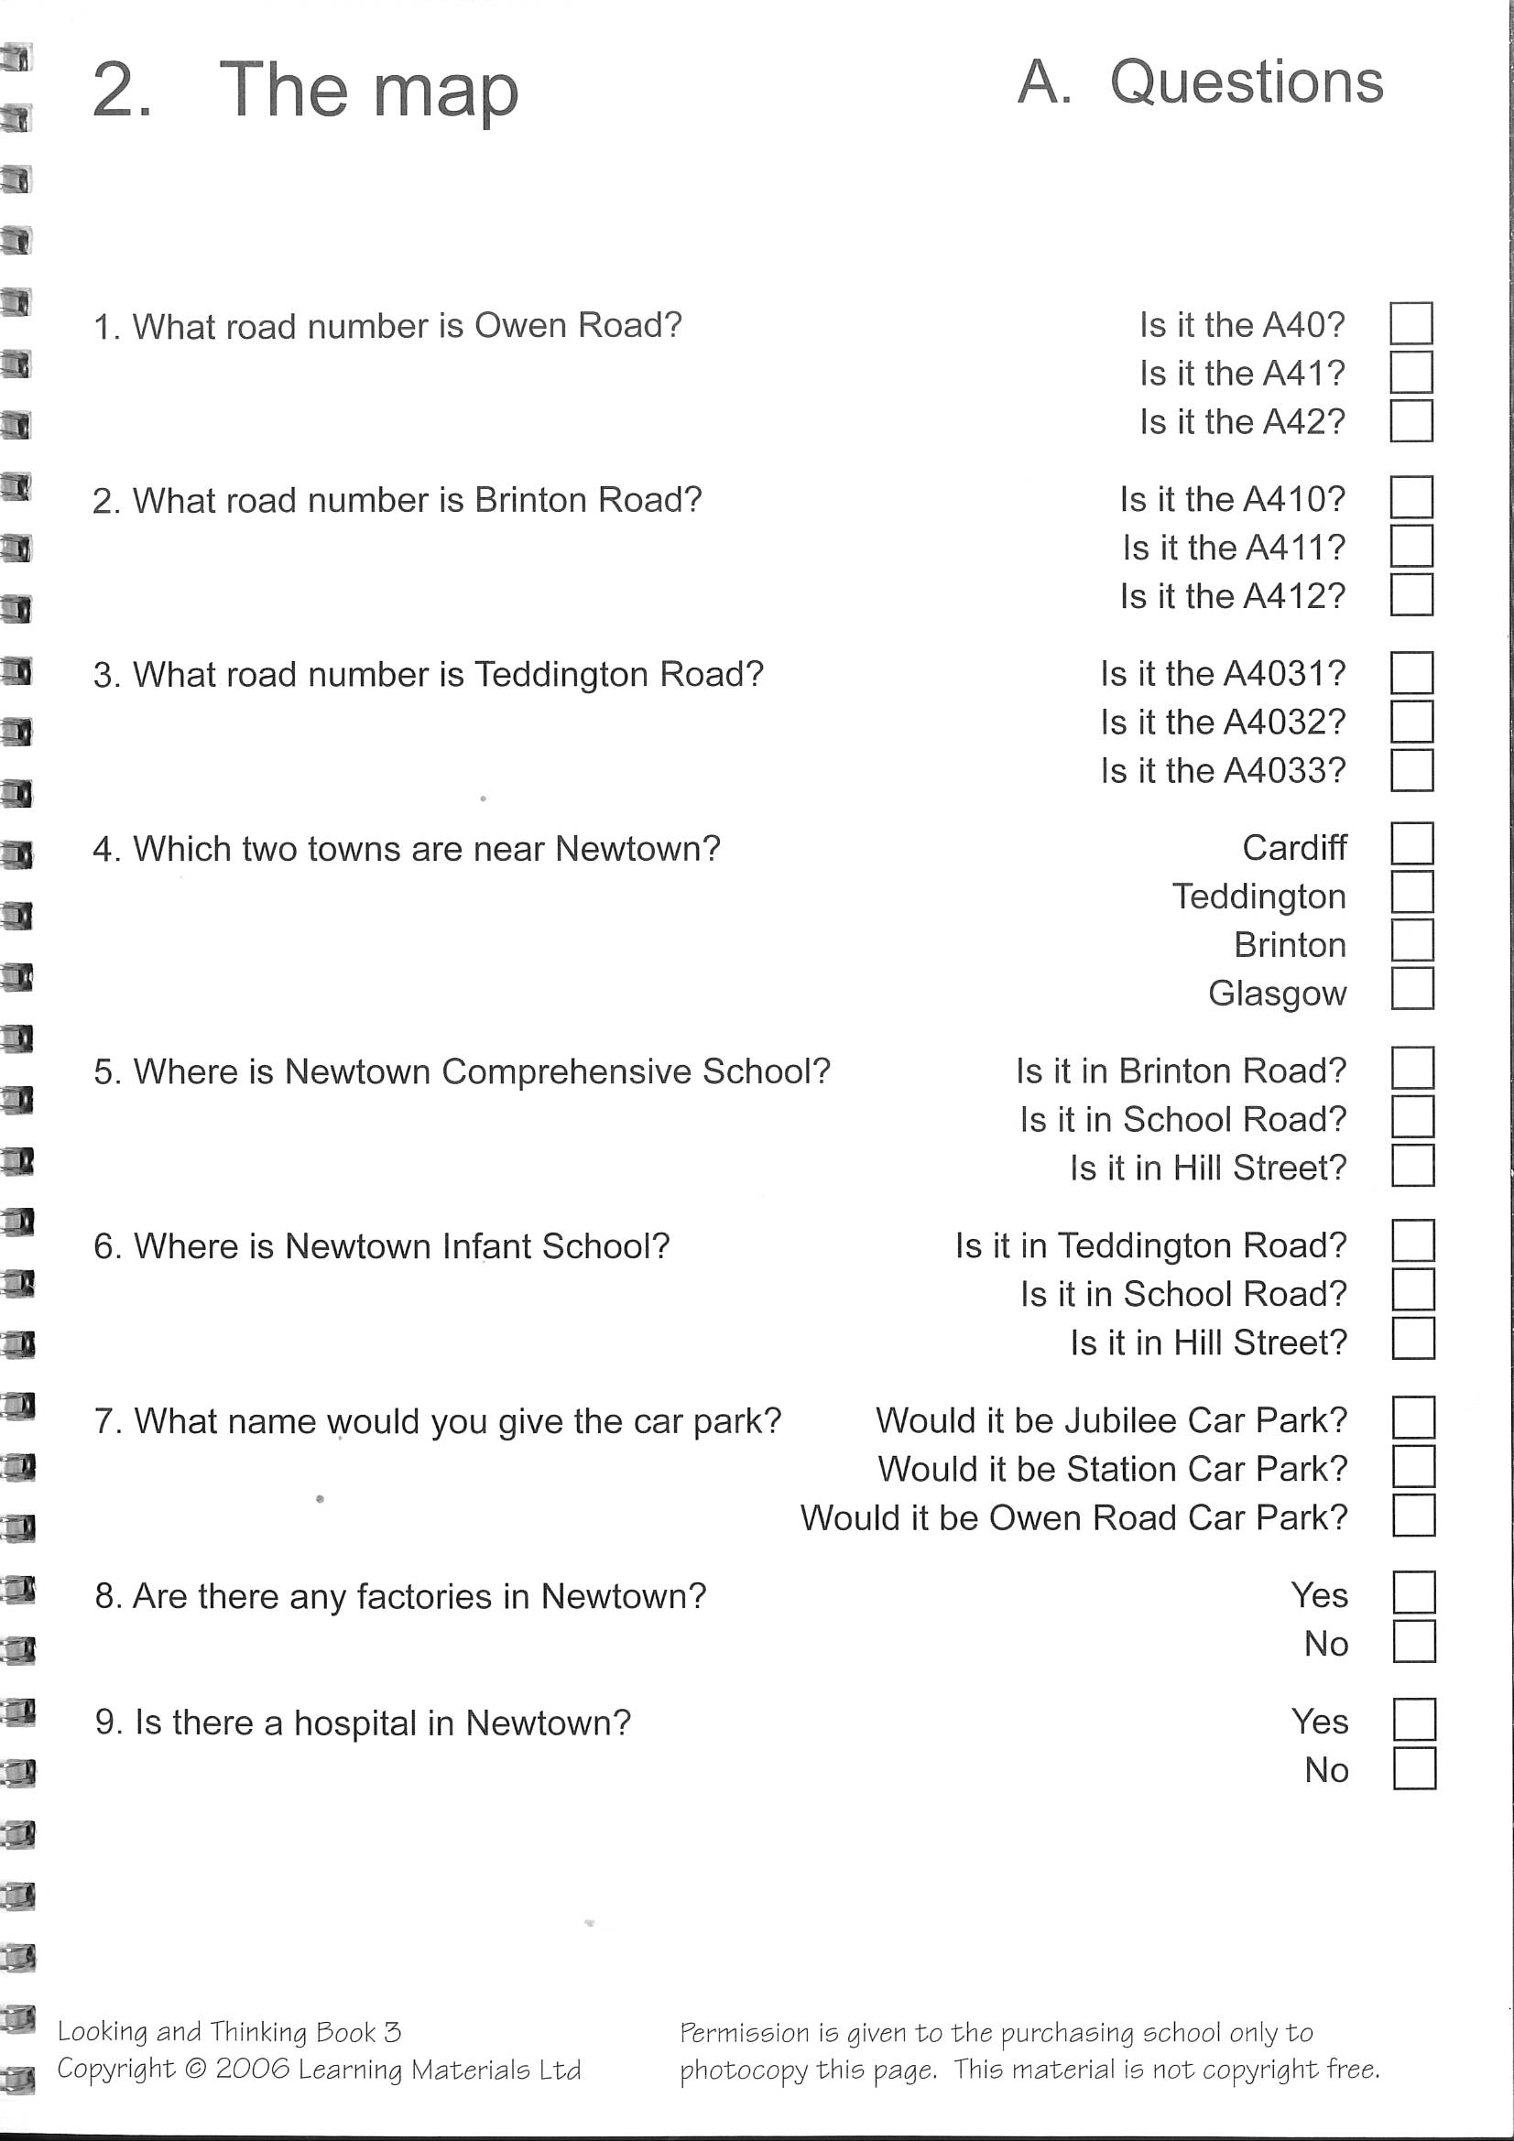

Questions B for ‘The Map’
