Year 5 Home Learning – Wednesday 20th May 2020
ENGLISH  We hope that you had fun completing the comic strip and collage to add to your virtual Time Capsule.  Let’s carry on:  Look at the document – TIME CAPSULE PROJECT- that you used on Monday and Tuesday.  Now try: ‘How I stay connected’ for Wednesday and ‘How I learn’ for Thursday. There are lots of ideas to get you started. |  | MATHS  Number Knowledge  Look at the number pyramid (scroll down).  How can you arrange the numbers to get :  1) the highest possible outcome at the top (summit) and  2) the lowest possible outcome at the top (summit).  You can make it a bit easier by removing a box or from the bottom or more challenging by adding a box to the bottom.
WONDERFUL WORDS
Look at the Year 5 & 6 Words List. You can find it as a link on our Coronavirus Closure, Home Learning Matrix, Year 5 tab: https://www.highworth.bucks.sch.uk/web/year_5/460996

Choose 4 or 5 words to practise at a time.
- Look up the definition in a dictionary to check the meaning of each word.
- Learn the correct spelling by using: Look, Say, Cover, Write, Check.
- Write a sentence which includes the word to show that you understand its meaning.
4. Challenge yourself to include a PLURAL word which requires a POSSESSIVE APOSTROPHE
in each of your sentences but BE CAREFUL because both of these are correct:
The teachers’ muscles were aching after their run. The children’s muscles were aching after their run.
SCIENCE VOCABULARY FUN  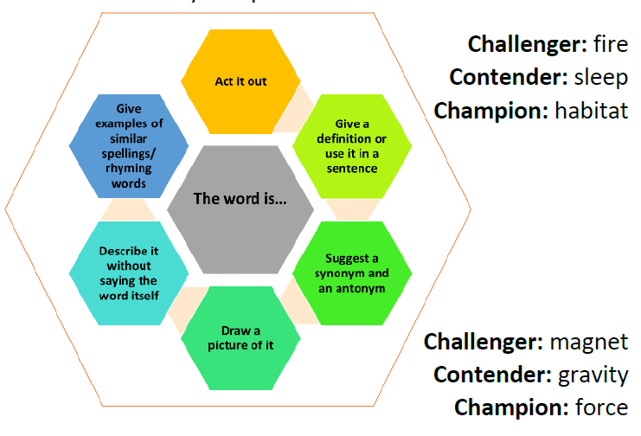  Try this game (Ask a family member to join in). Start with ‘Challenger’ and move on to ‘Champion’.  (There is a copy if you scroll down.)  Think about other words that you could use from Earth and Space and Properties of Materials. | HISTORY  Mosaics became popular from the first century AD.  The Romans used mosaics to decorate their homes.  Artists first drew the design, then spread some plaster and pressed small stones or coloured glass or stones onto it.  Let’s try our own:  Draw a design.  Tear paper into small squares.  Glue the squares into your design leaving small gaps between the squares. |  | Read Aloud  We are sure that you all enjoyed listening to the lovely stories from some of the adults on our school website.  Why don’t you do a read aloud?  Choose a short story or paragraph from a book that you really enjoyed.  Ask an adult to film you reading aloud and we’re sure that you will be impressed with the outcome.  You could even use some props if you wanted to.  You could send it to us but ask an adult for permission first!
In addition to the tasks above, please remember to spend 10 minutes reading every day!

