Extra Home Learning – HID Children No 3 Monday 27th April

To replace some of the tasks in the class home learning you may wish to try some of these. Parents, please simplify or extend depending on needs and age of children. Have fun! There is an email address prepared for you to use. Go to Signed Stories and use the arrows to find the story ‘Handa’s Surprise.’ For the Letter Bingo game print out the Bingo letter boards.

Signed Story ‘Handa’s Surprise’  Watch the signed story of Handa’s Surprise.’ Watch the questions at the end:  1. What is the name of Handa’s friend?  2. What 7 fruits did Handa put in her  basket?  3. What fruit did the elephant take?  4. What fruit did the giraffe take?  Can you teach your family the signs for the different fruits and animals in the story?  Can you make a picture, painting, collage of a basket with your favourite fruit? | Treasure Island Map and Game  Make a Treasure Island map on squared paper. Make a copy of it for a member of your family. Make 2 small treasure chests to put on your maps.  Game:  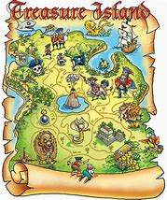  Put the treasure chest on  Your map and let someone guess  Where it is by asking questions or  You giving directions. Then you  Guess where their treasure is.  You can time it and see who finds  the treasure the quickest! Don’t  let them see your map during the game.
Treasure Hunt  Hide 5 objects around your house. Let members of your family find them. Who can find them first? You must give them instructions where to go. You can:  - Sign instructions  - Write instructions or clues  - Draw a map showing them where to go | Make a Board Game  Make your own board game with numbers and make cards that players need to  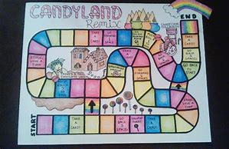  pick up when they land  on a number and do what  it says, e.g.  Sign 3 animals then  move forward 3
Guess Which Animal  Play ‘Guess Which Animal’ with people in your family.  Choose 3-5 different toys and put them on a table. Pick one and describe it to someone in your family and they have to guess which one you are describing. Don’t tell them which one it is. They have to guess. Then others can have a turn and you guess which toy they are describing.  You can describe:  - Colour  - Size  - Parts of the body, eyes, nose, ears, legs  You can video this and send it to me so I can guess which toy you are describing.  You can write a description using cloud words and ask someone to guess which toy. | Alphabet Bingo  Play alphabet bingo! Write out the alphabet from a-z and cut up to make cards to call out or sign.  Print out the attached bingo letter boards. There are 7 boards. Use counters or cut up paper or card to cover the letters on the boards.  When you have found your letter, you can:  - Sign the letter  - Say the sound of the letter  - Say which letter comes before or next in the alphabet  - Say or sign a word that starts with that letter

