Isolation Activity Ideas

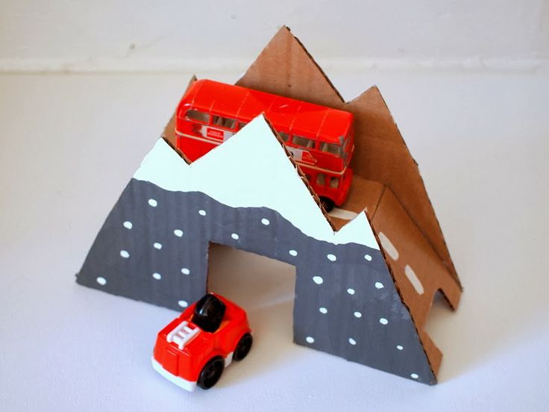
Creative Ideas
Activity | Yes | No | Maybe | Done
Craft (google ideas)

Make Playdough, saltdough or slime (see below)

Drawing and painting

Junk modelling

Collage making

Paper chains

Finger/potato printing

Homemade marble runs/tracks

Den building

Lego/construction

Story/poem writing

Origami/paper planes

Role Play and theatre shows with toys

Singing/karaoke

Basic home science experiments

Learn magic tricks

Face painting

Sock puppets

Design a magazine/newspaper

Make a time capsule

Make a happy thoughts jar/boxes/journals

Painting with unusual objects

Play shops

Write a diary or make an isolation survival book

Go tree/surface searching/rubbing with crayons

Dressing up

Physical Activities
Activity | Yes | No | Maybe | Done
Yoga

Exercise (youtube workouts)

Treasure Hunts

Dance party

Obstacle courses

Indoor skittles

Charades

Teach them a dance routine

Indoor picnics

Indoor camping

Play hide and seek

Play party games

Go for a walk/hike in open space – National Trust sites are opening their grounds for free!

Pick a colour and find how many objects of that colour you can find in your house

Life Skills

Activity | Yes | No | Maybe | Done
Cook dinner with the children

Sort/organise a room at home

Make bread

Reorganise cupboards/drawers/rooms

Teach them basic DIY skills

Practice basic mathematics – money/budgeting etc

Cooking & baking & menu planning

Helping cleaning/hoovering

Teach them to tie their laces

Teach them to use the washing machine

Teach them how to change their bed sheets

Quiet Activities

Activity | Yes | No | Maybe | Done
Send emails/letters/pictures to your friends and family

Board games and jigsaws

Teach them to braid hair

Handwriting practice – to do lists/ shopping lists etc

Read to the children

Get them to read to you

Have a PJ day

Have a movie day

Look through old photos and memory boxes

Emotional Wellbeing

Activity | Yes | No | Maybe | Done
Have a tablet/console/phone free day

Mindfulness exercises

Pamper evening

Gratitude treasure hunt (see below)

Resilience bingo (see below)

The five senses exercises (see below)

Meditation

Research and find your favourite positive affirmation or quote

Make a worry bag/jar/box and write or draw your worries and place inside

Learn a new skill or try something new

Stay active

Recipes
Playdough
Ingredients
1 cup plain (all-purpose) flour
½ cup salt
2 tablespoons cream of tartar
2 tablespoons vegetable oil
1 cup water with food colouring added
1 teaspoon vanilla essence (optional but it makes the play dough smell nice!)
Method
Put all the ingredients into a large saucepan, and stir over a medium heat until the dough forms into a ball. Allow to cool, and then knead until smooth.
Store in an airtight container (a Ziploc bag with the air pressed out is good).

Slime
Ingredients
PVA Glue
Bicarbonate of Soda or Baking Powder
Contact Lens/Eyewash solution that contains borax in the ingredients
Method
Squirt PVA glue into a bowl
Add a pinch of Bicarb or baking powder
Add 2-3 drops of lens/eyewash solution
Stir until totally mixed together and it starts to get stiff
Knead together in bowl
Add any food colouring or glitter and

Saltdough
Ingredients
1cup salt
2 cups all-purpose flour
1 cup luke warm water
Method
In a large bowl mix salt and flour.
Gradually stir in water. Mix well until it forms a doughy consistency.
With your hands form a ball with your dough and kneed it for at least 5 minutes. The longer you kneed your dough the smoother it will be.
Store your salt dough in a air tight container and you will be able to use it for days.
You can paint your creations with acrylic paints and seal with varnish or polyurethane spray. You can let your salt dough creations air dry, however salt dough can also be dried in the oven.
Bake at 200 F until your creation is dry. The amount of time needed to bake your creations depends on size and thickness; thin flat ornaments may only take 45-60 minutes, thicker creations can take 2-3 hours or more. You can increase your oven temperature to 350 F, your dough will dry faster but it may also brown, which won't matter if you are painting your entire creation (you can also cover your dough in the oven before it turns brown.

Gratitude Treasure Hunt:
Something that makes you feel happy
One thing you love to smell
Something you like to look at
One thing that tastes good
Something that is your favourite colour
Something that makes you smile in nature
One thing that is very useful for you
One song that makes you happy
Something to give to someone else to make them smile

Resilience Bingo
Find one item that makes you feel calm and happy
Think of a time you felt really happy
Take a deep breath in and breathe out slowly
Give yourself a hug
Get a drink of water and look after your body
Find a place at home that makes you feel calm and happy and sit there for a minute
Tell someone you love how important they are to you
STOP! Take a minute to think about what is happening

The Five Senses Exercise
Something you can SEE
Something you can HEAR
Something you can TASTE
Something you can FEEL
Something you can SMELL
Some useful links:
https://childmind.org/article/talking-to-kids-about-the-coronavirus/

https://www.bbc.co.uk/newsround/51342366

https://krisepsykologi.no/what-can-we-say-to-children-about-coronavirus/

https://www.twinkl.co.uk/

https://www.woodlandtrust.org.uk/blog/2020/03/nature-detectives/

https://positivepsychology.com/mindfulness-for-children-kids-activities/

