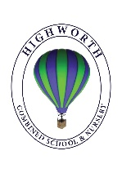
Home Learning Ideas for all
Tuesday 21st April 2020
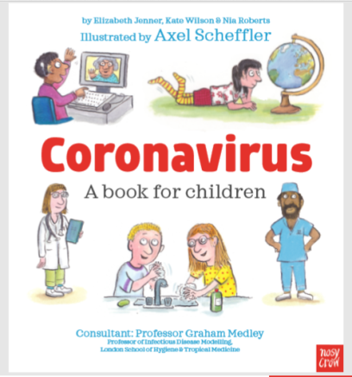
Coronavirus story for children

Axel Scheffler (illustrator of The Gruffalo) has illustrated a digital book for primary school age children about the coronavirus and the measures taken to control it. The free digital book answers key questions which your children may have in simple, child friendly language. https://nosycrowcoronavirus.s3-eu-west-1.amazonaws.com/Coronavirus_ABookForChildren.pdf

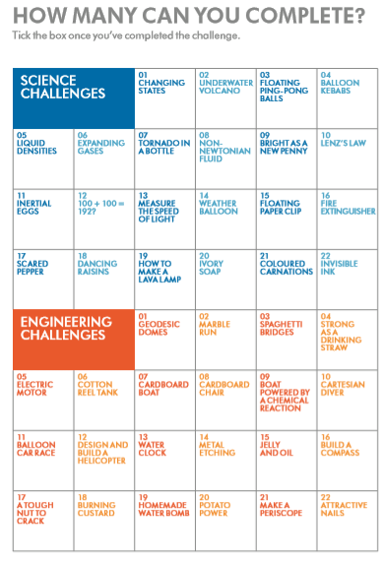
Dyson Challenges! https://www.jamesdysonfoundation.co.uk/content/dam/pdf/JDF_with%20cover%20challenge-cards_DIGITAL.pdf

Dyson engineers have designed challenges to encourage inquisitive young minds to get excited about engineering. How many challenges can you complete? We would love to see photos of you completing a challenge!

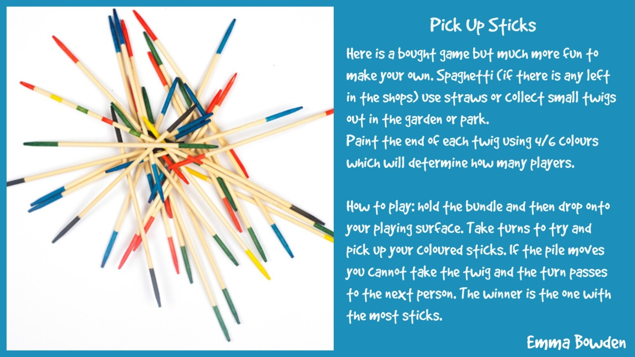
Pick Up Sticks!

