Week 5 Home Activities 1 of 3

Here are some suggested activities you could complete as a family. They are linked to our Early Years Foundation Stage Curriculum and current learning. Have fun and keep well!
Physical  Can you jump like a Kangaroo? How many kangaroo jumps can you do in 30 seconds? Ask an adult to time you.  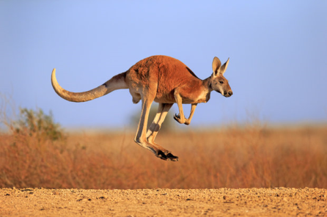 | Personal and Social  Can you help your family with daily chores? Can you set the table for dinner? Can you help sort the recycling? Can you tidy away your toys/books? Draw a picture of all the different ways you have helped at home. How did it make you feel to be a helper? | Creative  Make a colourful collage picture. You could use old fabric, paper, cardboard boxes, foil or even natural materials from the garden like petals, leaves to make your picture.

Literacy/Communication  Tell your family the story of ‘Goldilocks and the Three Bears’. What did Goldilocks do in the bear’s house? What happened when the bears came home? Try using different voices for the different characters.  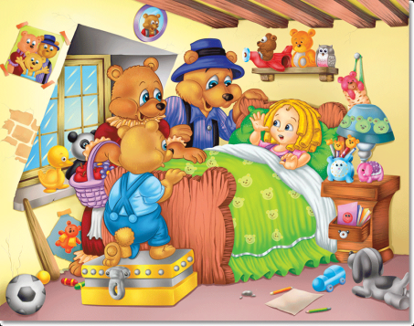 | Mathematical Development  Can you count how many doors, windows, chairs in each room of your house? Can you record what you find on paper?  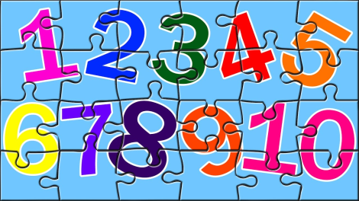 | Knowledge and Understanding of the World  Look around your home, ask an adult to help you count how many different types of technology you have. Do you have any toys that make a noise or move? Can you draw a picture of all the different types of technology you have? Do you know how to make them work?  