Year 5 Home Learning – Wednesday 24th June 2020
We’d love to see your work! Please send it to: Year5@highworthcombined.co.uk
ENGLISH Writing: Wizards  Now it’s time to design your own school! Will yours be a school of skateboarding, cycling, cookery, computer games, … the possibilities are endless.  Once you’ve drawn your floor plan, you’re going to plan your advert.  Remember to use the advert for the School of Wizardry to help you with some ‘weaselly’ language.  Scroll down for the worksheets and enjoy being imaginative and creative! |  | MATHS: Kilograms and Kilometres  This week we are working on measurement.  Scroll down to look at the knowledge organiser and learn the key words.  Take careful note on how to convert between the units – it may seem tricky but it is only multiplying and dividing by 10,100 and 1,000.  Have a go at the worksheet and refer to your knowledge organiser for help.  The answers are included so, when you have finished, you can mark your work.  If you have any incorrect answers, look back over your work, check your calculation and see if you can spot your mistake.
WONDERFUL WORDS
Look at the Year 5 & 6 Words List. You can find it as a link on our Coronavirus Closure, Home Learning Matrix, Year 5 tab: https://www.highworth.bucks.sch.uk/web/year_5/460996
Choose 4 or 5 words to practise at a time.
- Look up the definition in a dictionary to check the meaning of each word.
- Learn the correct spelling by using: Look, Say, Cover, Write, Check.
- Write a sentence which includes the word to show that you understand its meaning.
4. Challenge yourself to use expanded noun phrases in each of your sentences.
Scroll down for the Help Sheet and Practise Activity to get you started.
HISTORY  Medieval Monarchs  In our second lesson in this unit you are going to be learning about the people that contributed to Thomas Becket’s death.  Complete the lesson on the Oak National Academy website:  https://classroom.thenational.academy/lessons/who-was-responsible-for-the-death-of-thomas-becket  You will need paper, pen and your brain! | 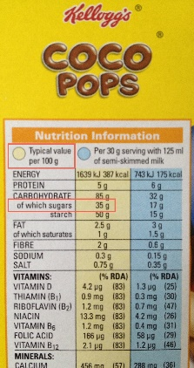  FOOD TECHNOLOGY  Which Foods  Contain the  Most Sugar?  Choose a  selection of food  items from your  food cupboard,  fridge and  freezer.  Then identify the nutritional label and record the amount of sugar that each food contains.  Once you have gathered the information, try to record the sugar contents on a bar chart and evaluate the data.  We wonder if your findings will change what you eat, or maybe how much of each food? |  | Geography  The United Kingdom  Use old newspapers and magazines to recreate a collage of the United Kingdom (scroll down for maps)  Use an atlas or Google Earth to  help you understand the terrain and physical features of key  areas and select colours and textures that reflect this e.g.  • greens for rural areas  • blue for rivers and seas  • graduated colours to white for mountains  • yellows for coastal areas/beaches.  Use small, thumbnail-sized pieces of paper and layer them  together to create your own UK collage.
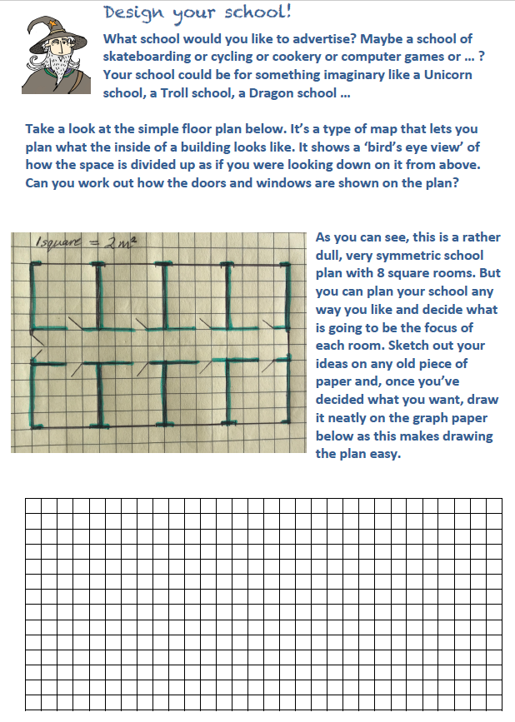
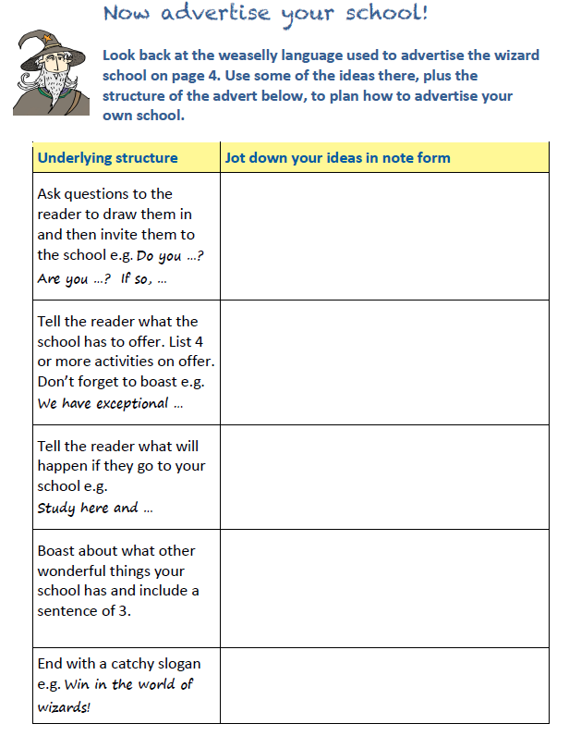

ADVERT FOR THE SCHOOL OF WIZARDRY
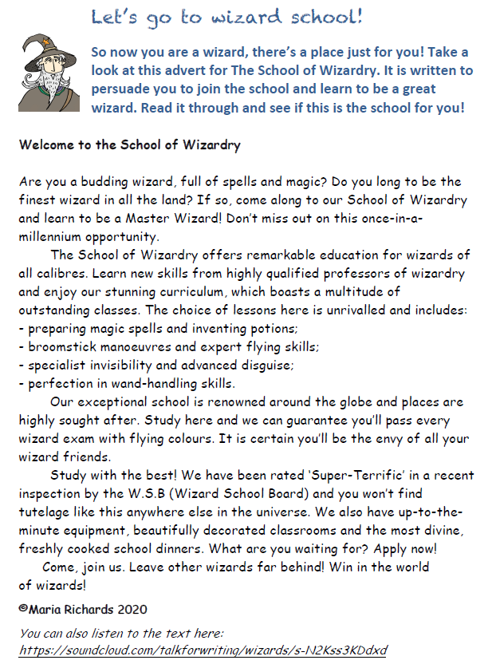
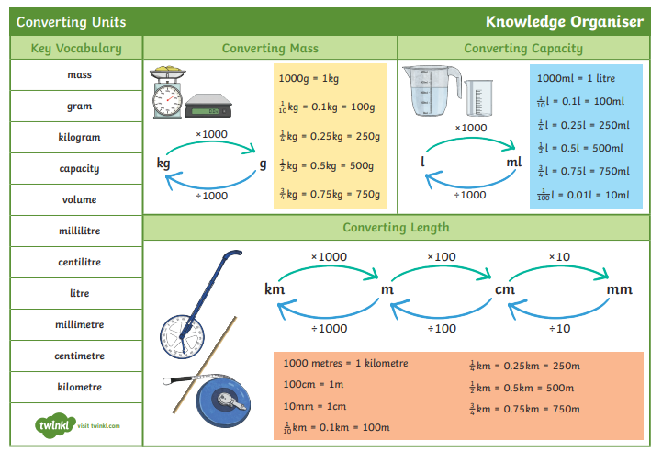

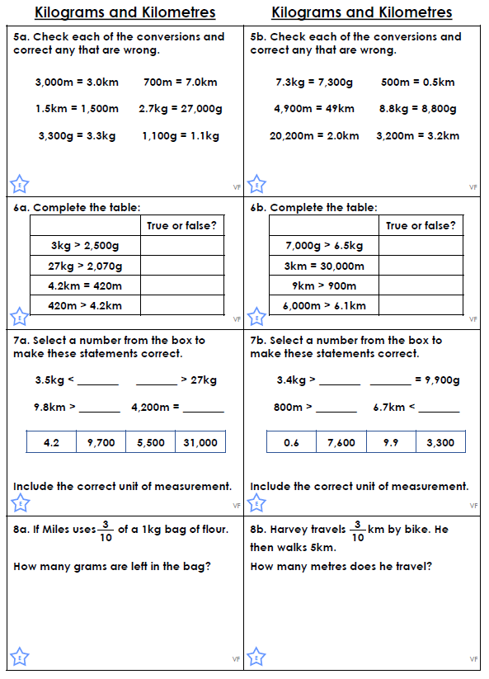
ANSWERS
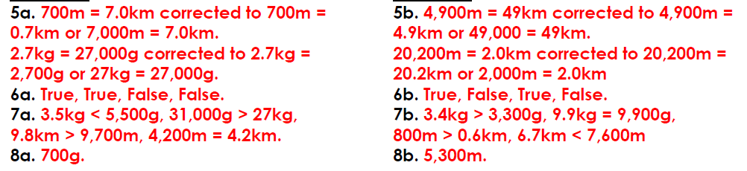

Help Sheet
Expanded Noun Phrases

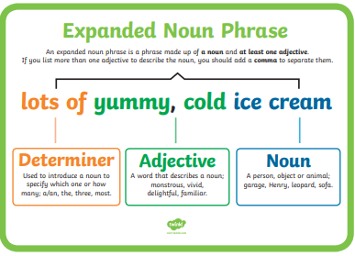
Scroll down for the practise activity.
