**100 Books To Read In Year 5 and 6**

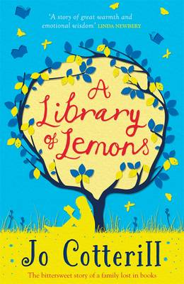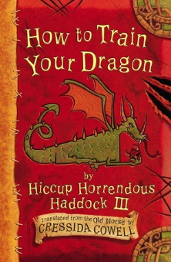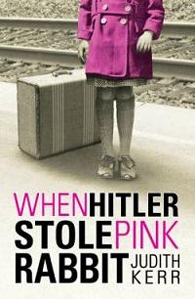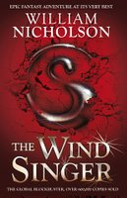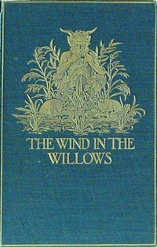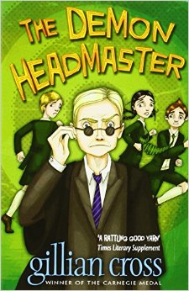

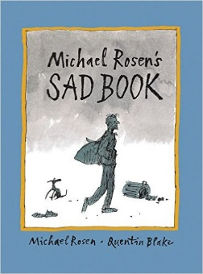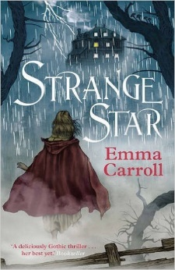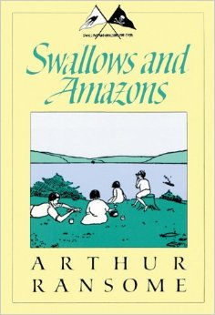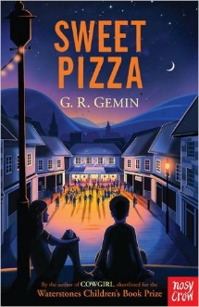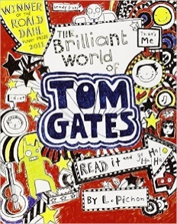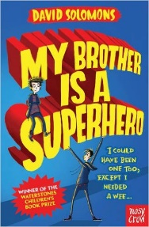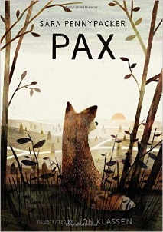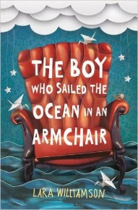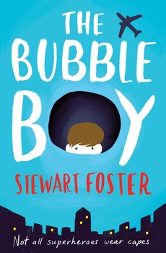

Pax

Sara Pennypacker

Ballet Shoes

Noel Streatfeild

The Arrival

Shaun Tan

Sad Book

Michael Rosen

A Long Walk To Water

Linda Sue Park

Strange Star

Emma Carrooll

Swallows and Amazons

Arthur Ransome

Sweet Pizza

G R Gremin

The Wind in the Willows

Kenneth Grahame

Black Powder

Ally Sherrick

The Brilliant World of Tom Gates

Liz Pichon

Liz Pichon

My Brother is a Superhero

David Solomons

The Boy Who Sailed the Ocean in an Armchair

Lara Williamson

The House With Chicken Legs

Sophie Anderson

The Bubble Boy

Stewart Foster

A Library of Lemons

Jo Cotterill

How to Train Your Dragon

Cressida Cowell

When Hitler Stole Pink Rabbit

Judith Kerr

The Wind Singer

William Nicholson

LionBoy

Zizou Corder

The Demon Headmaster  
  
Gillian Cross

