Extra Home Learning – HID Children No 7 - Monday 1st June

To replace some of the tasks in the class home learning you may wish to try some of these. Parents, please simplify or extend depending on needs and age of children. There’s more signing from Mrs Mills and use this link for more stories:
https://www.longwill.bham.sch.uk/blog-1/categories/storytime
Don’t forget to email me your child’s learning hid@highworthcombined.co.uk

Signed Story From Mrs Mills‘’  Watch the signed story of ’The Journey Home’  - What animals are there in the story?  - Why did they go on a journey?  - How do you think we should look after the places where animals live?  Read the Power Point of the story. There are tasks at the end of the power point and below.  The End of Kensuke’s Kingdom for Yr6:  Watch the ending of KK and complete the tasks:  - Chapter 9  - Chapter 10 part 1  - Chapter 10 part 2 to the end! | HID Afternoon Activity:  Make a Poster  Think back to your work about  Anger that you did a long time  ago in HID Afternoon.  You made a poster showing  all the things you can do to  help you when you are angry.  Make a poster to keep at home. See below for the list of your ideas that we talked about at school. You can choose different ideas as what works for you now may have changed.  Put your poster up at home so you can remember what to do when you get angry
Time for Time:  Write the times on the  worksheet below and  sign the time for each  time shown  Can you teach the signs  for numbers and how to  sign the time to members of your family? | Scientific Wordsearches:  Some fun word searches related to the science topics you have been learning. See below for:  - Properties and Materials Wordsearch  - Plants/Habitats  - Rocking Rocks  Can you remember the signs for the words on the word searches?
Story – ‘The Tiger Who Came to Tea’  Watch the signed story by going to the site:  https://www.longwill.bham.sch.uk/blog-1/categories/storytime Scroll down to find the story. Then read the story on the power point.  Tasks:  Draw and write what the tiger ate for tea.  What animal would you like to invite for tea? Draw a picture and write what you would give. | Looking and Thinking Activity - ‘Town Centre’  Look carefully at the picture below about ‘Town Centre’ and answer the quiz. There are 2 quizzes, A and B. Start with A and if you can, you can do B as well.  See below for the questions and some tasks at the end.
See 7 more pages below:
- Activities for ‘The Journey Home’ and Ideas for Anger Poster
- Time for Time worksheet
- Scientific Word search 1
- Scientific Word search 2
- Scientific Word search 3
- Looking and Thinking picture for ‘Town Centre’
- Questions A for ‘Town Centre’
- Questions B for ‘Town Centre’

Activities for ‘The Journey Home’ – see Power Point
- Draw the animals from the story and write their names. Draw a speech bubble for each animal and write why each animal had to leave their home.
- Chose an animal and find out about what is happening to their habitat. Write what you think we should do to try and save the animals.
- Draw a new home for each animal and describe what it should be like
- What do you think will happen next? Draw the next page for the story and write what you think will happen next.

Ideas for the Anger Poster
Here are some of the ideas you discussed in HID afternoon that you might like to include in your poster. Make sure you choose the ones that work for you.
jump on my bed  punch a pillow  do exercises  squeeze a ball  take deep breaths  talk to an adult  sit in a quiet place  play a game  pop balloons  clench my fist (hands)  clench my teeth | stamp on the stairs  shout outside  shout in my room  lie down  count to 10  count backwards from 10  throw a squishy ball  punch the air  draw a picture  jump on the trampoline  watch a calm film

1 - Properties/Materials Wordsearch

p m a t e r i a l s m

e f a p r y l e j p e

b c o r k z c d h o t

b m r o t s g u w n e

l z p u f b i l u g l

e a n g l x v l k e s

w y s h i n y k l c p

o s m o o t h p u q o

w o z b e r a s c t o

w f h o i u r k z j n

l t n p r s d m b q z

materials rough dull hard pebble cork

soft metal spoon sponge smooth shiny

2 – Plants/Habitats Wordsearch

s u n l i g h t z h

d f p e t a l w o a

e b h a m p r k l b

s y x f l o w e r i

e k y v h n a w o t

r s t e m d t i o a

t o l u g q e d t t

f i e l d s r n c j

m w o o d l a n d z

stem root desert
leaf habitat woodland
flower pond fields
sunlight water petal

3 – Rocking Rocks Wordsearch

s e d i m e n t a r y

a v c g r a n i t e x

n u h n m p c f d w o

d q a e t y r o c k s

s b l o z h m s x m l

t o k u e c o s q a a

o z i s l b k i p r t

n h l l b z y l n b s

e r f h r w m s a l y

r c q c a m a v l e r

m e t a m o r p h i c

j o l i m e s t o n e

metamorphic sedimentary soil
fossils rocks crystals
granite limestone marble
chalk igneous sandstone

Looking and Thinking Activity: Town Centre
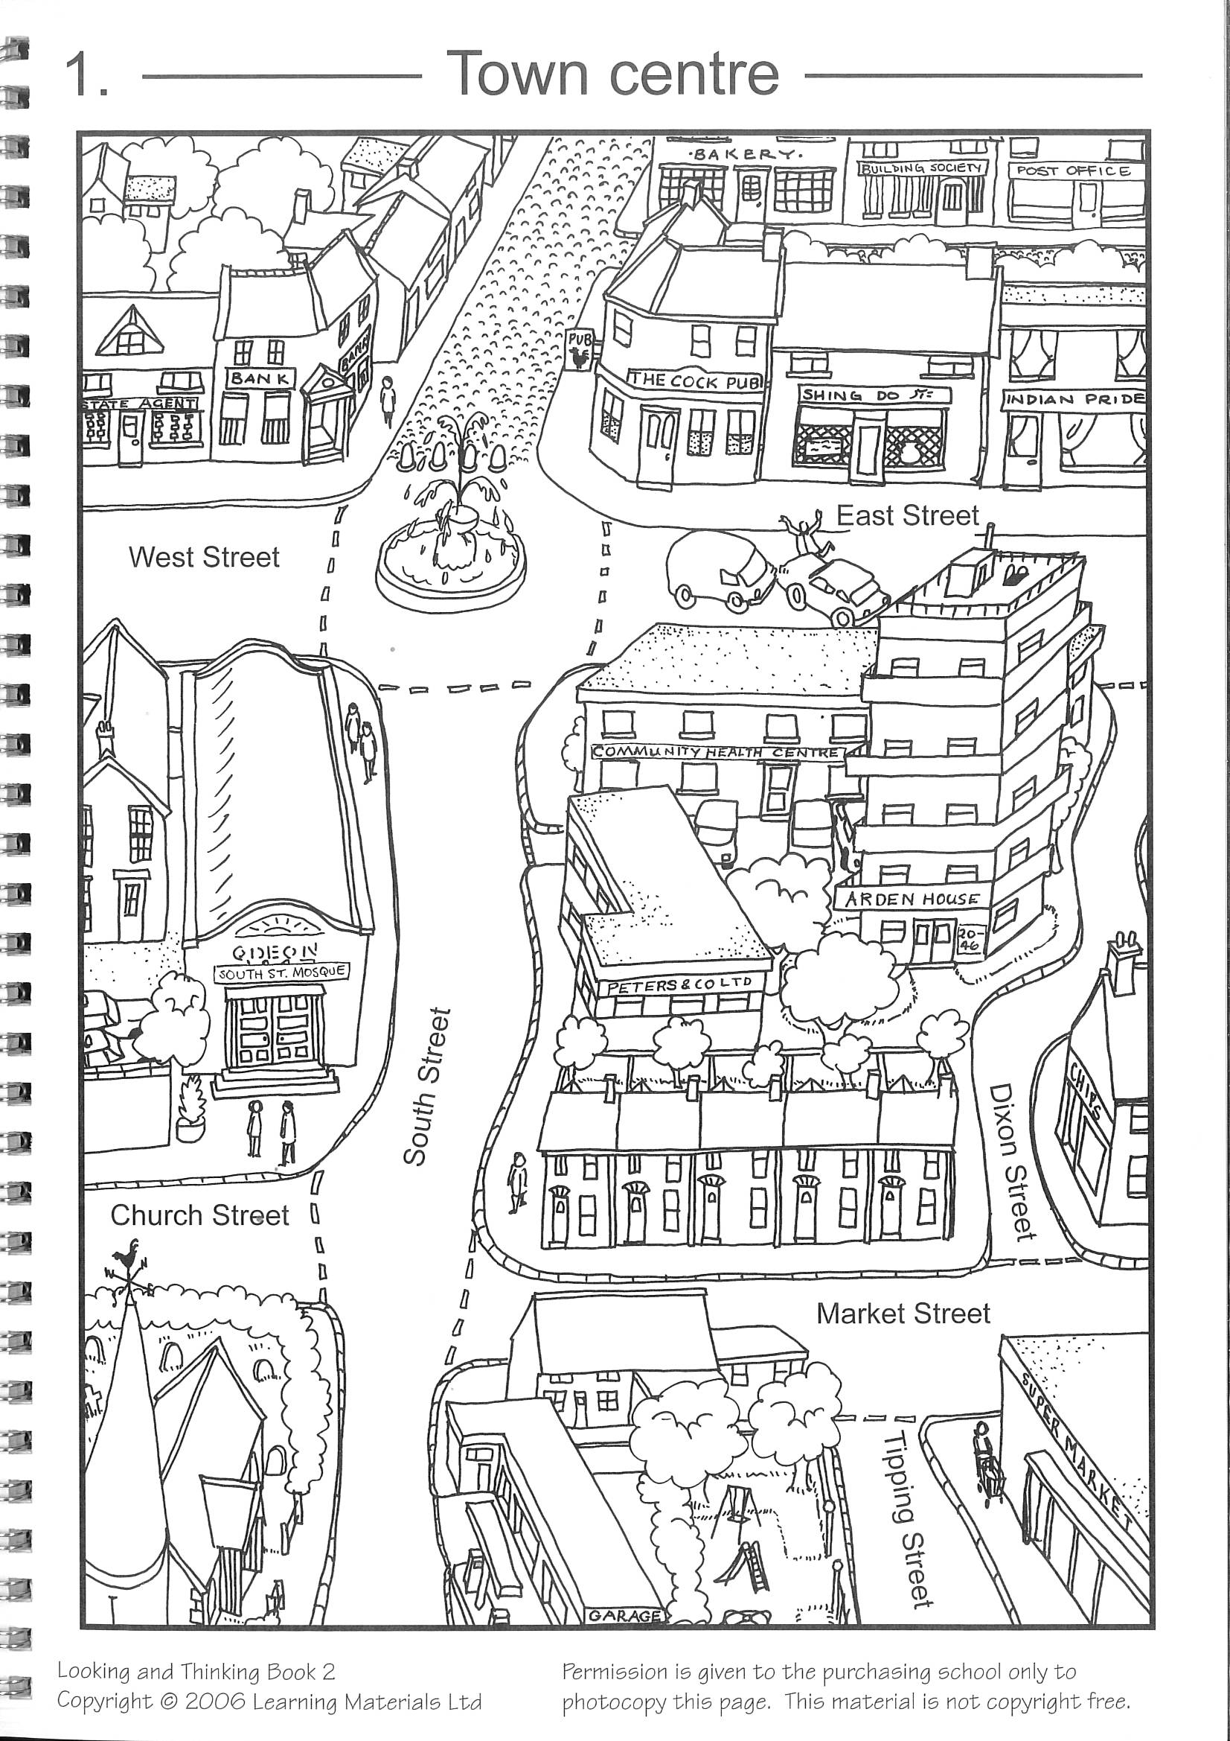

See below for Questions A then Questions B for ‘Town Centre’

