Week 4 Home Activities 3 of 3
Here are some suggested activities you could complete as a family. They are linked to our Early Years Foundation Stage Curriculum and current learning. Have fun and keep well!

Literacy/Communication  .  Play the game ‘I hear with my little ear!’  Take it in turns to imitate the sound of something and guess what makes that sound.  You could imitate the sounds of things found around the house, like a clock or telephone or a recognisable animals like a cat or a dog? | Mathematical Development  Can you copy and continue a pattern with things around your house and outside? Leaf, twig, leaf, twig, leaf, twig....  Train, dinosaur, train, dinosaur, train... | Knowledge and Understanding of the World  Using rolled up paper or two toilet/kitchen rolls tubes. Join then together with tape to make your own pair of binoculars.
Physical  Using a tray from the kitchen trip a small amount of sand, rice or salt you can then practice your mark making, can you make different marks with your finger? A zig-zag? wavy line? | Personal and Social  Together as a family talk about what jobs you would like to do and why?  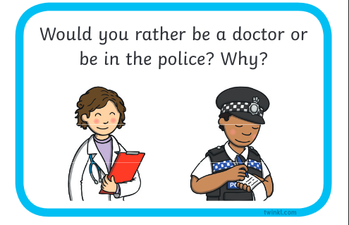 | Creative  Can you draw, stick or paint a rainbow to stick inside tour window to cheer people up?

