Year 5 Home Learning – Thursday 16th July 2020
We’d love to see your work! Please send it to: Year5@highworthcombined.co.uk
ENGLISH:  End of Year 5!  Dear Year 5,  We have come the end of your Year 5 year!  It has certainly been very different! You have all been brilliant and we are so glad to have taught you this year! We know that this school year is one that we will never forget!  For your last activity, we would like you to write a letter to us telling us about your year in 5K and 5N.  You could include some highlights, not so great moments, friendships, sporting or musical activities and what you are looking forward to next year.  Remember to use the correct format for a letter and to sign off correctly.  We are looking forward to reading your letters! |  | MATHS:  You are going to be using your knowledge about Number and Place Value to practise place value up to three decimal places (3dp).  You will need some paper for working out.  We have also included some extra Rapid Reasoning questions.  Scroll down and try to answer the questions.  The answers are included so, when you have finished, you can mark your work.  If you have any incorrect answers, re-read carefully to make sure you’ve understood the question, check your work and see if you can spot your mistake.
WONDERFUL WORDS
Look at the Year 5 & 6 Words List. You can find it as a link on our Coronavirus Closure, Home Learning Matrix, Year 5 tab: https://www.highworth.bucks.sch.uk/web/year_5/460996
Choose 4 or 5 words to practise at a time.
- Look up the definition in a dictionary to check the meaning of each word.
- Learn the correct spelling by using: Look, Say, Cover, Write, Check.
- Write a sentence which includes the word to show that you understand its meaning.
4. Challenge yourself to include relative clauses and adjectives in each of your sentences.
HISTORY  Medieval Monarchs  Use this link for the next lesson 7 in History.  We are going to finish off our essay on Medieval Monarchs.  https://classroom.thenational.academy/lessons/to-plan-and-write-an-essay-about-medieval-monarchs-0f188b  You will need a pen, paper and your brain!  Well done for persevering with this interesting topic! | Reading  We are sure that you are going to be doing some reading during the summer holidays.  So, we have attached a reading challenge for you to complete.  You have a choice as to how many and which activities you would like to do.  You could keep it safe so that you can see how many you have done!  Have fun! |  | Wellbeing:  Wordsearch, number search and colour in sheets!  Try these fabulous activities to calm down and relax. Use different colours or a just a pencil.  We are looking forward to seeing your works of art!
NUMBER AND PLACE VALUE
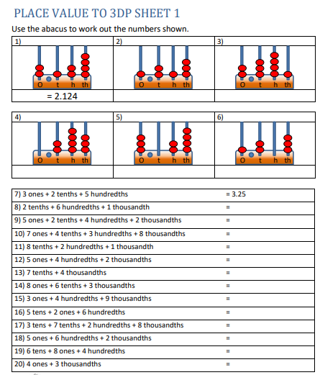

Rapid reasoning
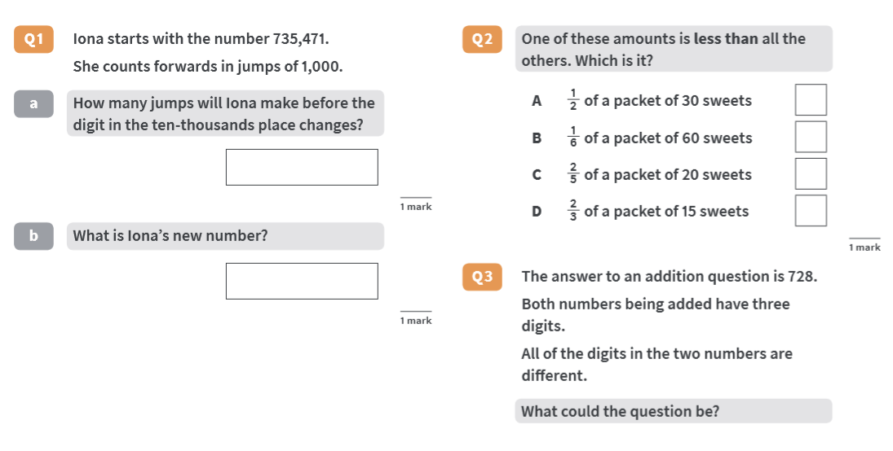
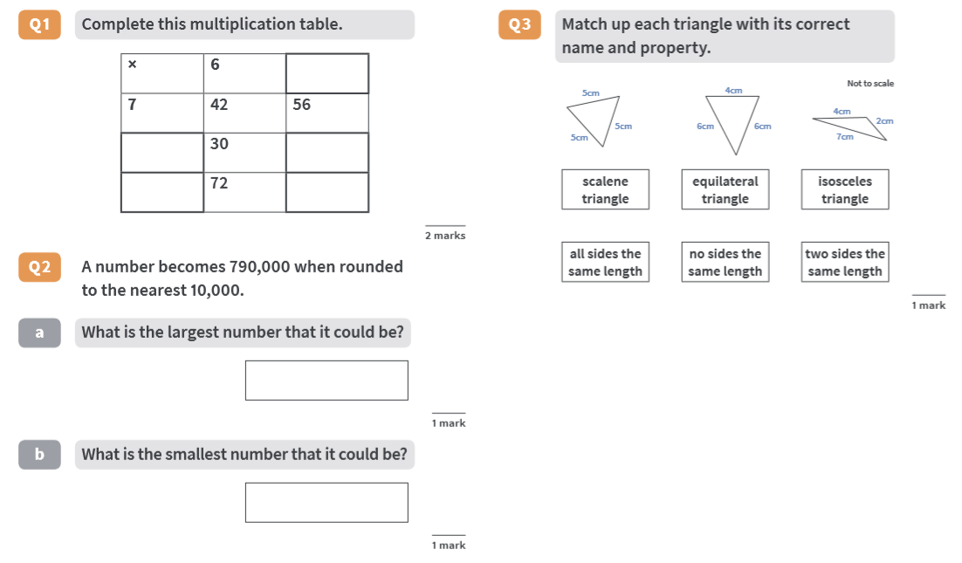
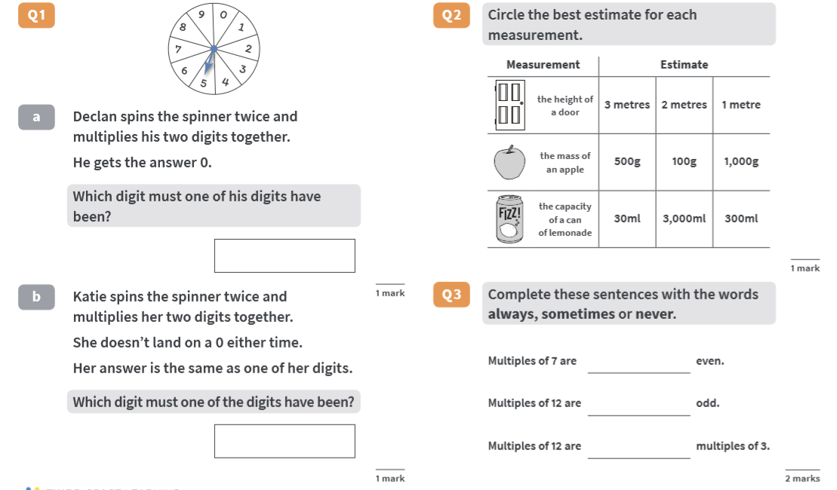

Answers
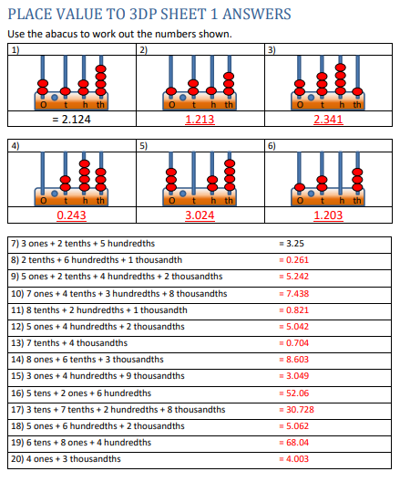

ANSWERS RAPID REASONING
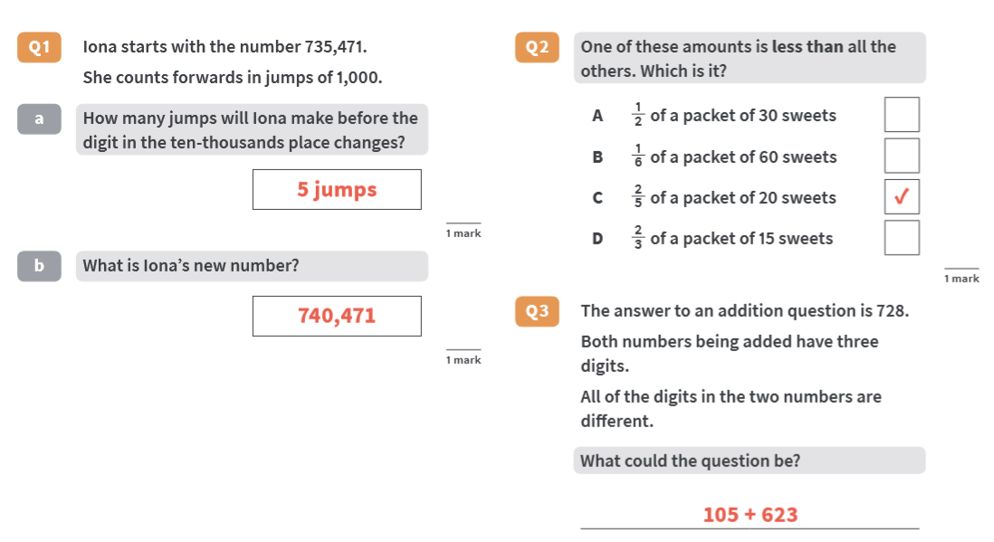

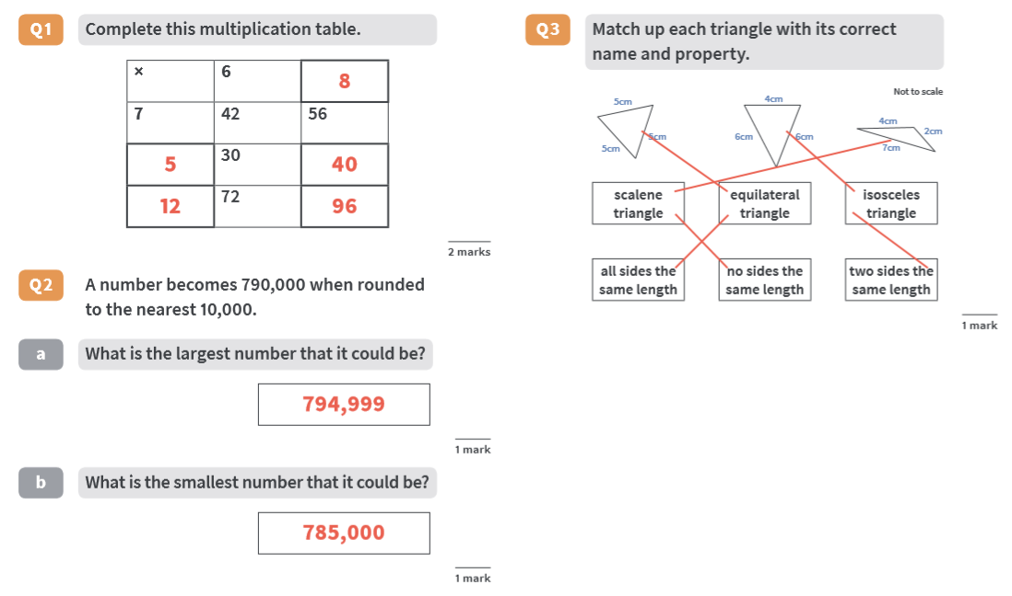
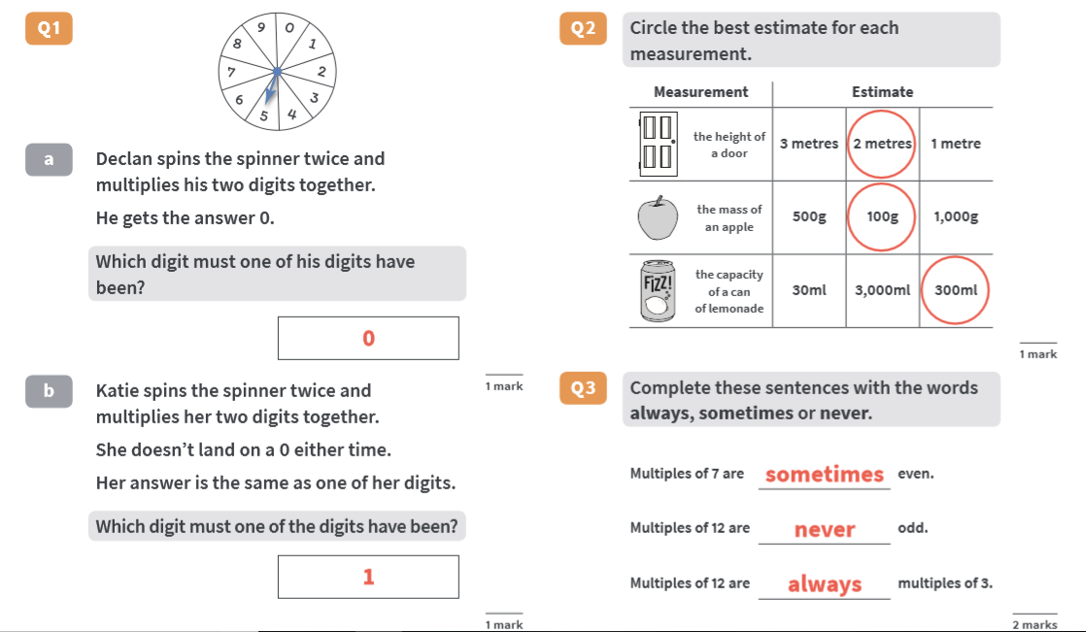

Wellbeing Activities
