Year 5 Home Learning – Monday 15th June 2020
We’d love to see your work! Please send it to: Year5@highworthcombined.co.uk
ENGLISH  Wizard Words  Today we are going to have some fun with words.  You’re going to create some new words for a Wizard’s spell by taking an everyday word and then putting an ending on it. For example, explode-ium  Scroll down for the full instructions and then  complete the activities. Make sure you say your words out loud – it’s great fun!  Finally, have a go at the Challenge to write some spells for a wizard. Remember those commas! |  | MATHS  SHORT DIVISION  We are going to practise dividing 4-digits by 1-digit.  Scroll down for a help sheet and some questions for you to answer.  The answers are included so, when you have finished, you can mark your work.  If you have any incorrect answers, look back over your work, check your calculation and see if you can spot your mistake.
WONDERFUL WORDS
Look at the Year 5 & 6 Words List. You can find it as a link on our Coronavirus Closure, Home Learning Matrix, Year 5 tab: https://www.highworth.bucks.sch.uk/web/year_5/460996
Choose 4 or 5 words to practise at a time.
- Look up the definition in a dictionary to check the meaning of each word.
- Learn the correct spelling by using: Look, Say, Cover, Write, Check.
- Write a sentence which includes the word to show that you understand its meaning.
4. Challenge yourself to show possibility by including an adverb or a modal verb in each of your
sentences. Scroll down to the REVISION CARD for a reminder about them.
SCIENCE  What lives in the deep ocean?  This week, you can go on a journey to one of the deepest, darkest places on Earth, where life has evolved in strange ways. Watch this video  https://www.youtube.com/watch?v=HEdDOr1rqDI&t=82s  Scroll down for some questions to think about whilst you watch the video a second time.  There’s also another fascinating video about how whales use sound to communicate! | ART  Relax, enjoy, create!  Here are some art ideas to think about and maybe try to create. You don’t need any fancy art materials to try these out, simply a pen/pencil and a sheet of paper.  Don’t worry about creating amazing works of art, just let your mind wander and hand doodle.  You can try the ideas in any order and do as many as you want on any particular day, or you can really challenge yourself and stick to the order and do one a day for the week:  1. Clouds  2. Plants/Flowers  3. The benefits of lockdown  4. Favourite Movie  5. Eyes |  | FOOD TECHNOLOGY  Can you master a frittata?  Watch this video to learn how to cook a tasty and healthy potato & pepper frittata.  It looks delicious!  The recipe is for 4 people, so why not try cooking it for you and your family? Obviously, check with your adult first!  We’d love to see a photo of your finished dish.  BON APPETIT!  https://classroom.thenational.academy/lessons/potato-and-pepper-frittata-all/activities/2
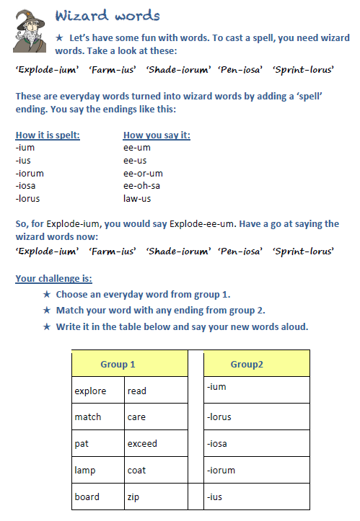

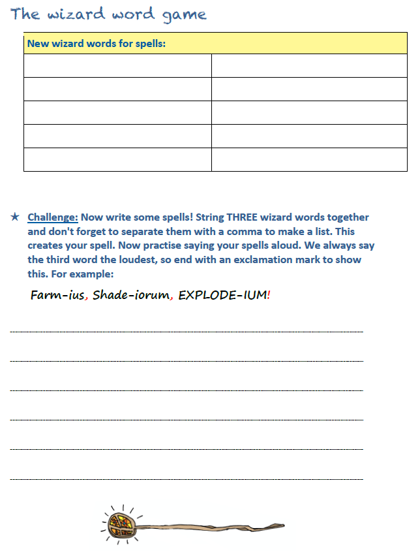

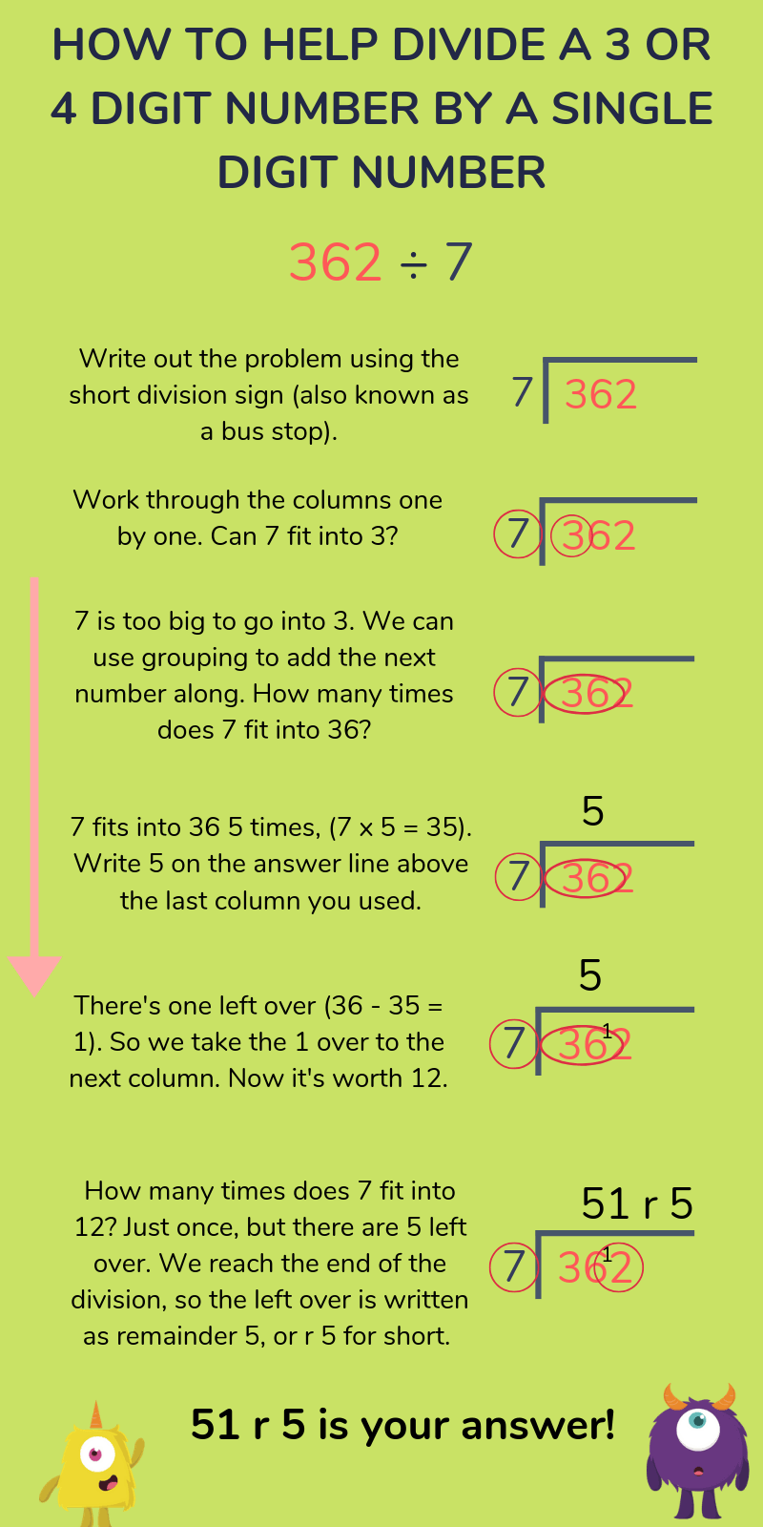
SHORT DIVISION HELP SHEET

SHORT DIVISION
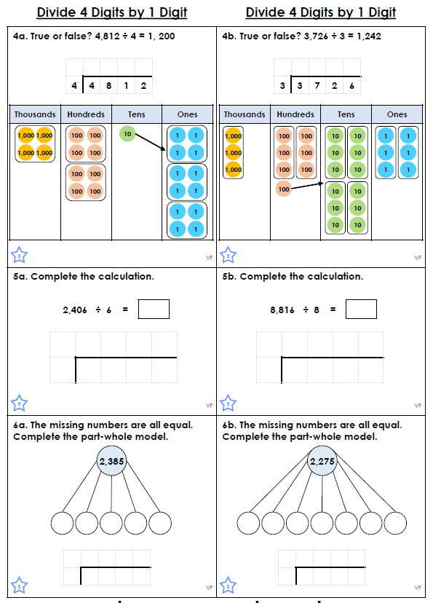

SHORT DIVISION ANSWERS
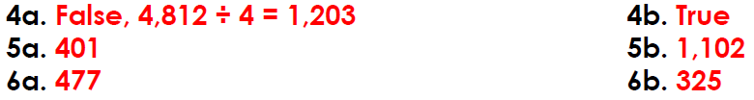

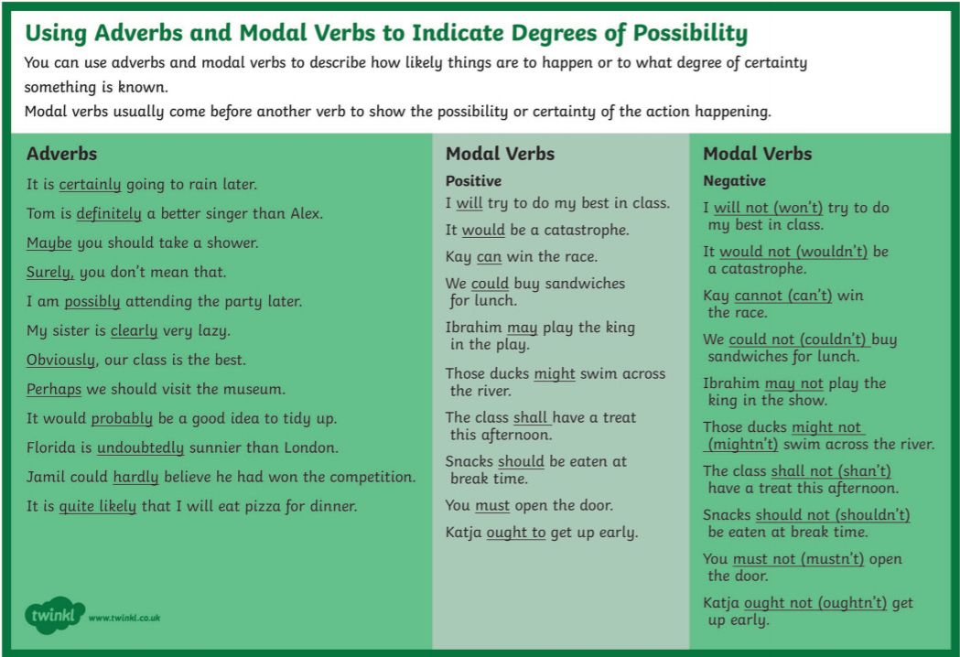
WHAT LIVES IN THE DEEP OCEAN?
https://www.youtube.com/watch?v=HEdDOr1rqDI
1) What is the abyss? What is life like in the abyss?
2) Why do you think the deepest parts of the ocean are
difficult to explore?
3) Would you like to travel to the abyss, if you could? What
would you like to see?
4) Why is World Oceans Day important and why do you think we
need to protect our oceans?

WHY IS NOISE POLLUTION A PROBLEM FOR WHALES?
Watch this video to discover how whales use sound to communicate, and why noise pollution is a big problem for all life in the ocean:
https://www.youtube.com/watch?v=06KO52bIxp0&feature=youtu.be&utm_source=twigeducation.com&utm_medium=email&utm_content=june-11-2020-bonus-summerschool&utm_campaign=tsr-summerschool

QUESTIONS TO THINK ABOUT WHILE YOU WATCH:
1) How does noise pollution put whales and other animals at
risk?
2) How can we reduce the level of noise pollution in the oceans?
Do you have any solutions?
3) What do you think will happen to whales if we don't reduce
noise pollution?

