Priests were the most powerful people in the Maya times as they believed that they could talk to the Gods.
Priests and nobles were the only people who could read and write.
Priests would have been brought gifts and given free manual labour for whatever they needed by the common people.
The people who supported the priests rarely saw them, except at the religious festivals.
The Maya priests did not have to pay taxes but still had to follow the law. If a priest was found guilty of a crime, they were often punished even more severely than a commoner.
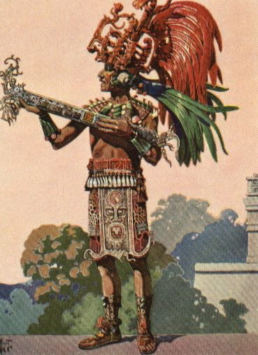
Living conditions
Priests usually lived away from the common people and lived a life of luxury with servants and attendants.
Entertainment
Religious ceremonies were the main source of entertainment. They also played music, danced and played ball games.
Job
During religious festivals that were held every 20 days, the priests would dance on the steps of the temple, so that the people could see them speaking with the gods and keep people in favour of the gods.
The priests were responsible for telling the people when to plant, harvest, go to war, marry, make a personal sacrifice and even how to behave.
The Kings would have asked for the priest’s advice on what to do in a crisis and to get predictions of the future.
Some special priests would have been responsible for teaching the noble’s children maths, science, astronomy, medicine, writing, and other subjects.
Clothing
During the religious festivals the priests would have worn elaborate and rather scary costumes.
At other times they would have worn colourful clothing made from animal skins. They also wore tall hats and feather headdresses and fancy jewellery.
Food
The Maya ate very well. The most important food that the Maya ate was maize. They made all types of food from maize including tortillas, porridge, and even drinks. They also ate beans, squash, and chilies. For meat the Maya ate fish, deer, ducks, and turkey.
Priests would have also enjoyed a chocolate drink flavoured with chilli peppers.

