Year 5 Home Learning – Wednesday 1st July 2020
We’d love to see your work! Please send it to: Year5@highworthcombined.co.uk
MANY APOLOGIES YEAR 5! Our matrix for Monday 22nd June did not include the answers for the Michael Morpurgo text, as stated. Please scroll down to access them now so that you can check your work.
ENGLISH: Wizards A POTION POEM  First, read the very imaginative poem, My Wonderful Wizard Potion.  Then, you’re going to use it to plan your own potion poem. Remember to follow the pattern of the original poem to help you and be as creative as you can!  Next, you’re going to draft your poem. Remember to read it through carefully to see if there are any improvements you can make and check your spellings are correct too. Try to edit your work in a different colour pen to show us how you’ve made it even better.  We’re really looking forward to reading your work because we know how much you enjoy writing poems.  Finally, when you’re happy with your poem, you can publish it by writing it in the bottle outline  Scroll down for the poem and the activity sheets. Make sure read the instructions carefully. |  | MATHS:  Scroll down for the Equivalent Fractions and Rapid Reasoning worksheets.  Try to answer as many questions as you can.  Remember to look at the Fractions Wall to help you with equivalent fractions.  The answers are included so, when you have finished, you can mark your work.  If you have any incorrect answers, re-read carefully to make sure you’ve understood the question, then check your work and see if you can spot your mistake.
WONDERFUL WORDS
Look at the Year 5 & 6 Words List. You can find it as a link on our Coronavirus Closure, Home Learning Matrix, Year 5 tab: https://www.highworth.bucks.sch.uk/web/year_5/460996
Choose 4 or 5 words to practise at a time.
- Look up the definition in a dictionary to check the meaning of each word.
- Learn the correct spelling by using: Look, Say, Cover, Write, Check.
- Write a sentence which includes the word to show that you understand its meaning.
4. Remember to always edit your sentences to check for correct punctuation and spelling.
RE  Buddhism  Complete the final lesson on Buddhism using the link below to find out more about Buddhist beliefs and the Dalai Lama:  https://classroom.thenational.academy/lessons/who-is-the-dalai-lama  You will need paper, pen and your brain! | ART  We would like you to make some art using items from the natural world. You could collect items from a walk in the woods, the park or in your own garden. You can use leaves, sticks, pebbles, bark, petals or anything else that you can find.  You might decide to create a picture by collaging some of the treasure you have found or maybe you might decide to make a sculpture!  Scroll down for some ideas to get you started but please let your imagination fly and see what you can make.  We’re really looking forward to seeing your creations! |  | FOOD TECHNOLOGY  Feeling Chilli?  Watch this video to learn how to cook a tasty and healthy Veggie Chilli. It looks delicious!  The recipe is for 4 people, so why not try cooking it for you and your family? Obviously, check with your adult first!  https://classroom.thenational.academy/lessons/veggie-chilli-all  We’d love to see a photo of your finished dish.  BON APPETIT!
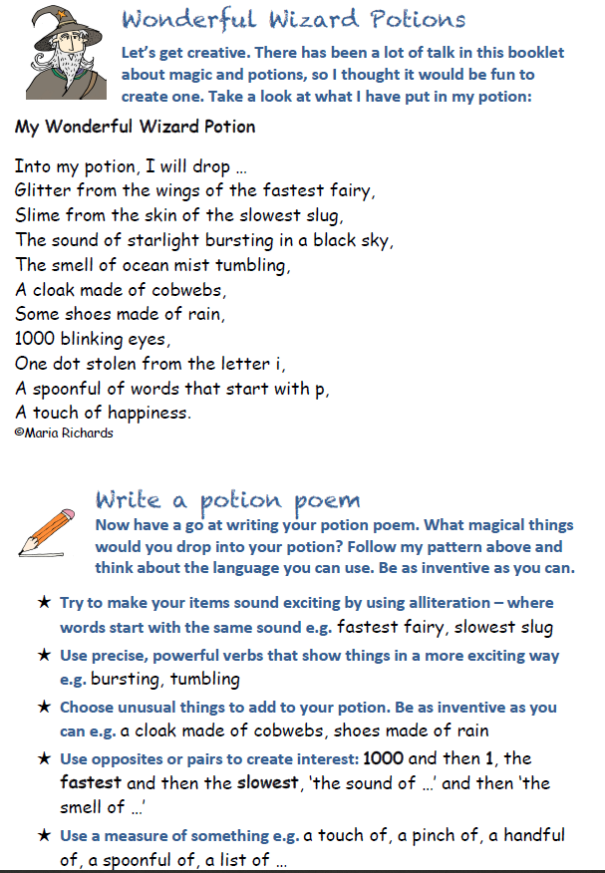
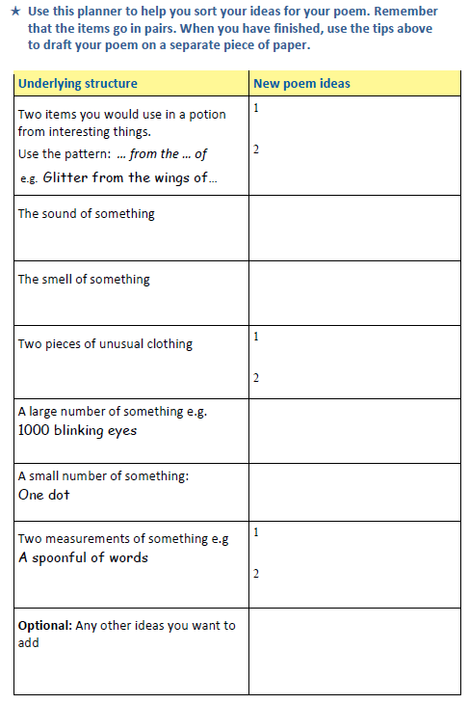

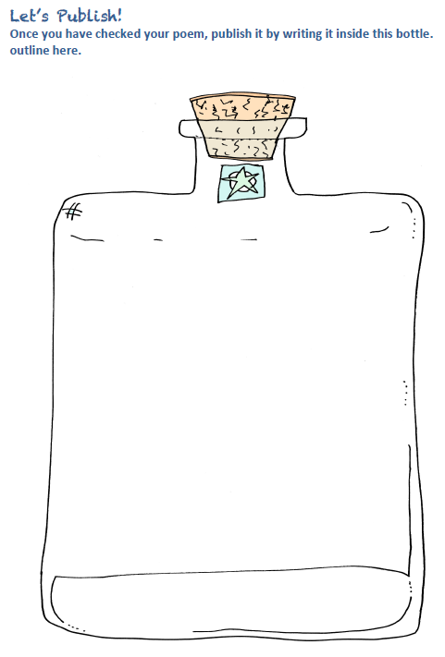

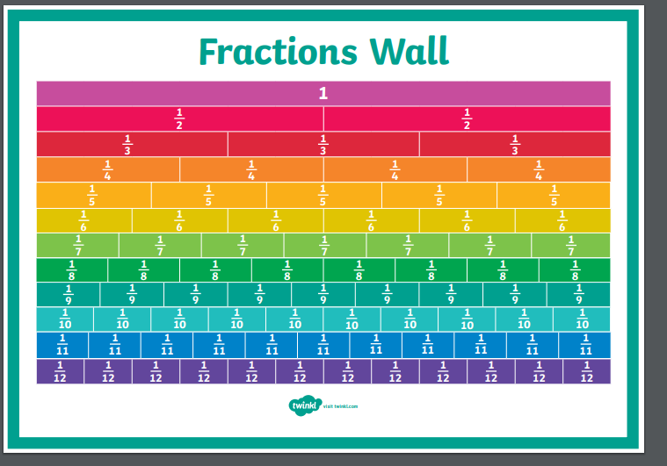

EQUIVALENT FRACTIONS
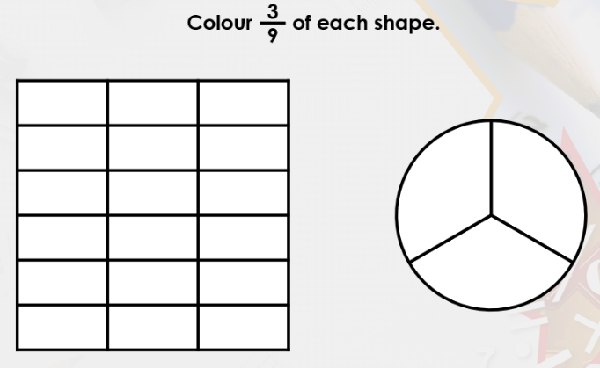
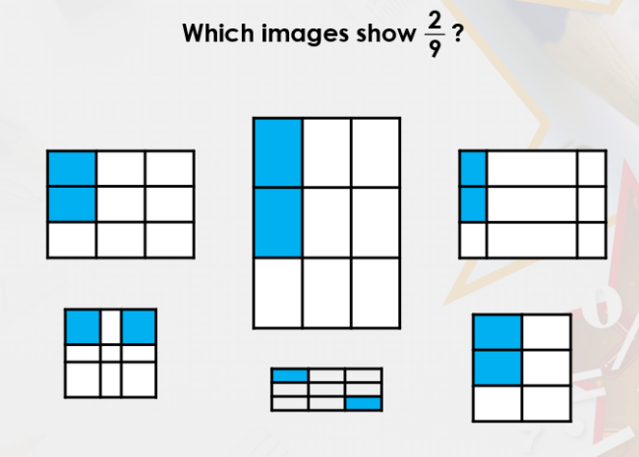
1) 2)

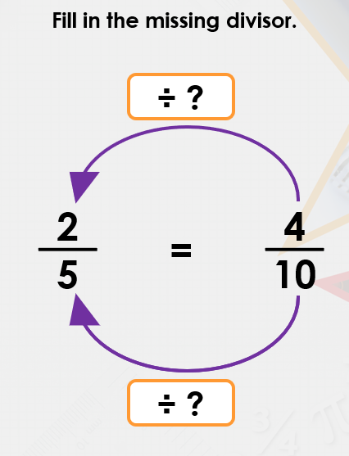
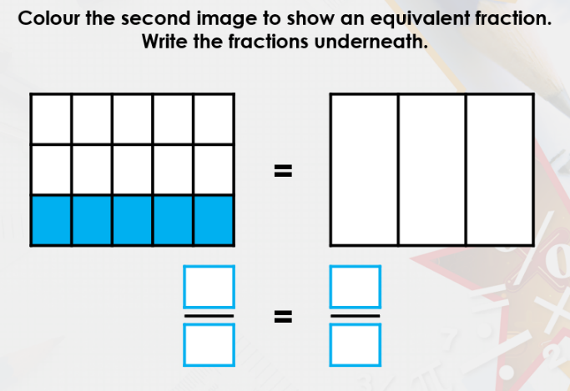
3) 4)

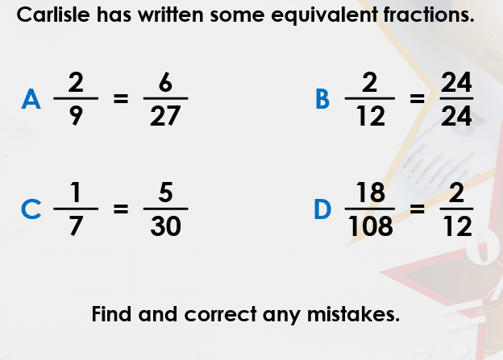
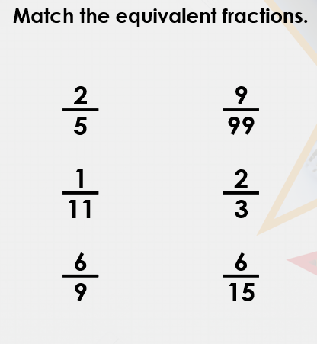
5) 6)

ANSWERS EQUIVALENT FRACTIONS
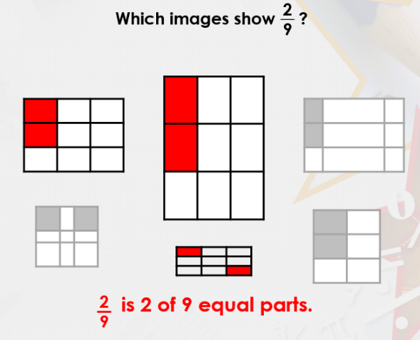
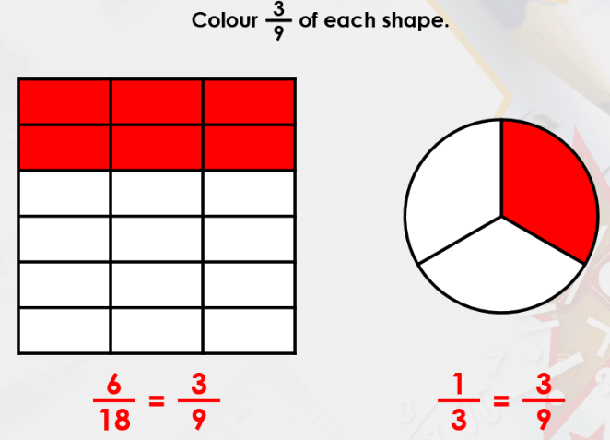
1) 2)

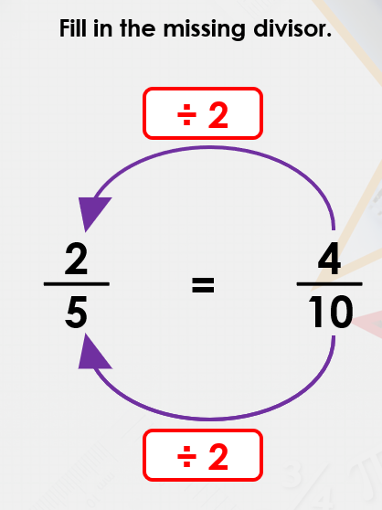
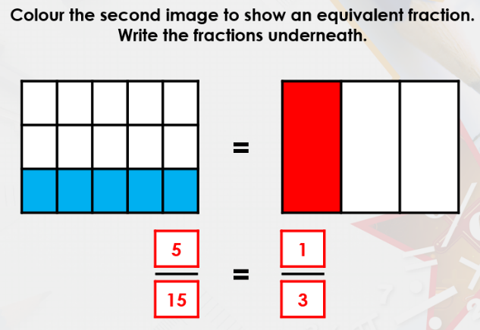
3) 4)

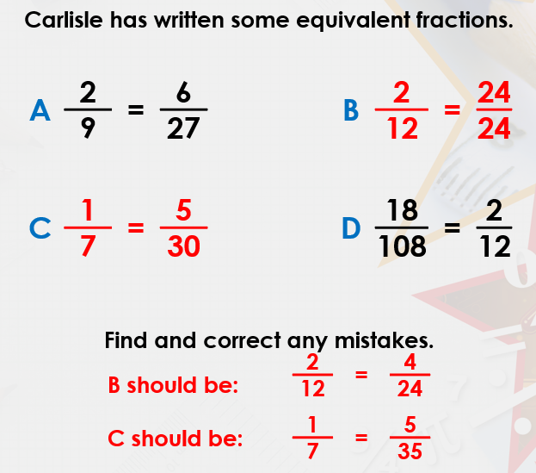
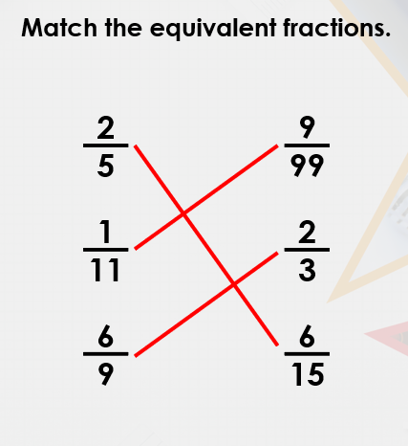
5) 6)

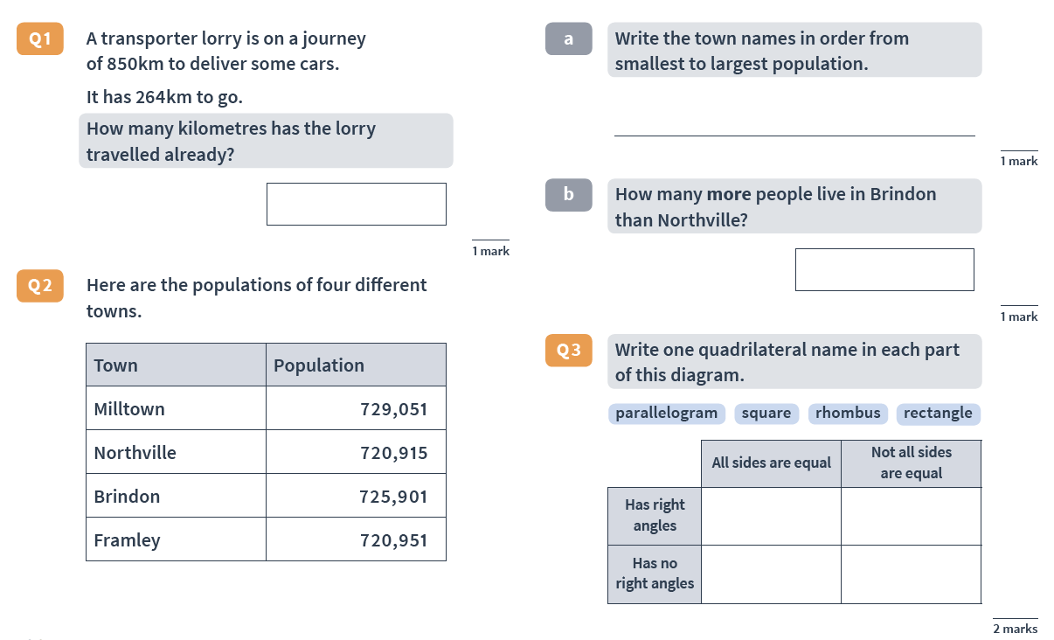
RAPID REASONING

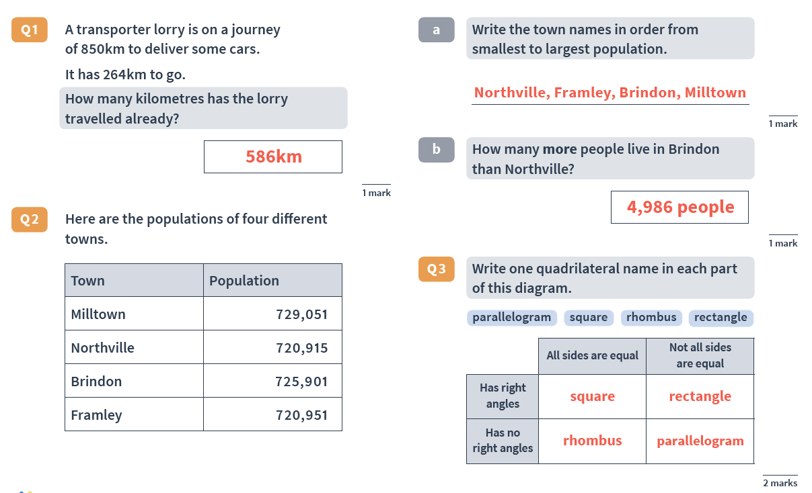
ANSWERS RAPID REASONING

NATURAL WORLD ART IDEAS
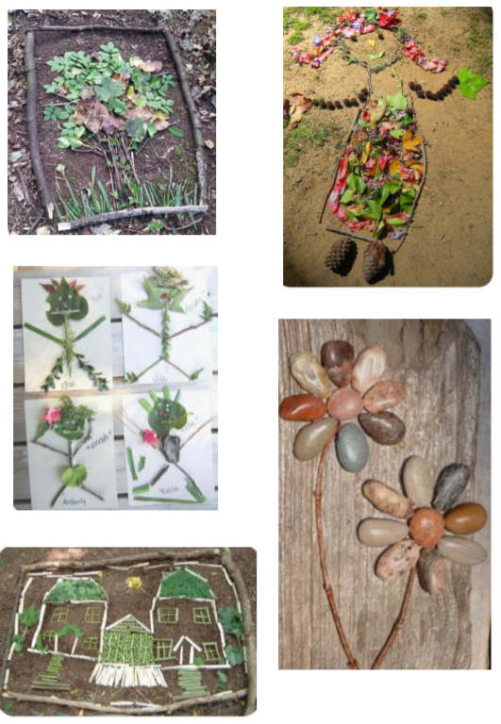

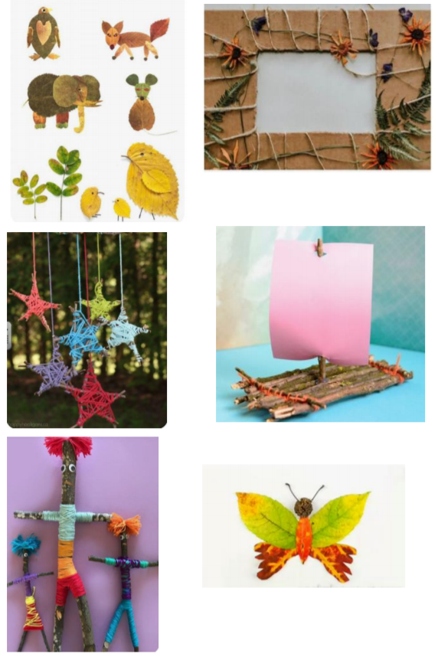

MANY APOLOGIES YEAR 5! Our matrix for Monday 22nd June did not include these answers for the Michael Morpurgo text, as stated.
