Year 4 Home Learning – Monday 30th March 2020
Remarkable Writing!  This week is going to be poetry themed! The activities will continue throughout this week, so by the end of the week you will have written your own list poem. The poem you are going to use as a starting point is attached on the page below … Ten Things Found in a Wizard’s Pocket by Ian McMillan.  Activity 1: copy out (and keep it safely for the rest of this week’s activities) and read this list poem. Then create a text map using simple drawings to help you learn the poem by heart. | Resilient Readers!  My Shadow by Robert Louis Stevenson.  Time for some poetry themed reading comprehension!  Both the poem and the questions are attached below as word documents.  Remember to think about your answers, use the poem to help you and answer in good sentences!  Alternative activity: Write some questions about the list poem for someone else to answer. For example: what size was the elephant? How do you know?
Super Science!  Use the link below that has a number of opportunities to find out what food chains are. From this, can you create a food chain dictionary that includes the following words:- producer, consumer, predator, prey, herbivore, omnivore, carnivore, decomposer, food chain?  A worksheet is included below. You can type directly on it, or print it and complete it, or you can recreate it in the books you were given.  https://animals.pppst.com/what-animals-eat.html | Terrific Topic!  Can you use some recycling materials you can find at home (cardboard boxes, scrap paper etc) to make a model of a Viking longboat? You will find pictures and ideas on the internet!
Marvellous Maths!  Times Tables and division practice for quick recall.  Without internet: You could write them out, ask someone to quiz you or create your own beat the clock grid. Or you can use this link: https://www.topmarks.co.uk/maths-games/daily10  Angle Hunt  To remind you about the different angles we have studied, a reminder poster is attached below.  Now, search around your house to find examples of each type of angle. Can you identify 10 examples of each? |  | Wonderful Wellbeing!  This week’s winning way to wellbeing is: CONNECT (Take time to find out how someone in your family is feeling, share something you have learnt over the past week)  Show an act of kindness to someone in your family and then tell us what it was!
We hope you enjoy completing these activities. If you wish to present the information in a different way, or to extend the activity, we would be delighted to see what you produce. For all Twinkl resources and access to Espresso, please refer to the log on details under the Home Learning Ideas on the school website.

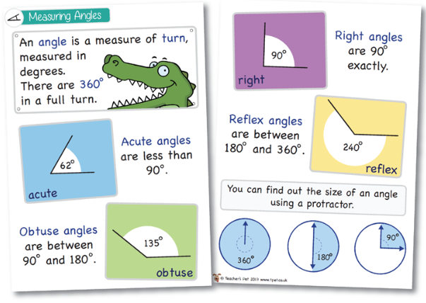
Food Chain Dictionary
Remember to list the words in alphabetical order.
WORD | PICTURE | DEFINITION
carnivore | 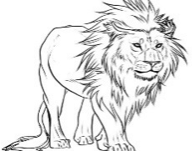 | Any animal that eats only meat.

